Deploying a Wordpress Website using AWS

1)Login to the AWS console.

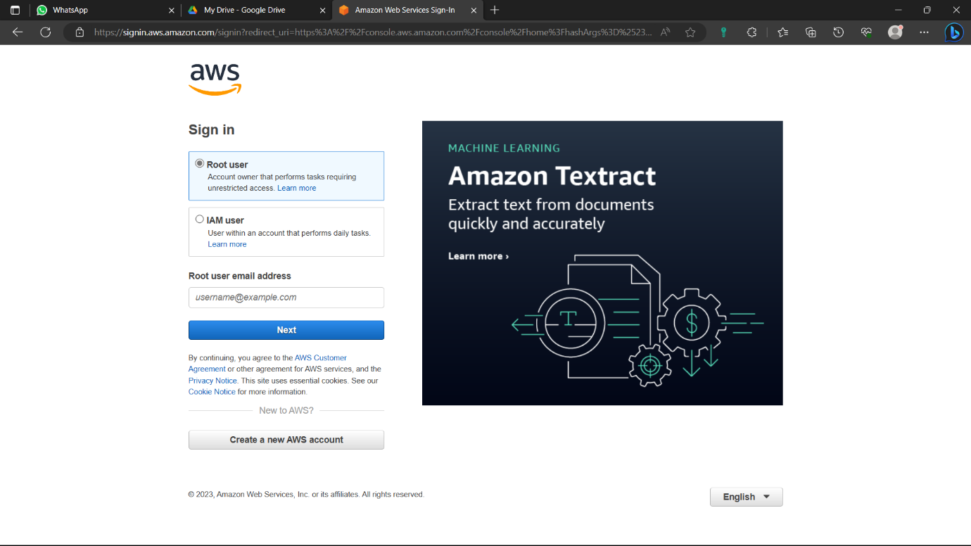

2)Type “IAM” in the search bar and select the “IAM” option below.

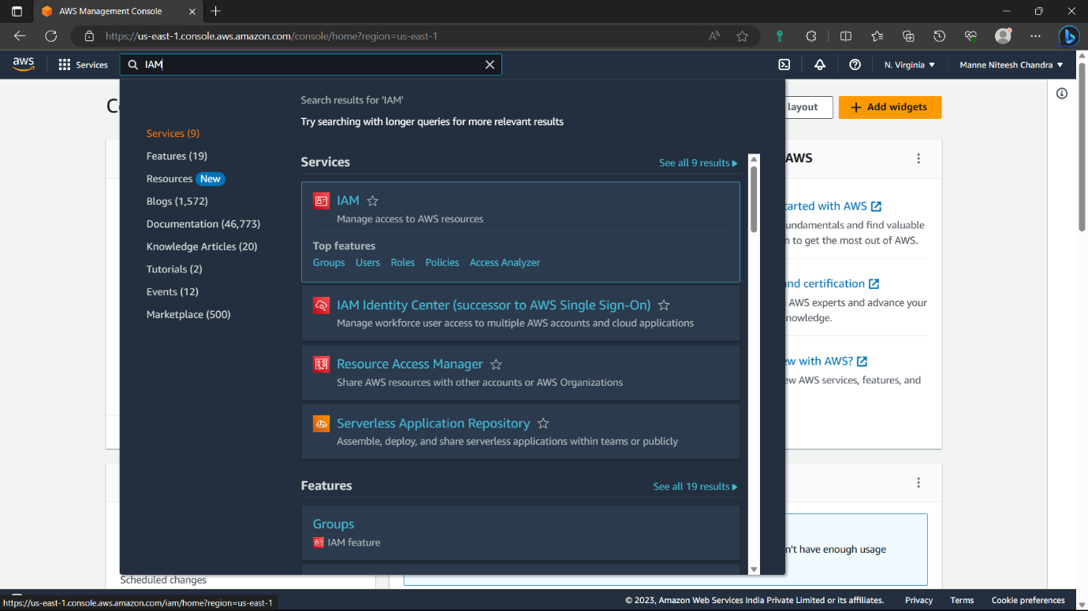

3)Click on “Users” option in left navigation panel.

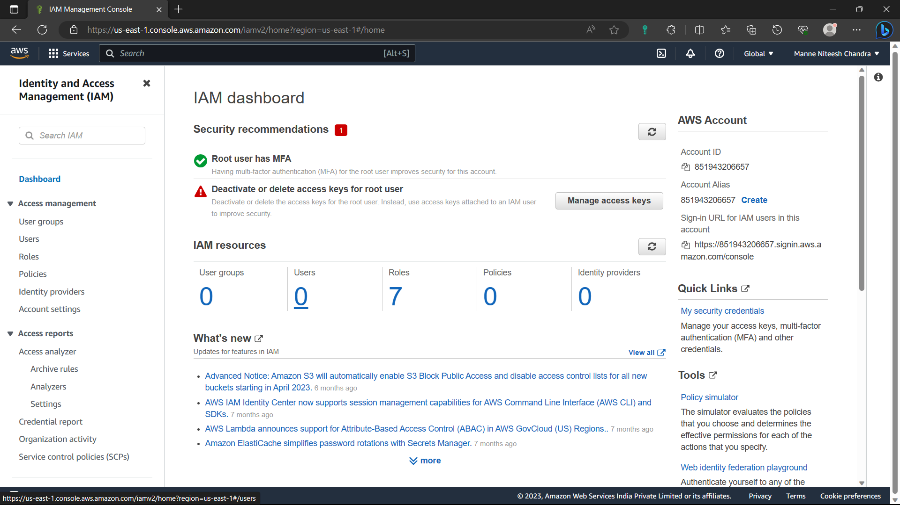

4)Click on “Add users” option i.e., in blue colour.

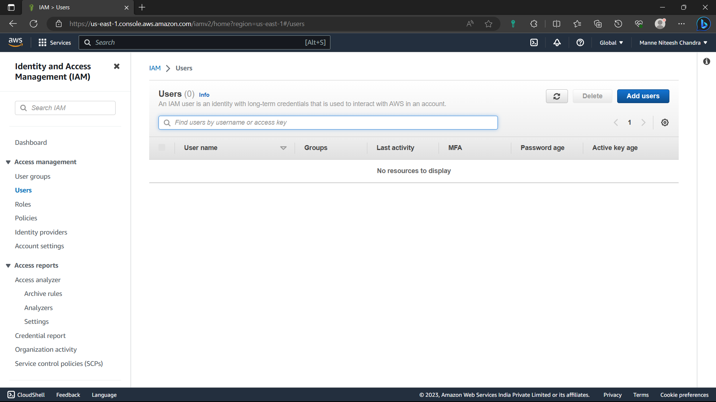

5)Give a name to the user, select “I want to create an IAM user”, console password- “Autogenerated password”.

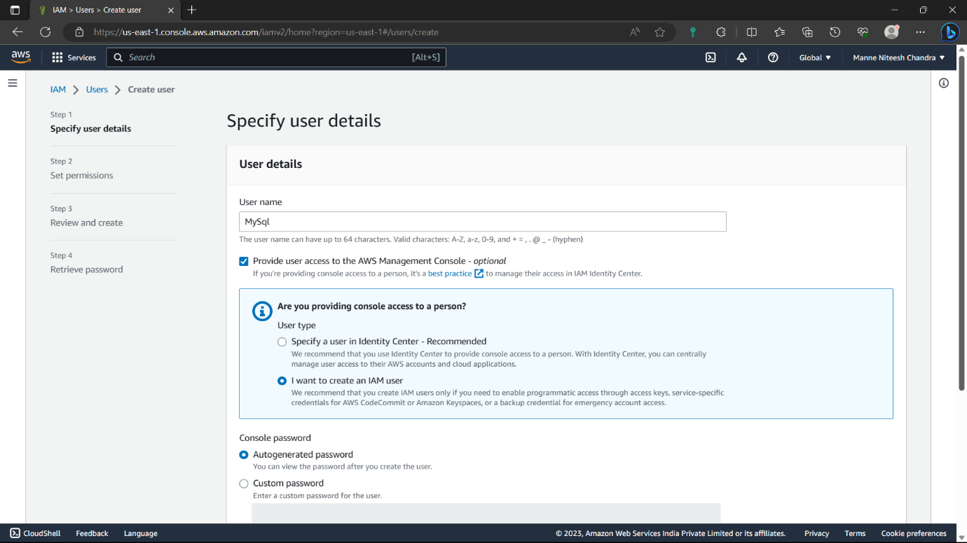

6)Enable “User must create a new password at nest sign-in” and click on “Next” option.

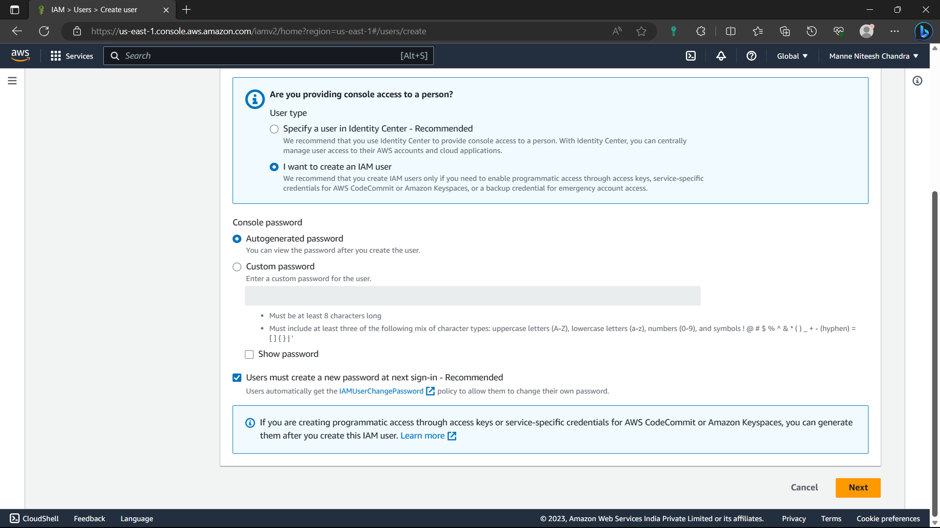

7)Select the “Attach policies directly” option.

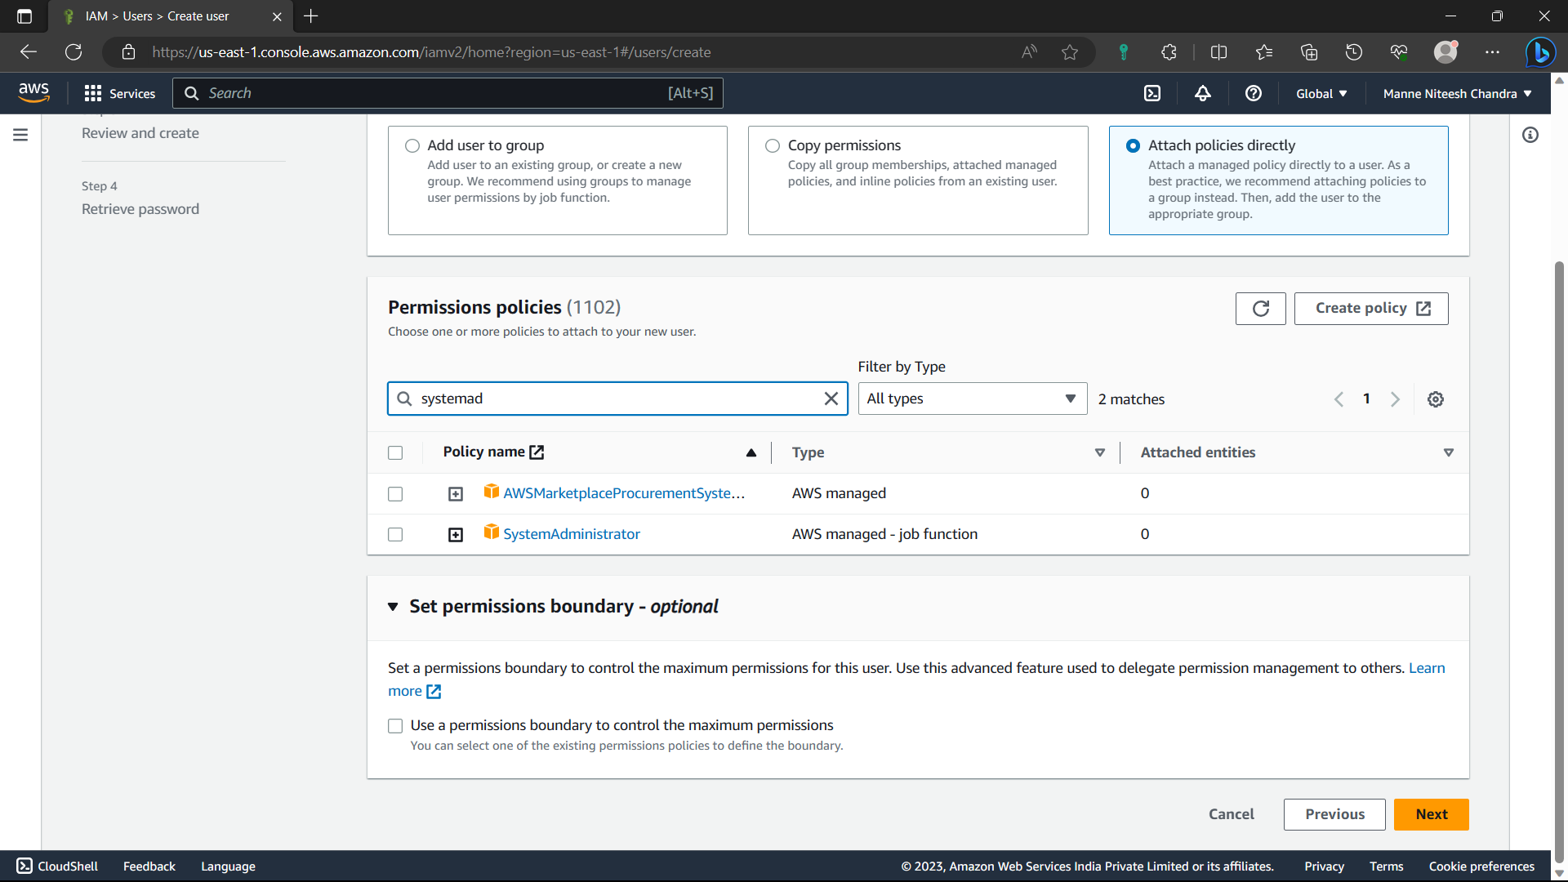

8)Add “administrator access” permission option.

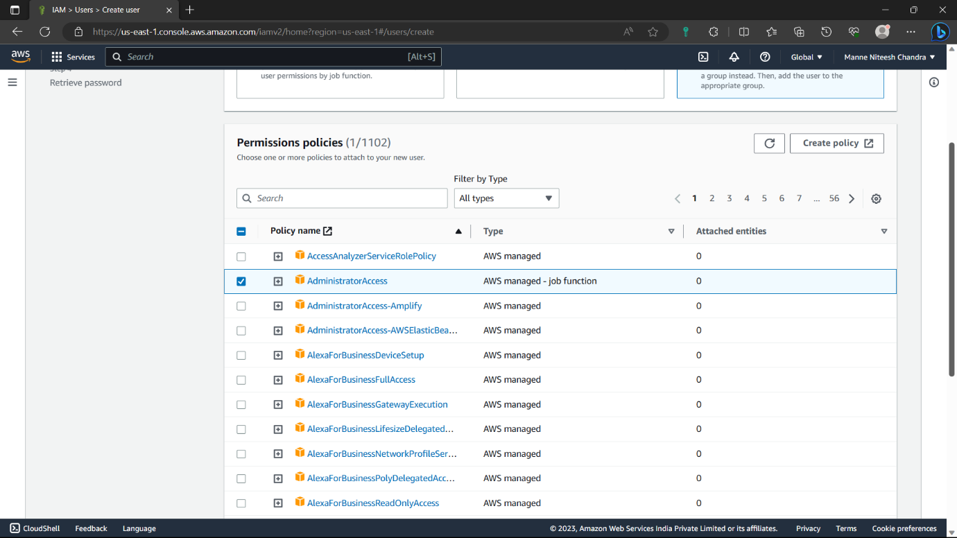

9)Click on “Next”.

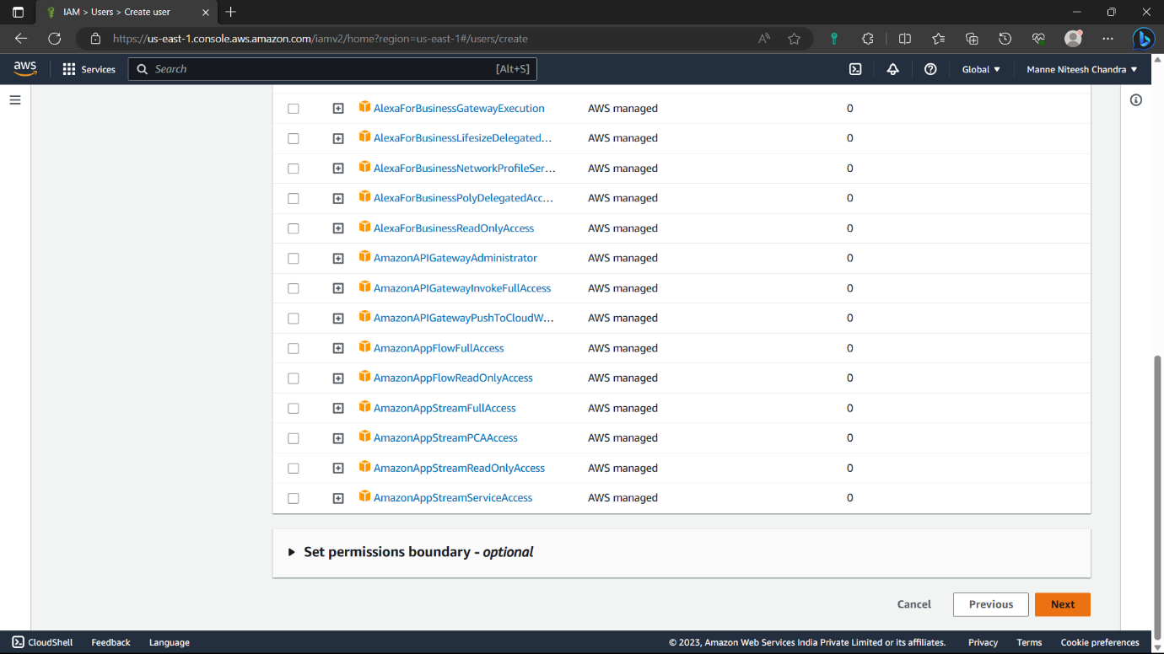

10)Review everything and click on “create user” option.

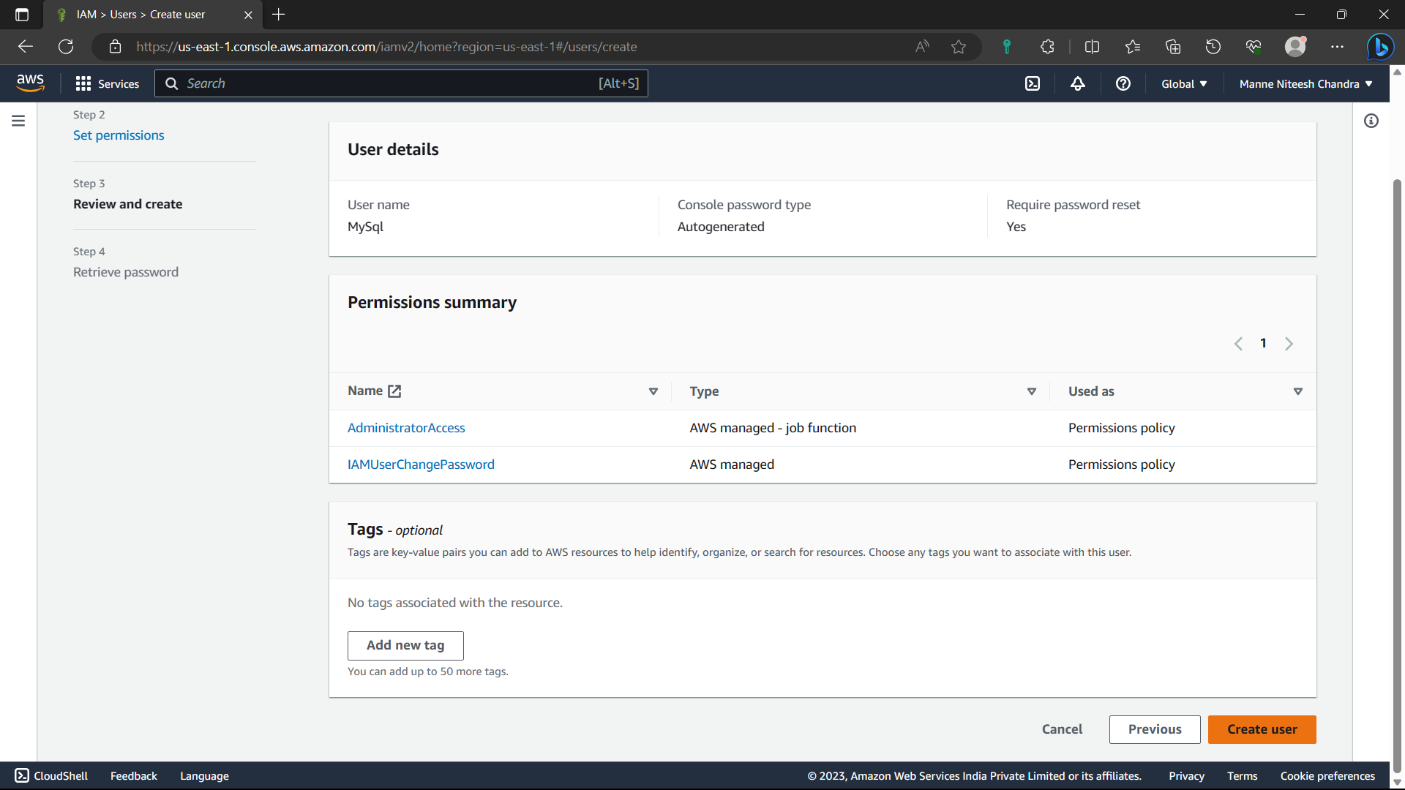

11)Click on “Download .csv file” now a copy of credential details is downloaded in you’re local machine. Cop “console sign-in URL”. Click on “Return to Users list”.

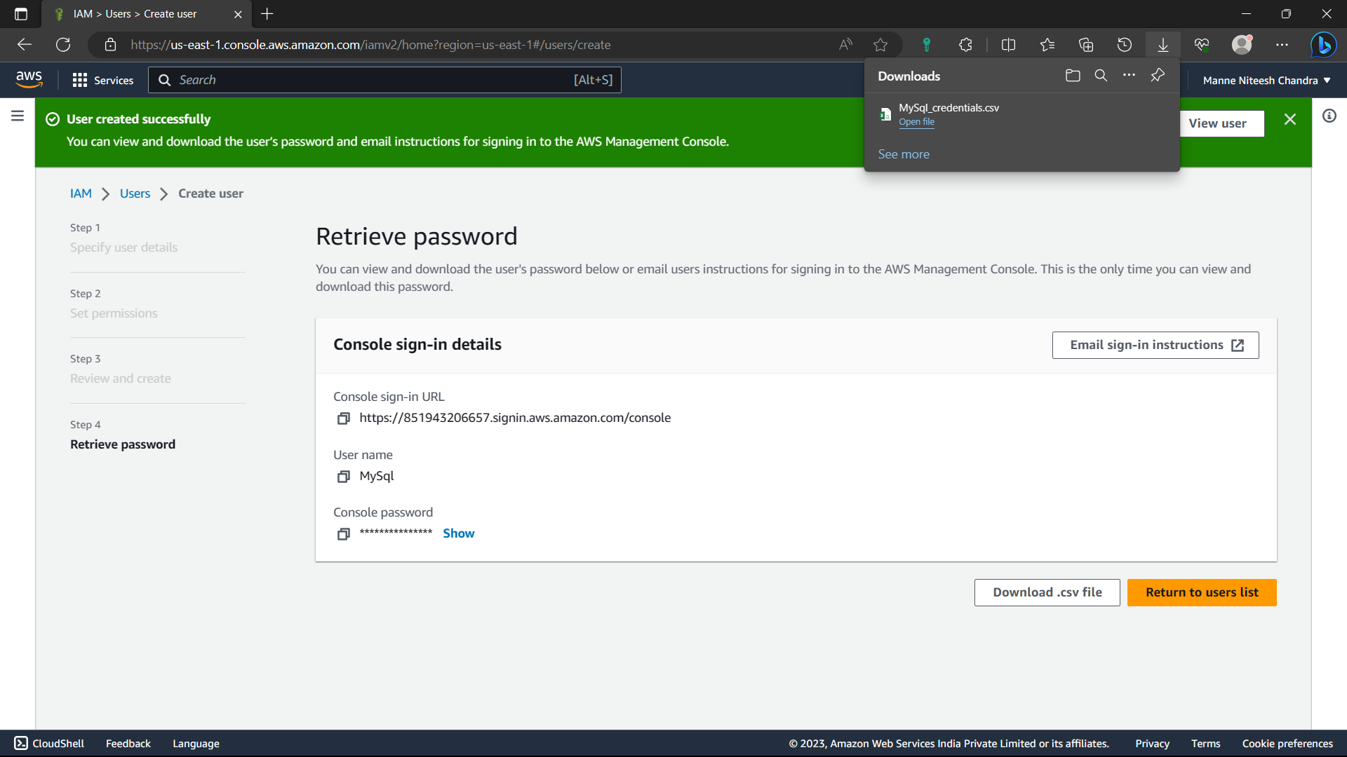

12)Paste the sign-in URL in a incognito tab. It will open the aws iam account login page.

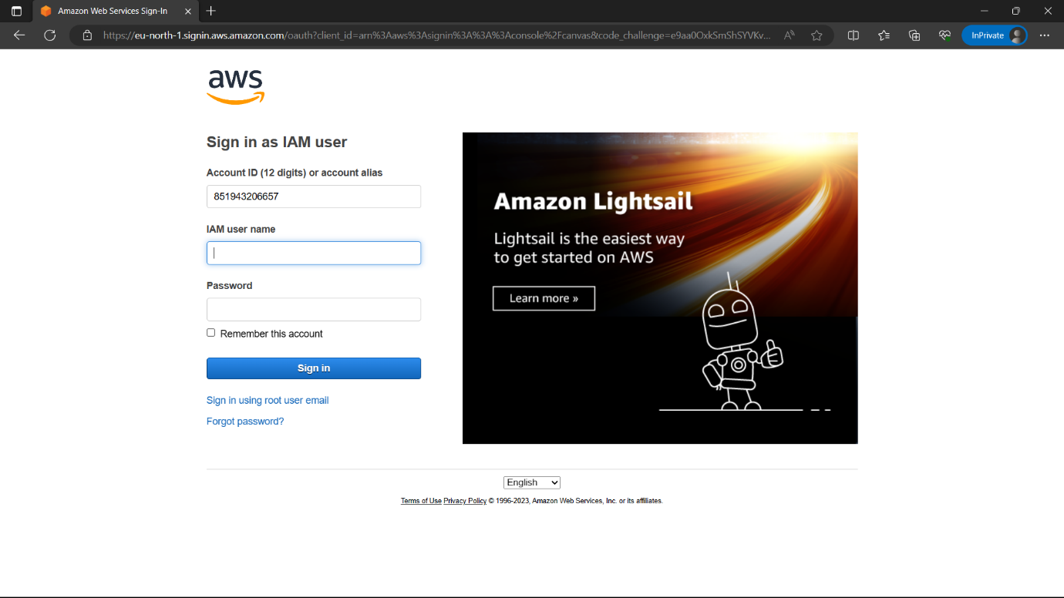

13)Type the username and password from the of local machine and click on “sign-in” option.



14)Type the old password, and type the password in new password you want to use for logging in for AWS IAM user.

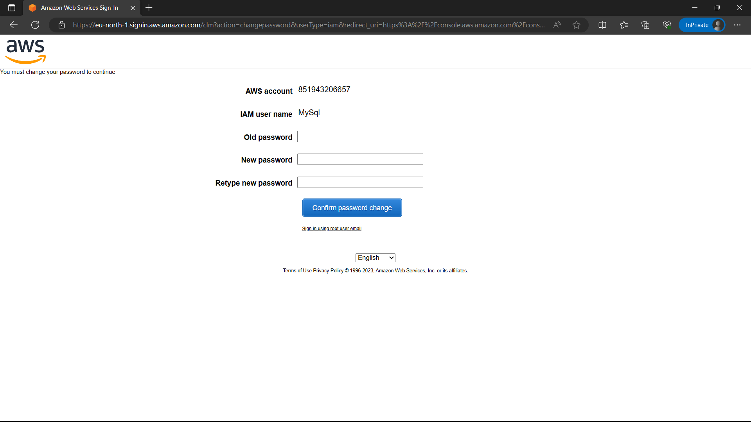

15)Now we are logged in to the AWS console as IAM User.

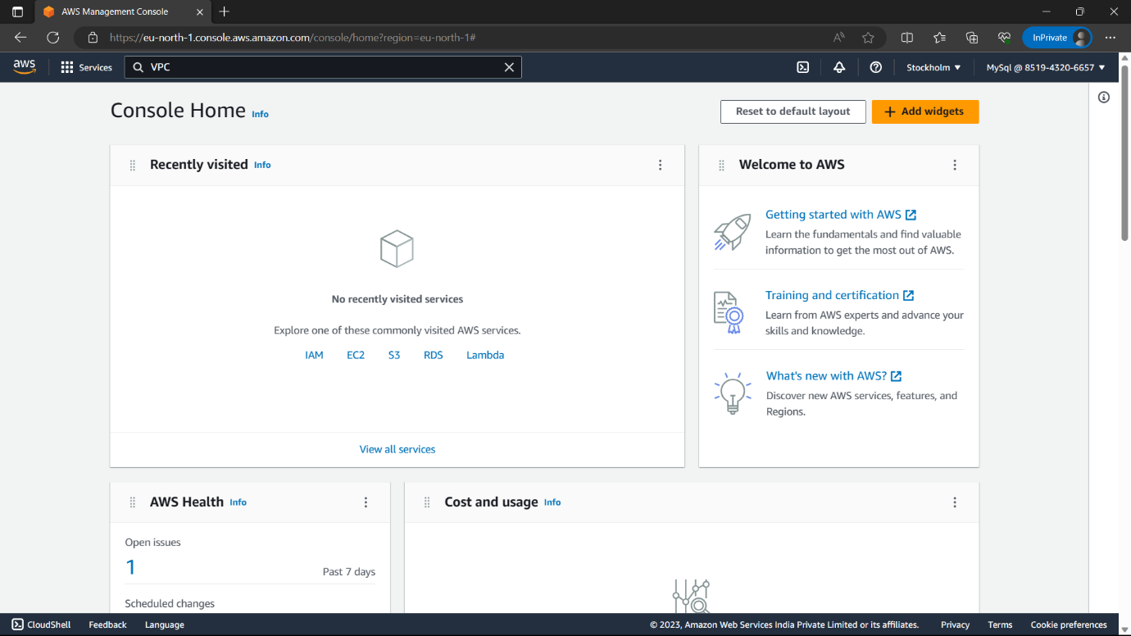

16)Type “VPC” search bar and select the “VPC” option below.

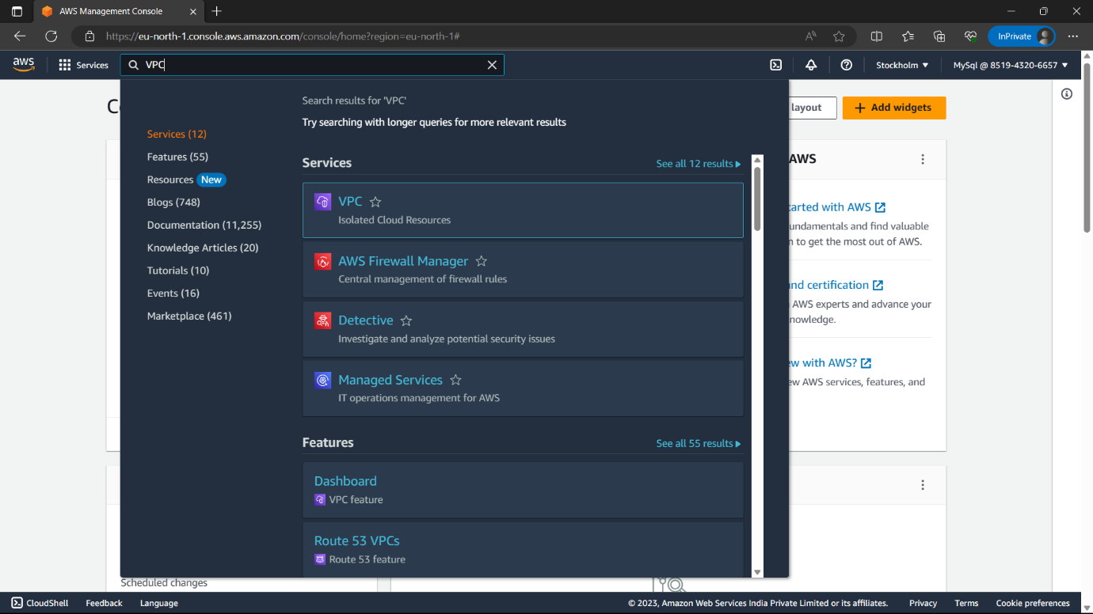

17)Click on “Create VPC” option i.e., in yellow colour.

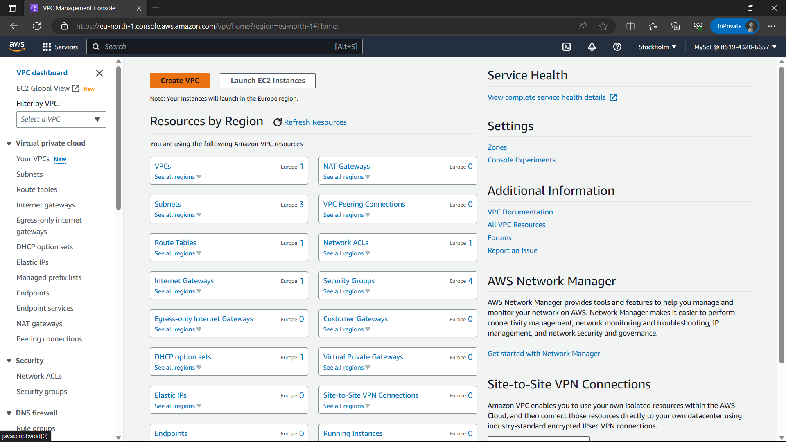

18)VPC only, Type the name you want to give to VPC, CIDR-10.0.0.0/20.

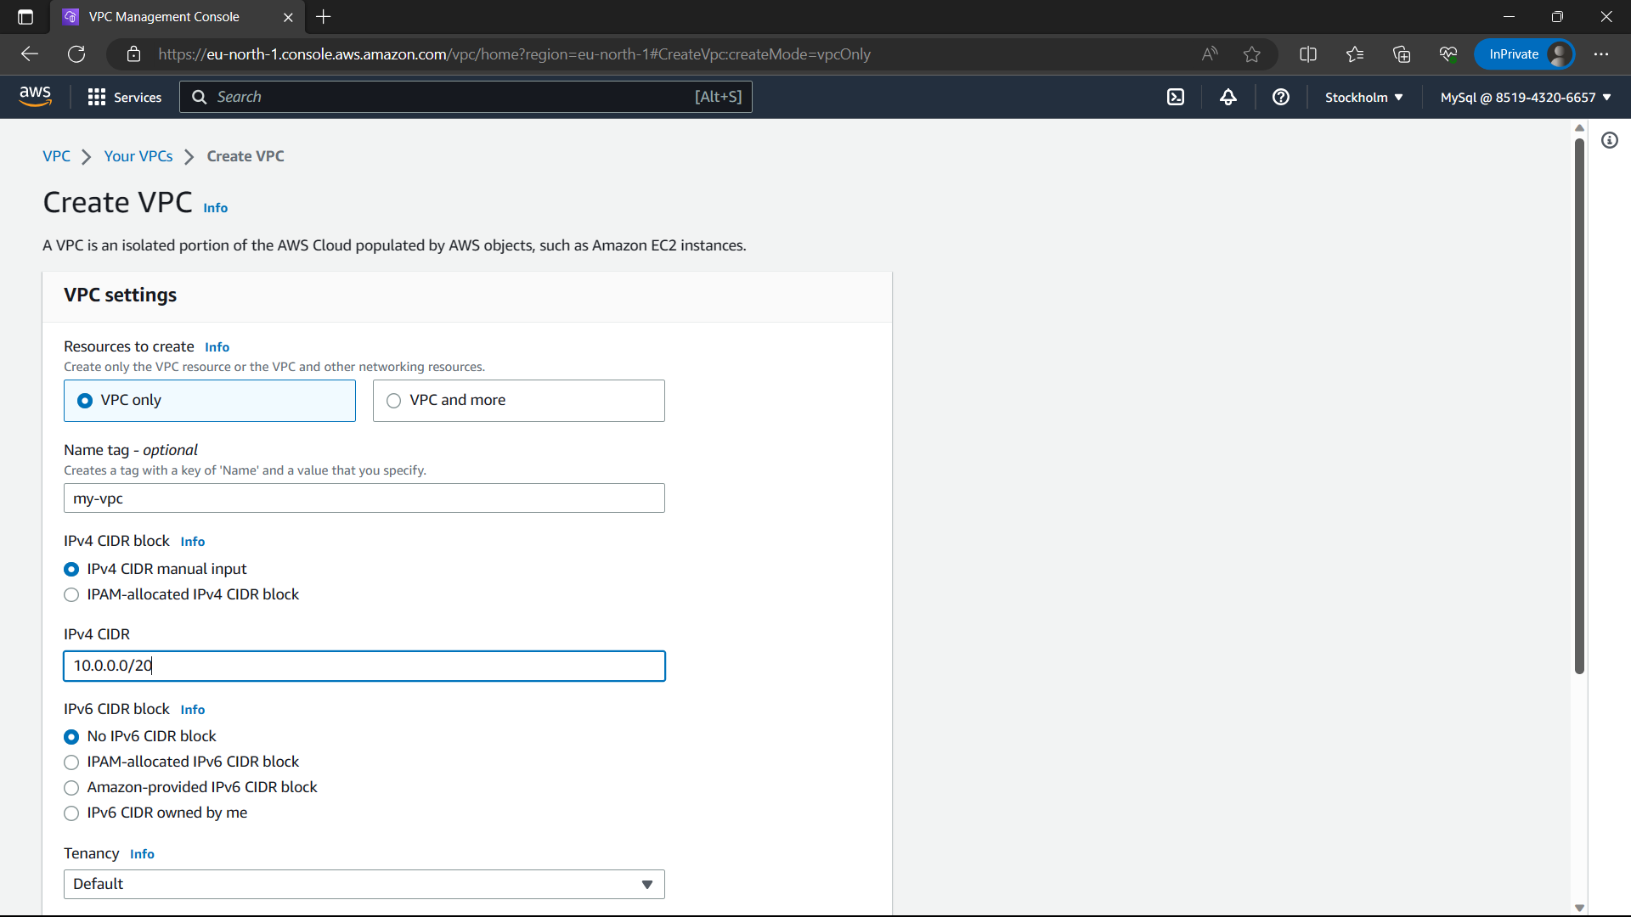

19)Click on “Create VPC” option.

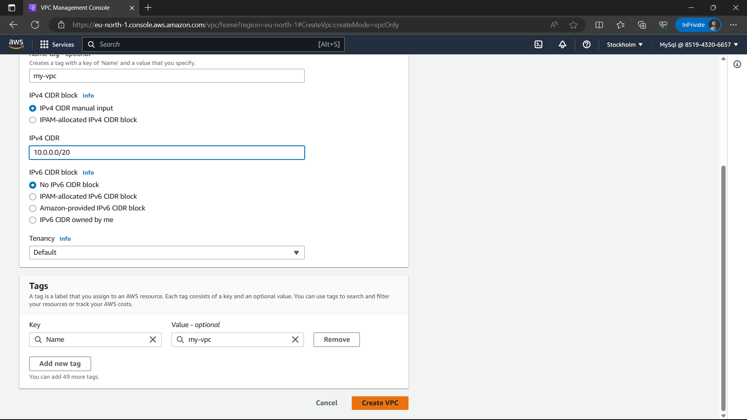

20)The VPC is created, Click on “Subnets” option in navigation panel below the VPC.

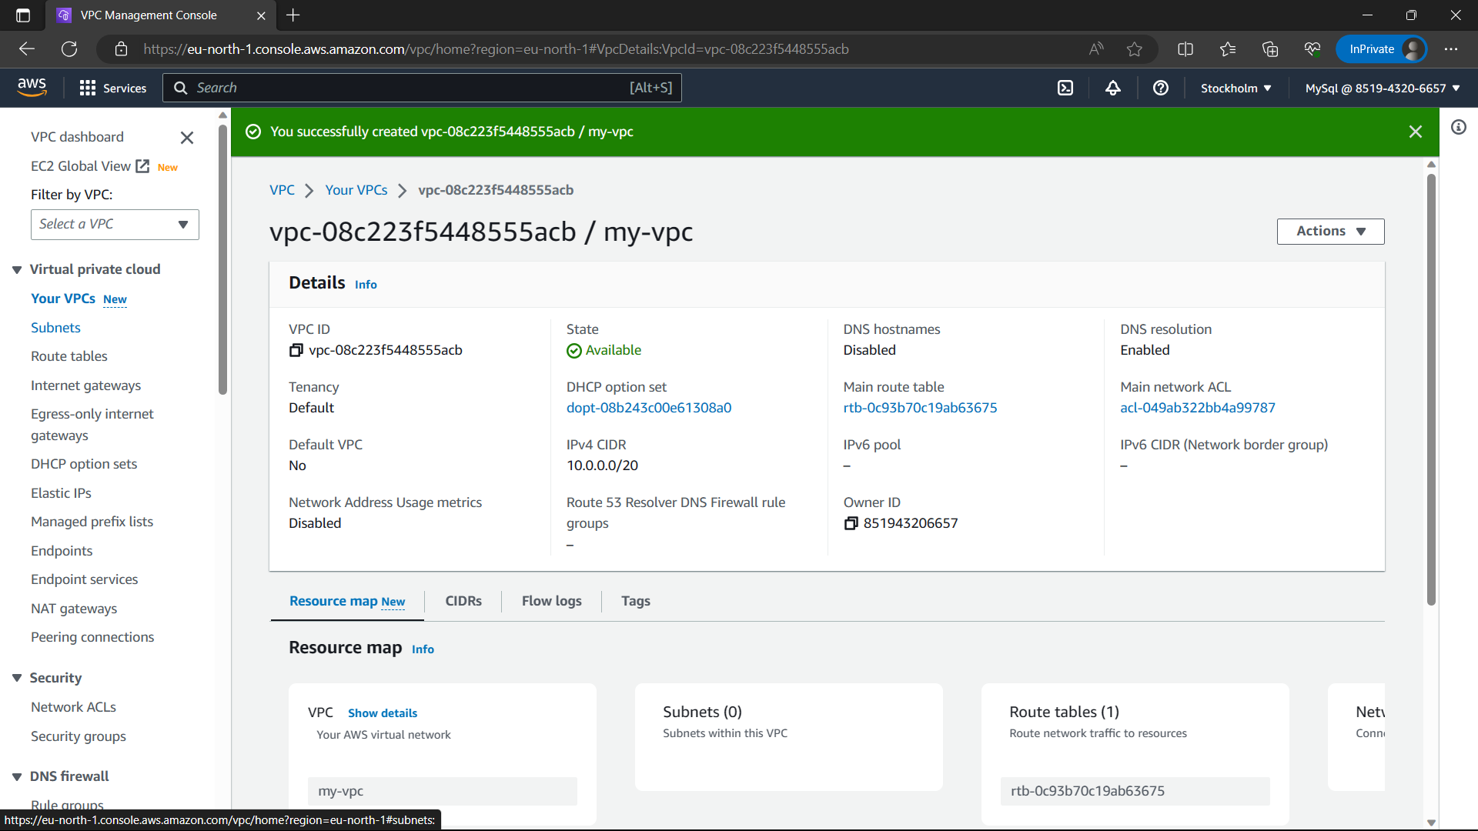

21)Click on “create subnet” option i.e., in yellow colour.

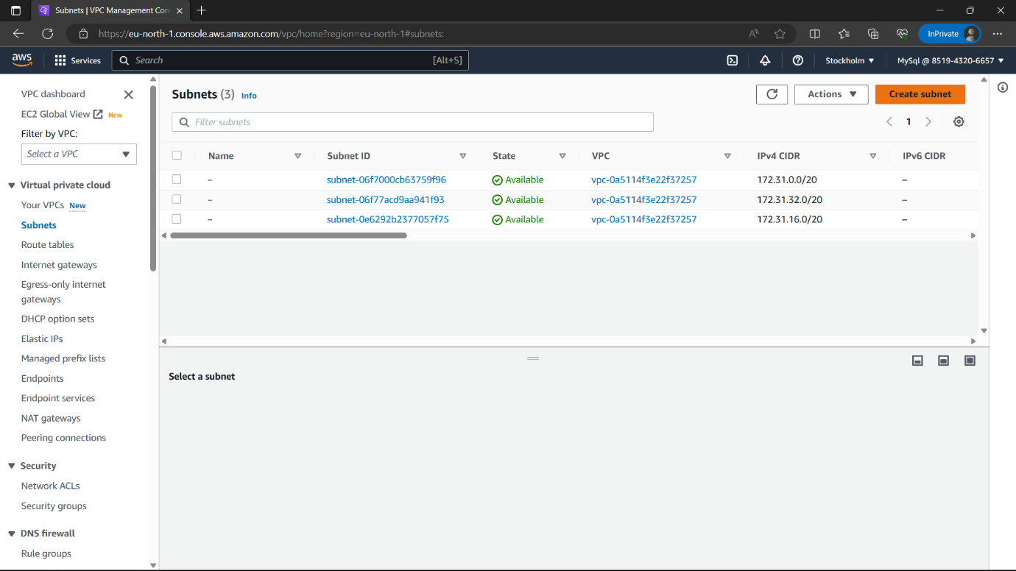

22)VPC ID- “VPC” you created.

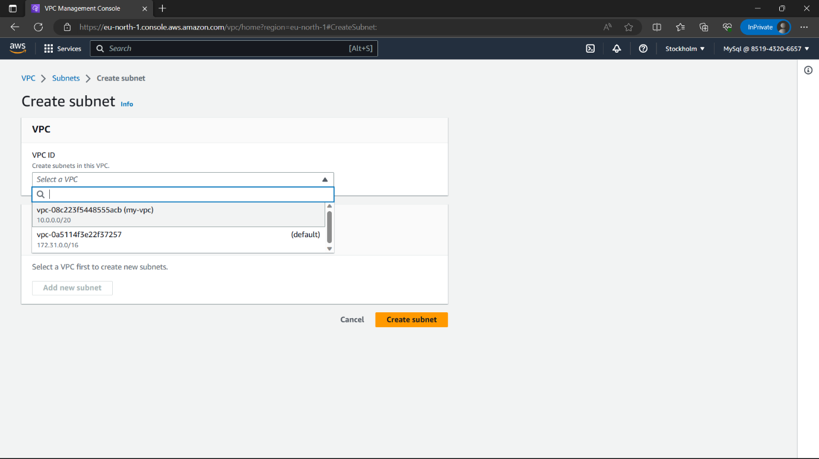

23)Name-“pub-sub”, Zone-Select a zone (don’t leave it none”), Give CIDR Range and click on “create subnet” option. Now the pub-sub is created, repeat the same procedure with another name: pvt-sub and click on “create subnet”

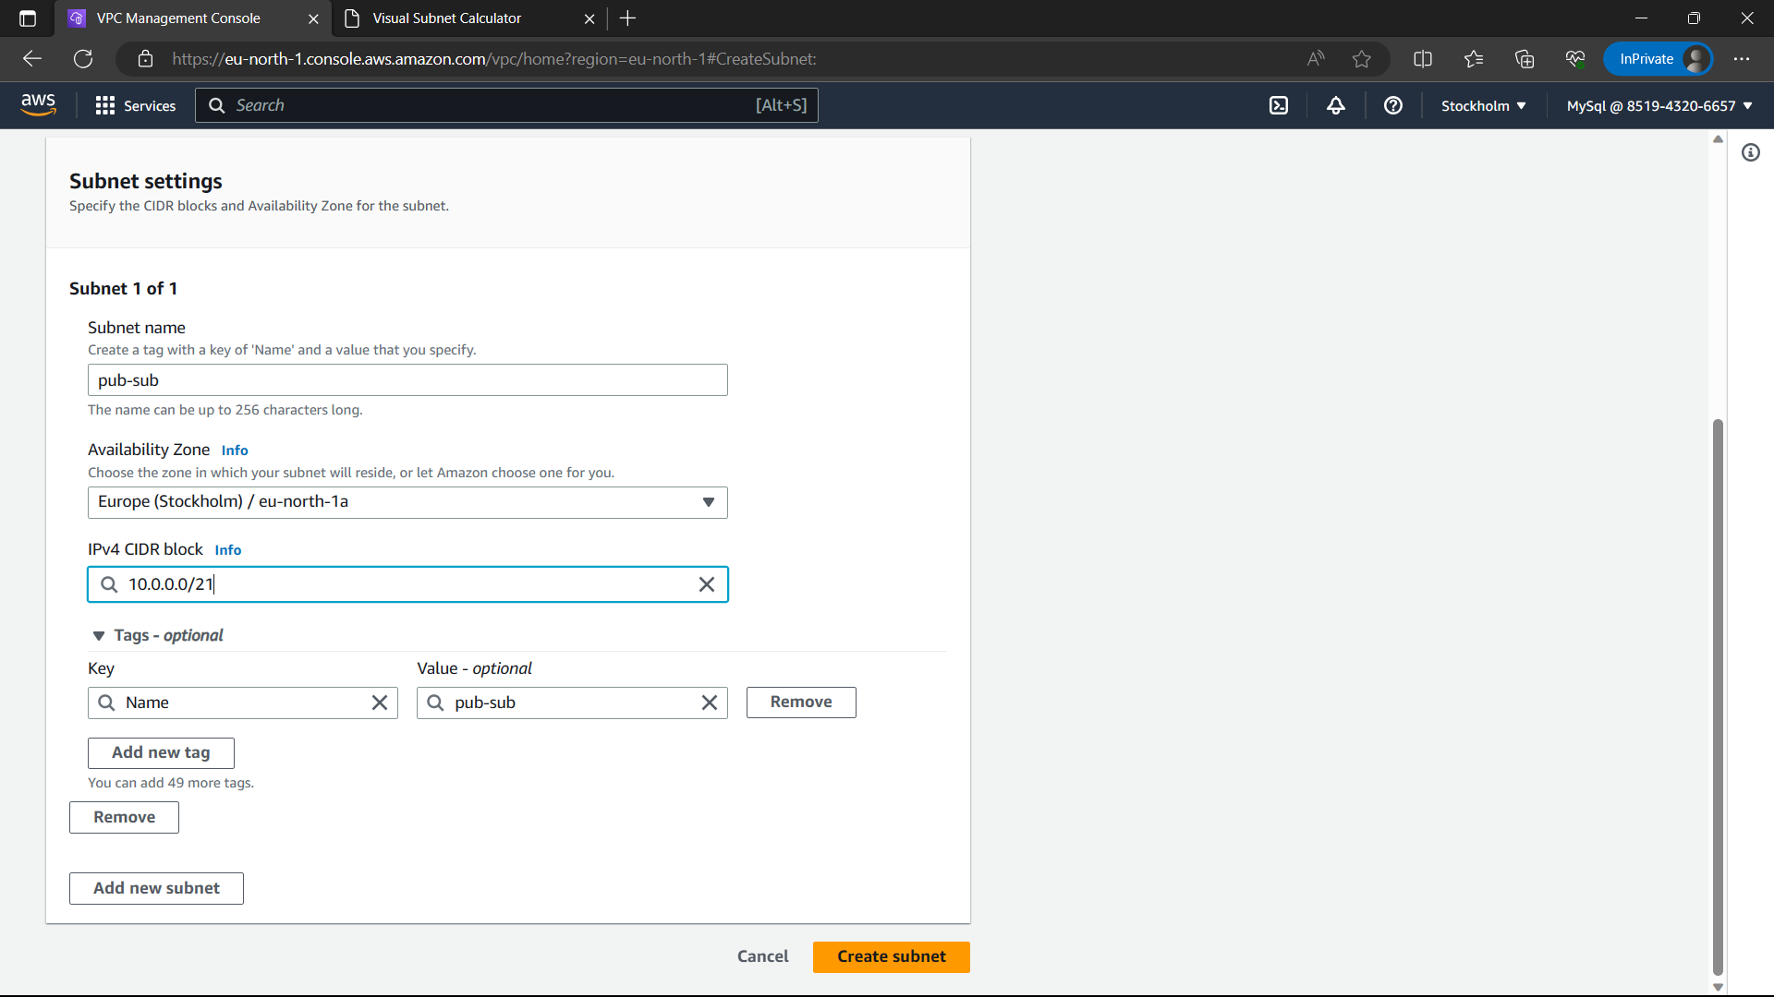

24)The subnets are created. Click on internet gateway which is below the route table in navigation panel.

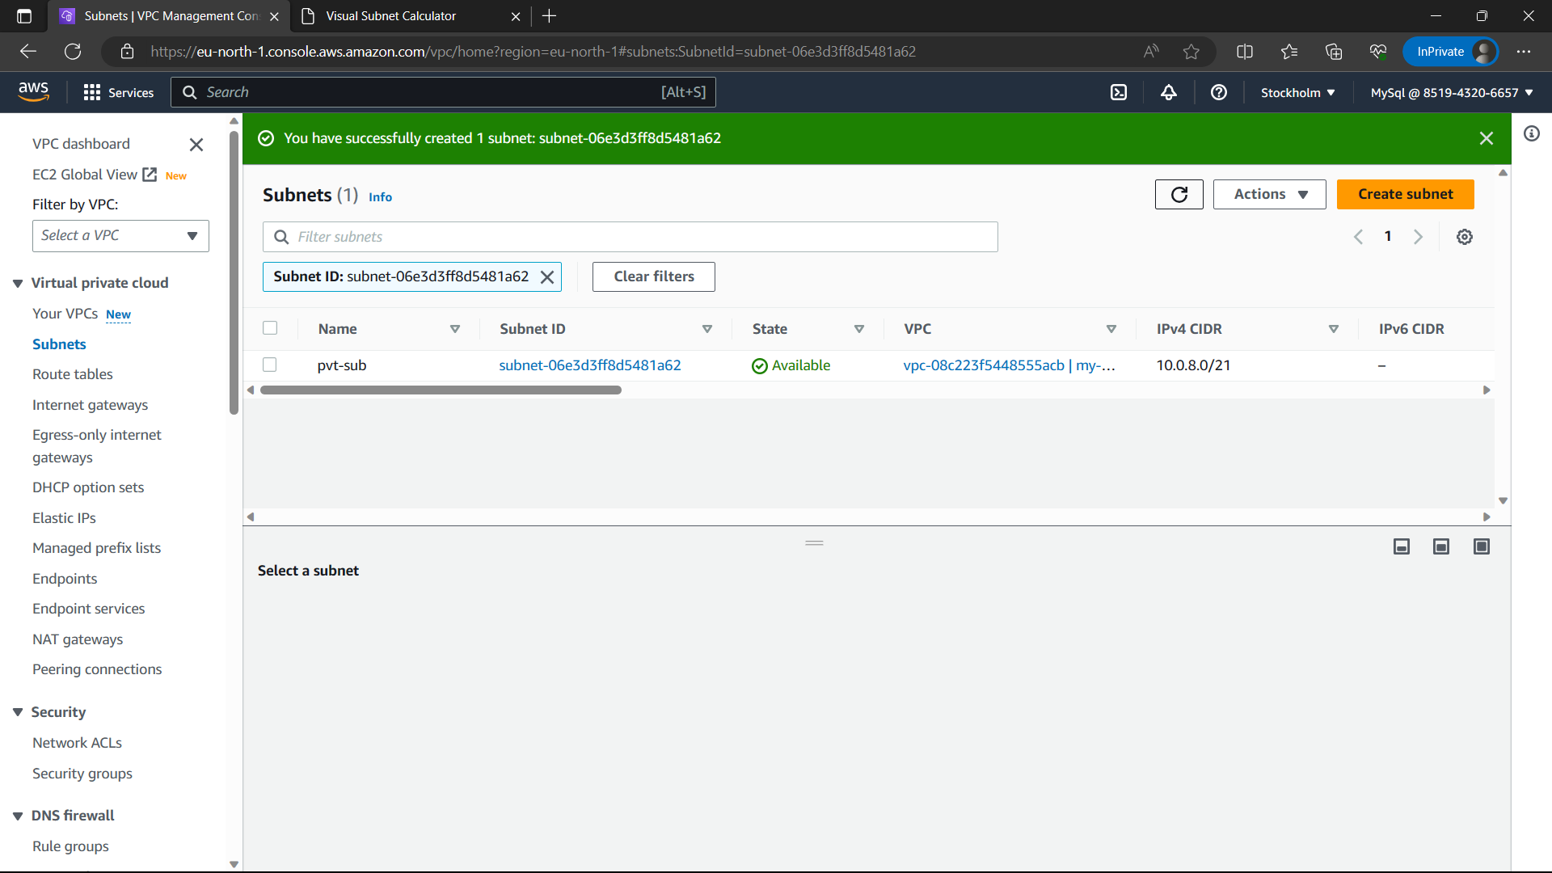

25)Click on “Create internet gateway” in yellow colour.

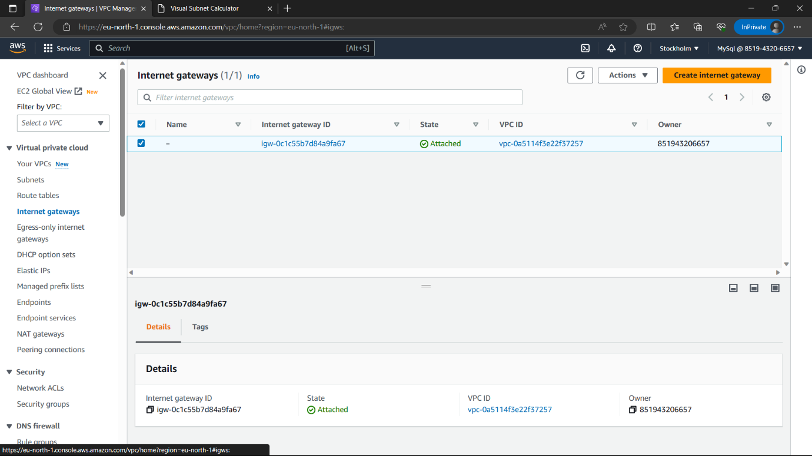

26)Give a name to the internet gateway and click on create “Create internet gateway” option.

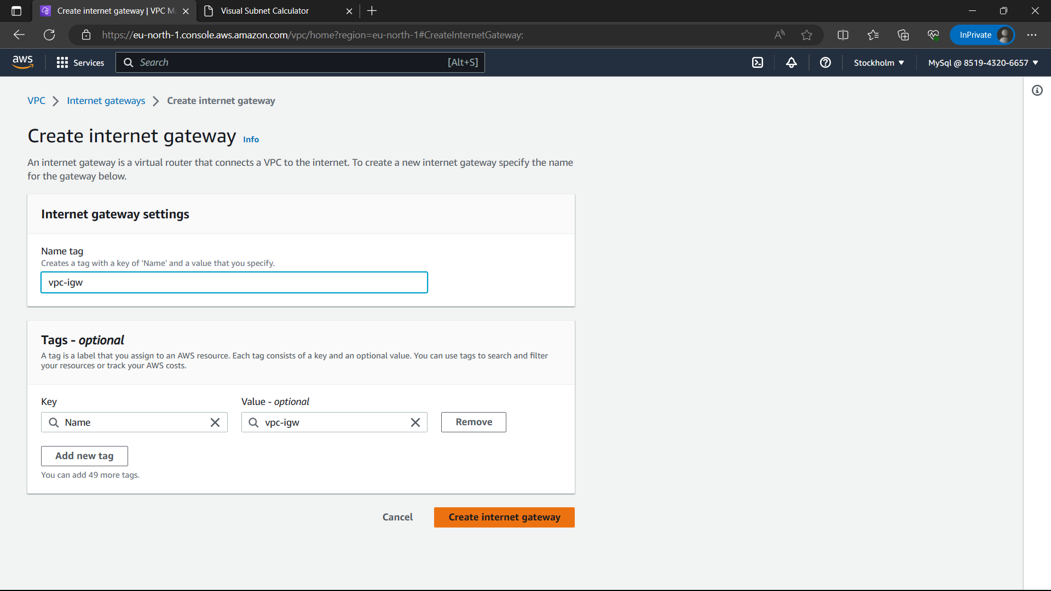

27)Now internet gateway is created. Select the created IGW and select “Actions”🡪”Attach to VPC”.

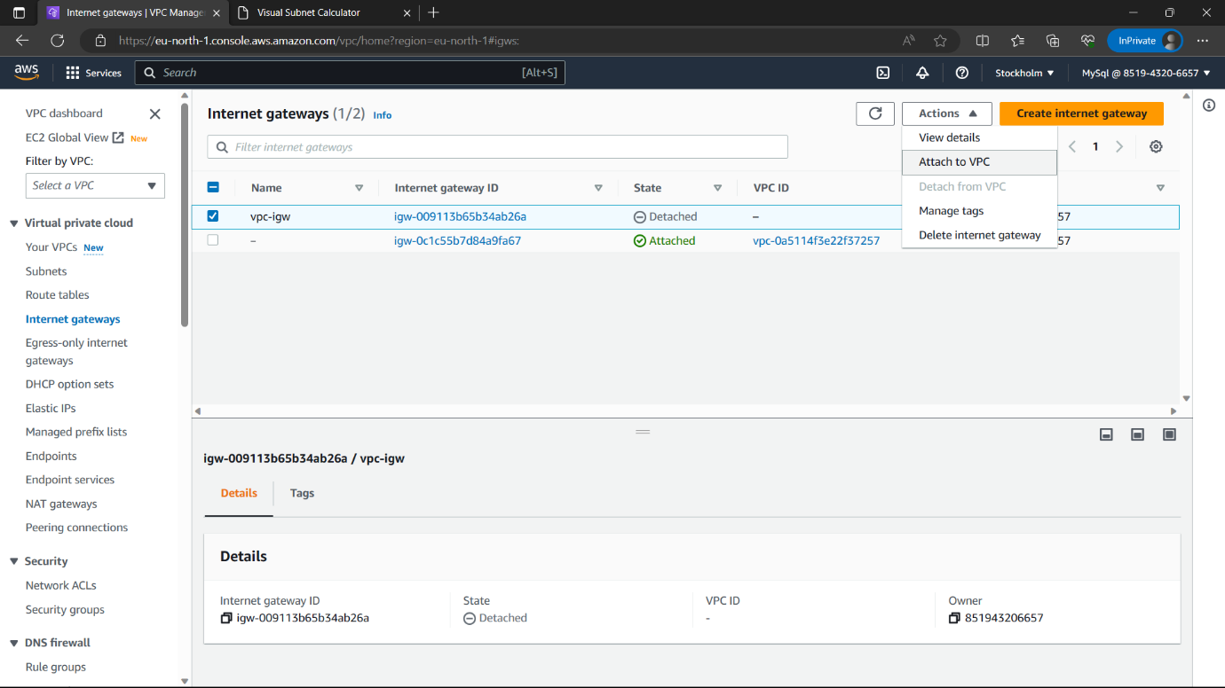

28)Select the VPC you created and click on “Attach internet gateway”.

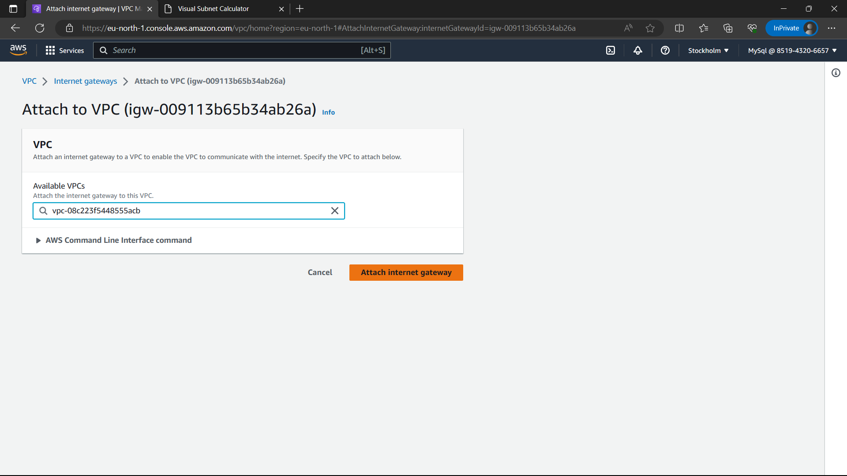

29)Now go to route tables and click on “Create route table”.

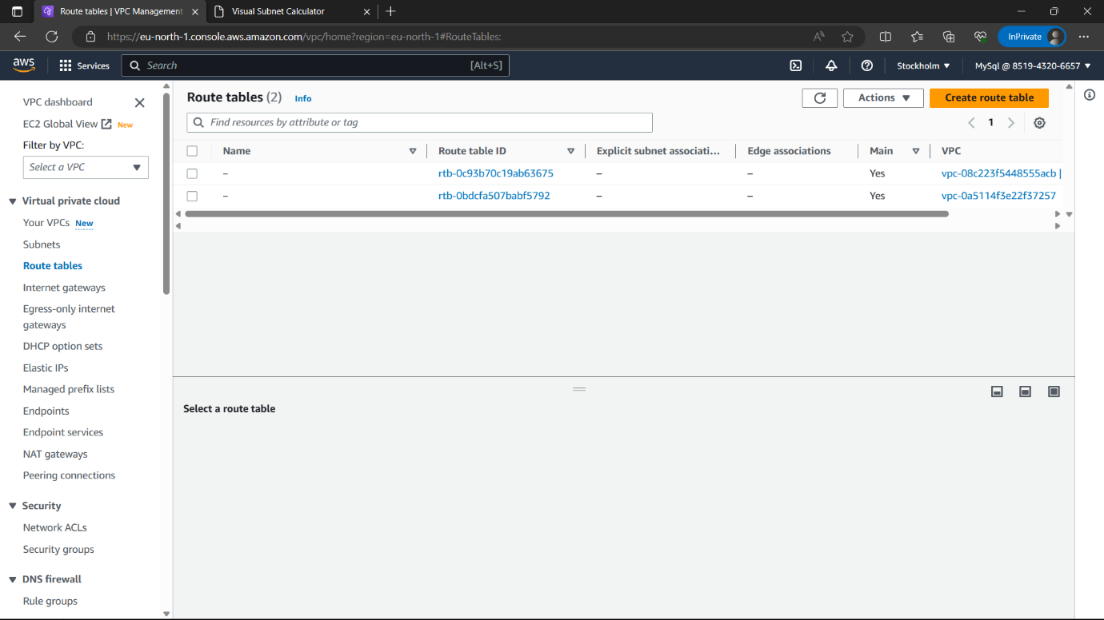

30)Give a name to the route table and select the VPC you created(my-vpc) and click on “Create route table” option.

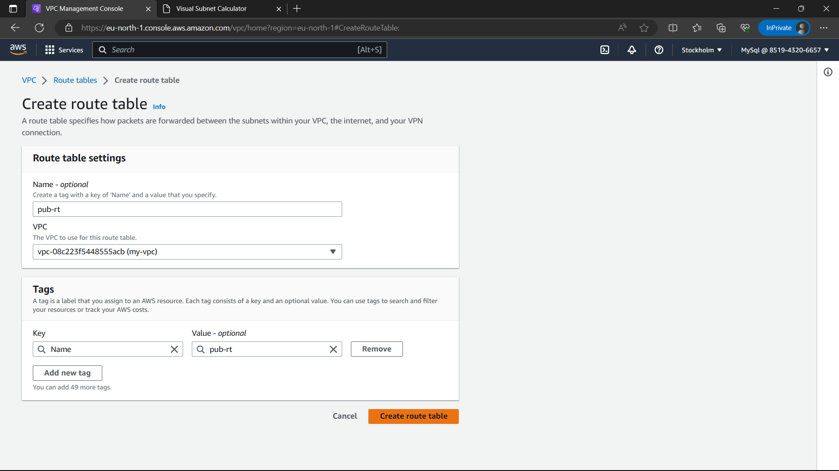

31)Now go to route tables and click on “Create route table”. Give a name to the route table and select the VPC you created(my-vpc) and click on “Create route table” option. Two route tables are created. i)pub-rt

ii)pvt-rt

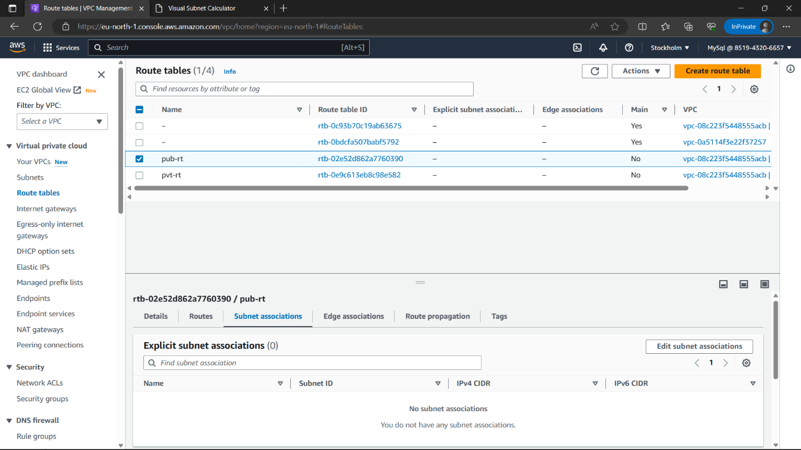

32)Select the pub-rt and browse to “Subnet-associations”🡪”Edit subnet associations”.



33)Select “pub-sub” option and click on “Save associations”.

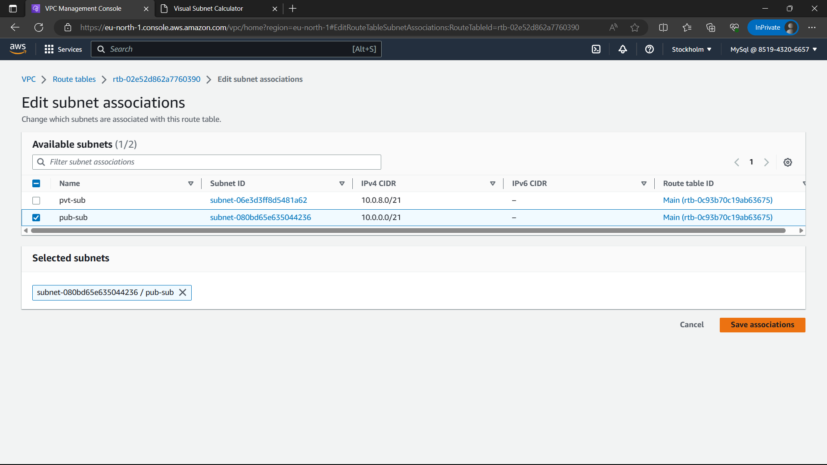

34)Select the pvt-rt and browse to “Subnet associations”🡪”Edit subnet associations”.

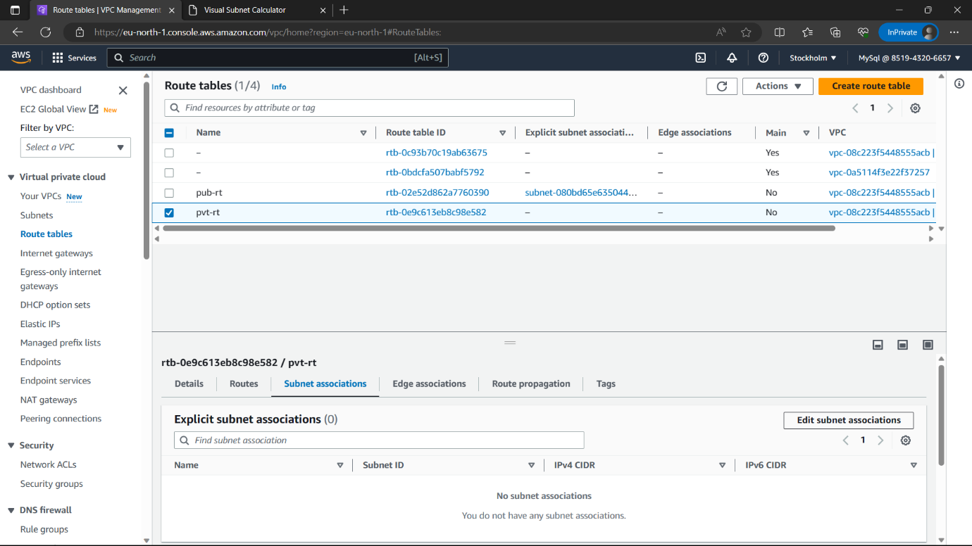

35)Select “pvt-sub” and click on “Save associations”.

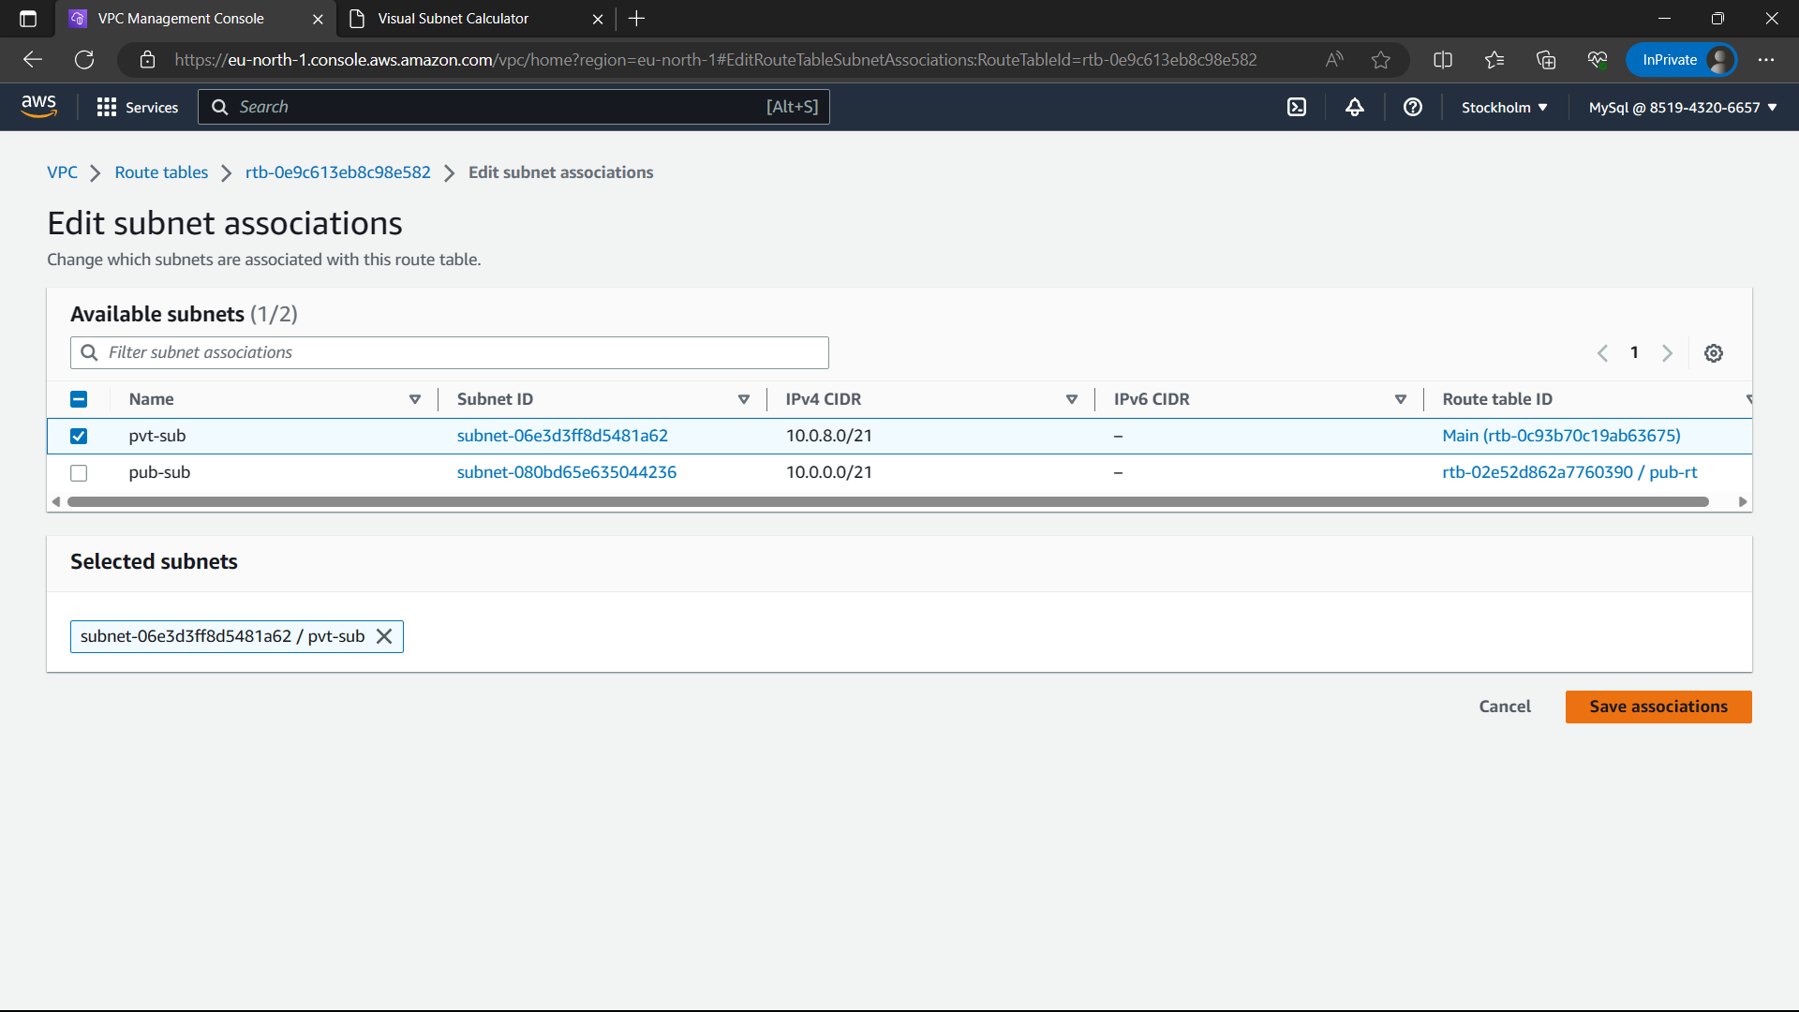

36)The routes are associated and click on “NAT gateway” option in navigation panel.

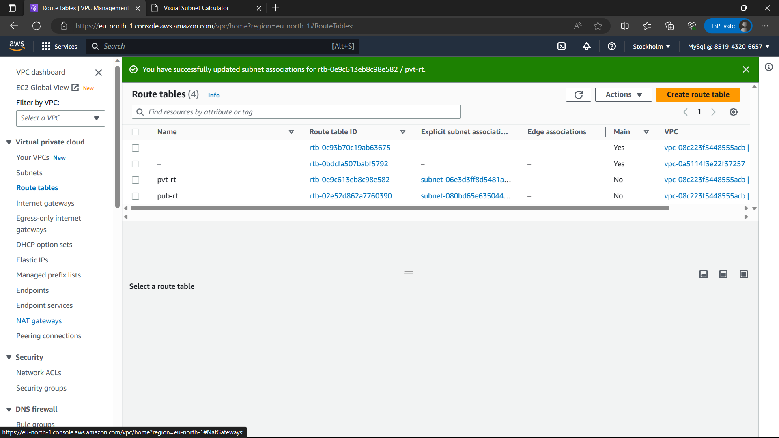

37)Click on “Create NAT gateway” option i.e., in yellow colour.

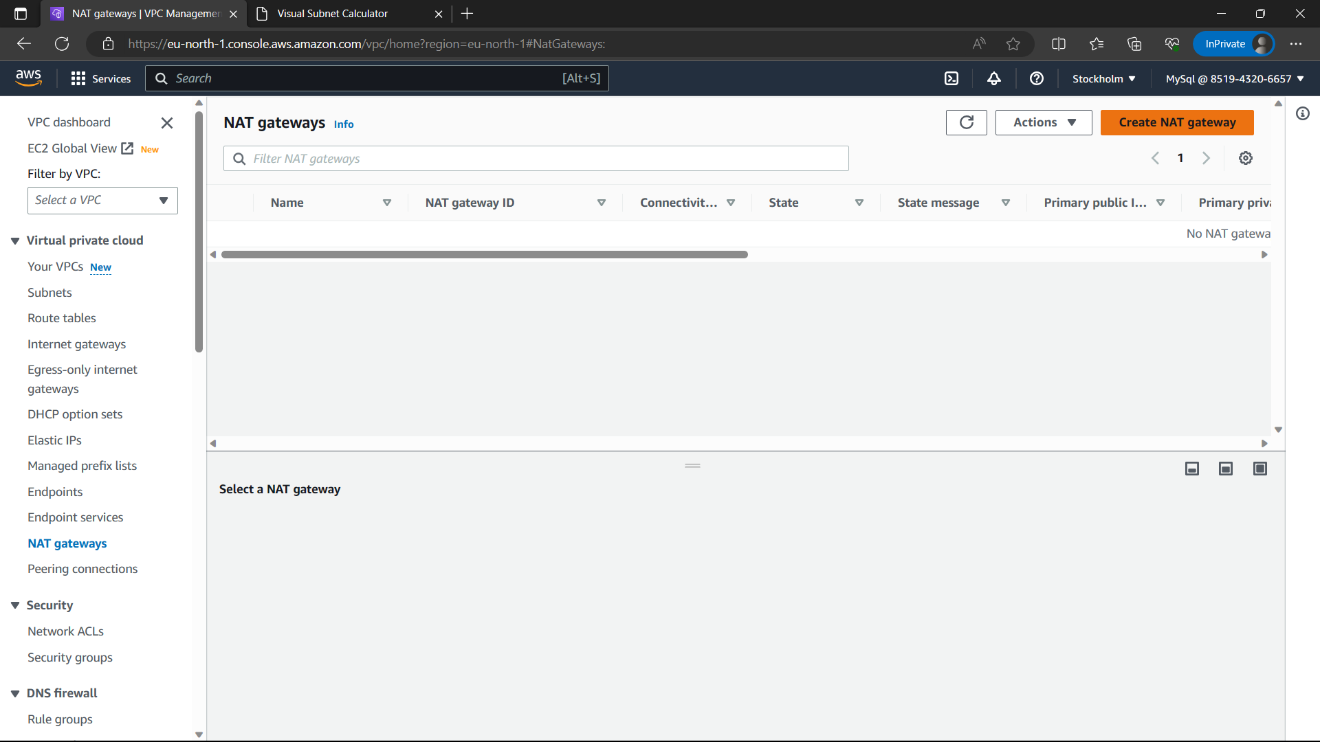

38)Give a name to NAT gateway, VPC -: pub-sub(because access pvt-inst with pub-inst), connectivity type-public, click on Allocate elastic IP.

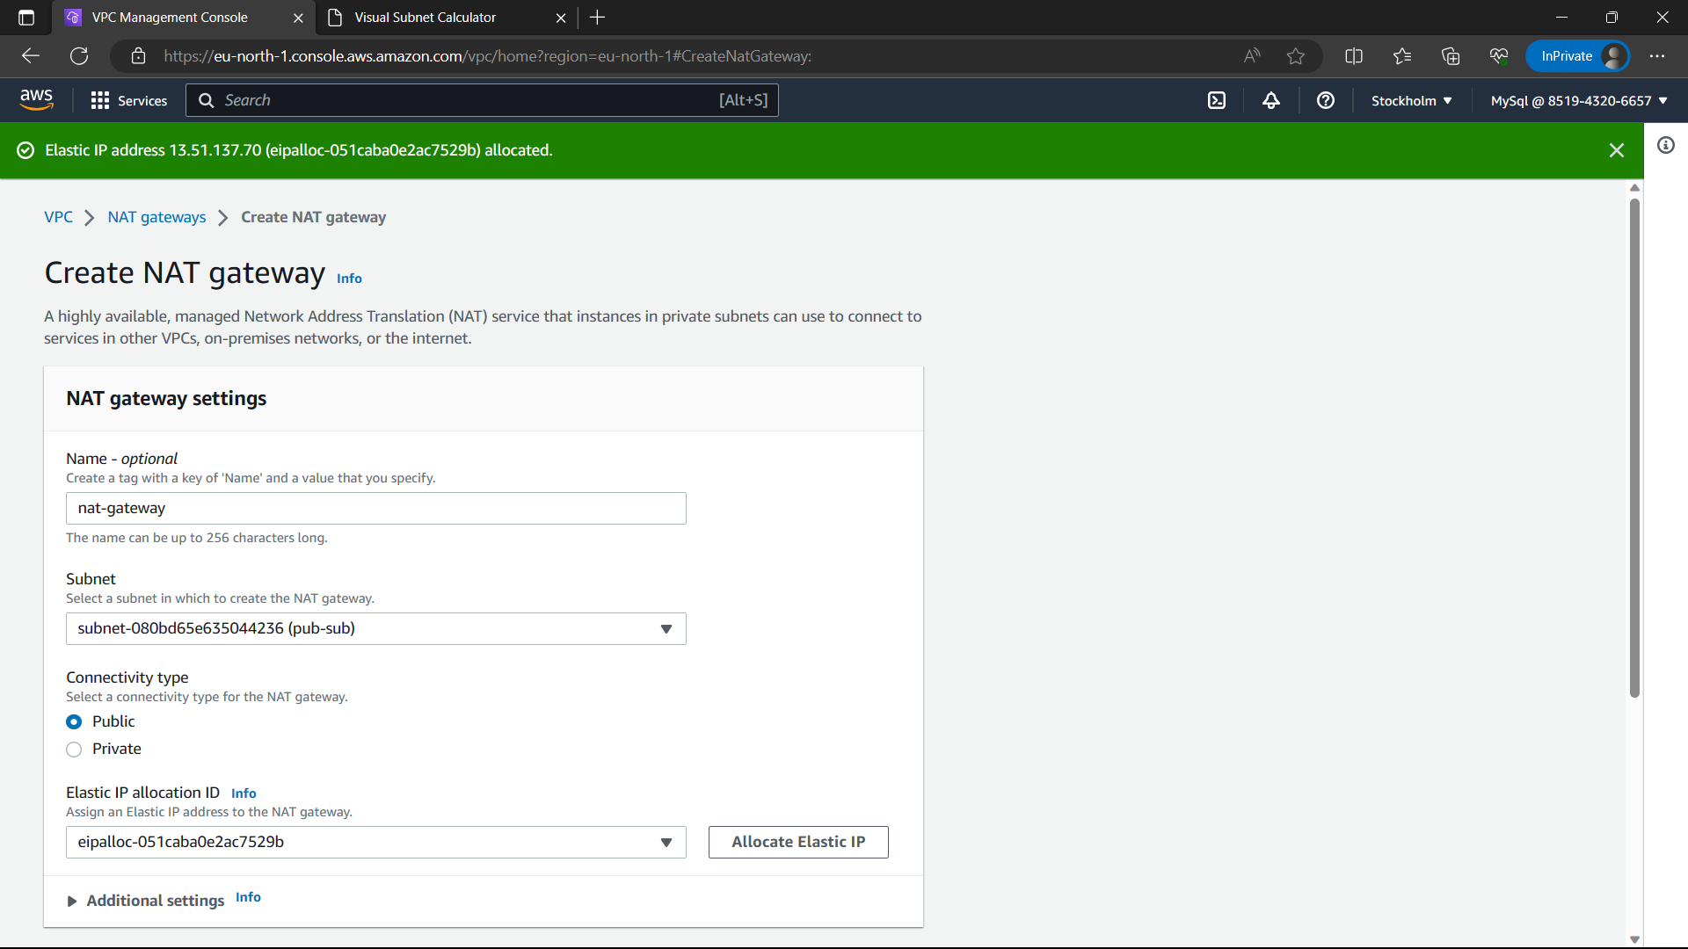

39)Click on “Create NAT gateway”.

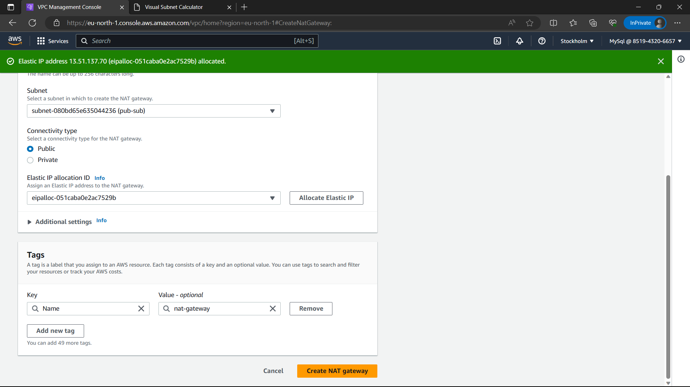

40)The NAT gateway is created.

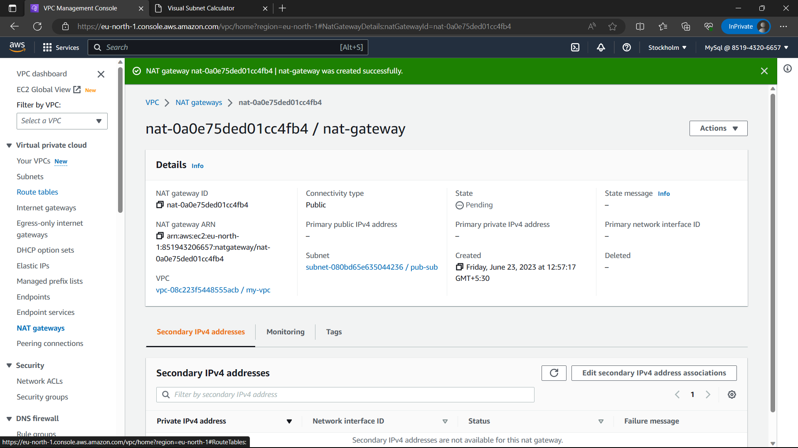

41)Go to “route tables” and select the “pvt-rt” and click on “Routes”🡪”Edit routes”.

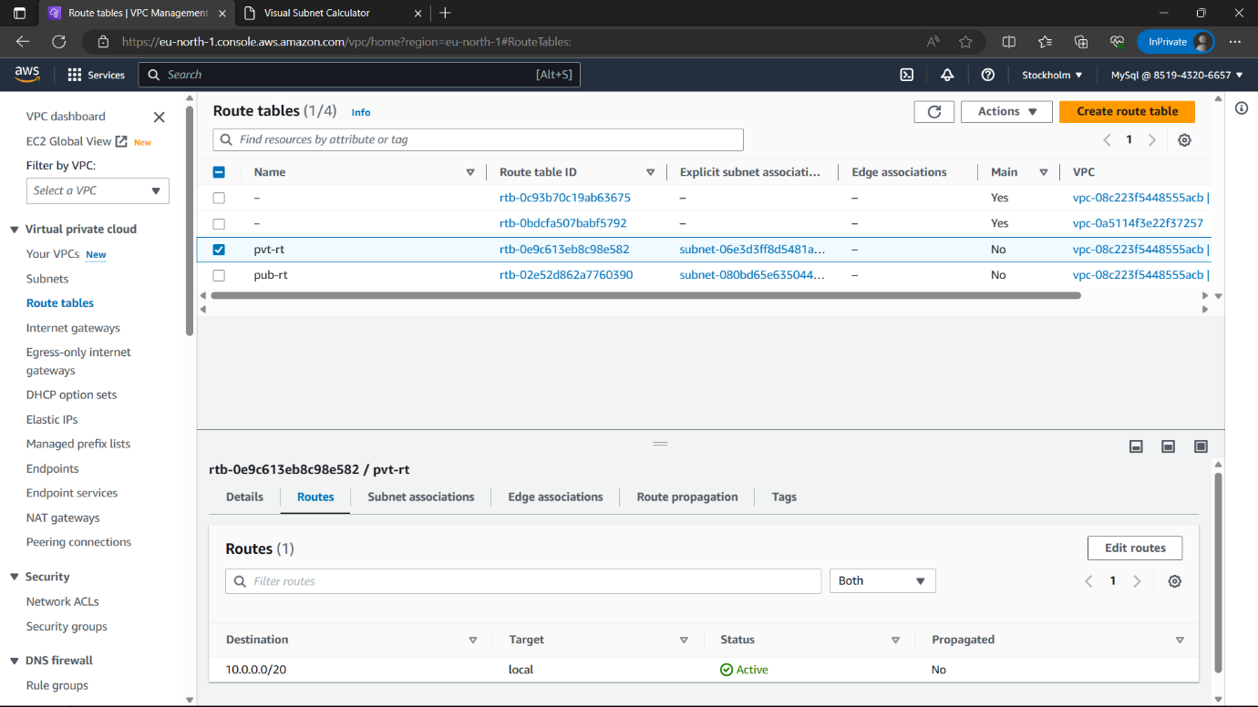

42)Click on “Add route”.

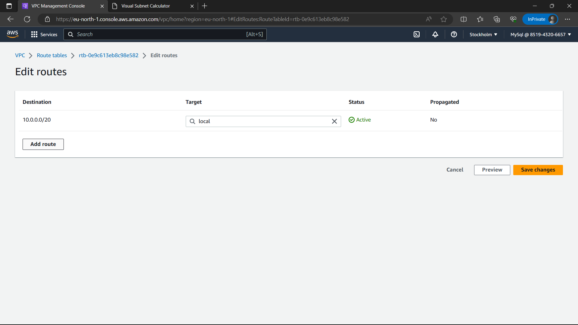

43)Destination-0.0.0.0/0, Target-NAT Gateway(you created) and click on “Save changes” option.

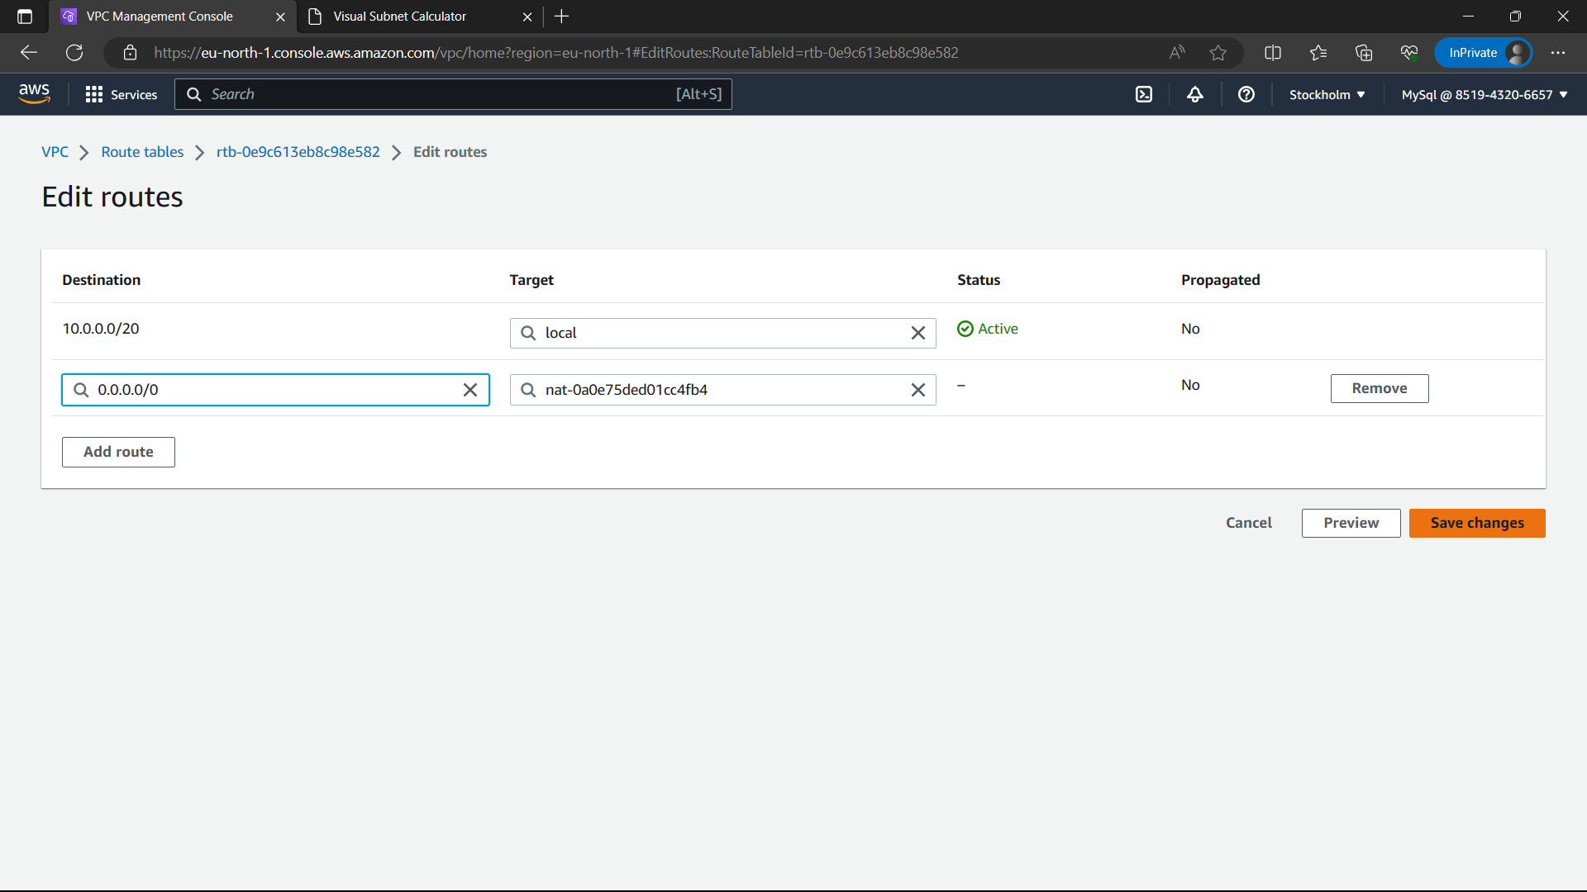

44)The private route table’s route is successfully updated.

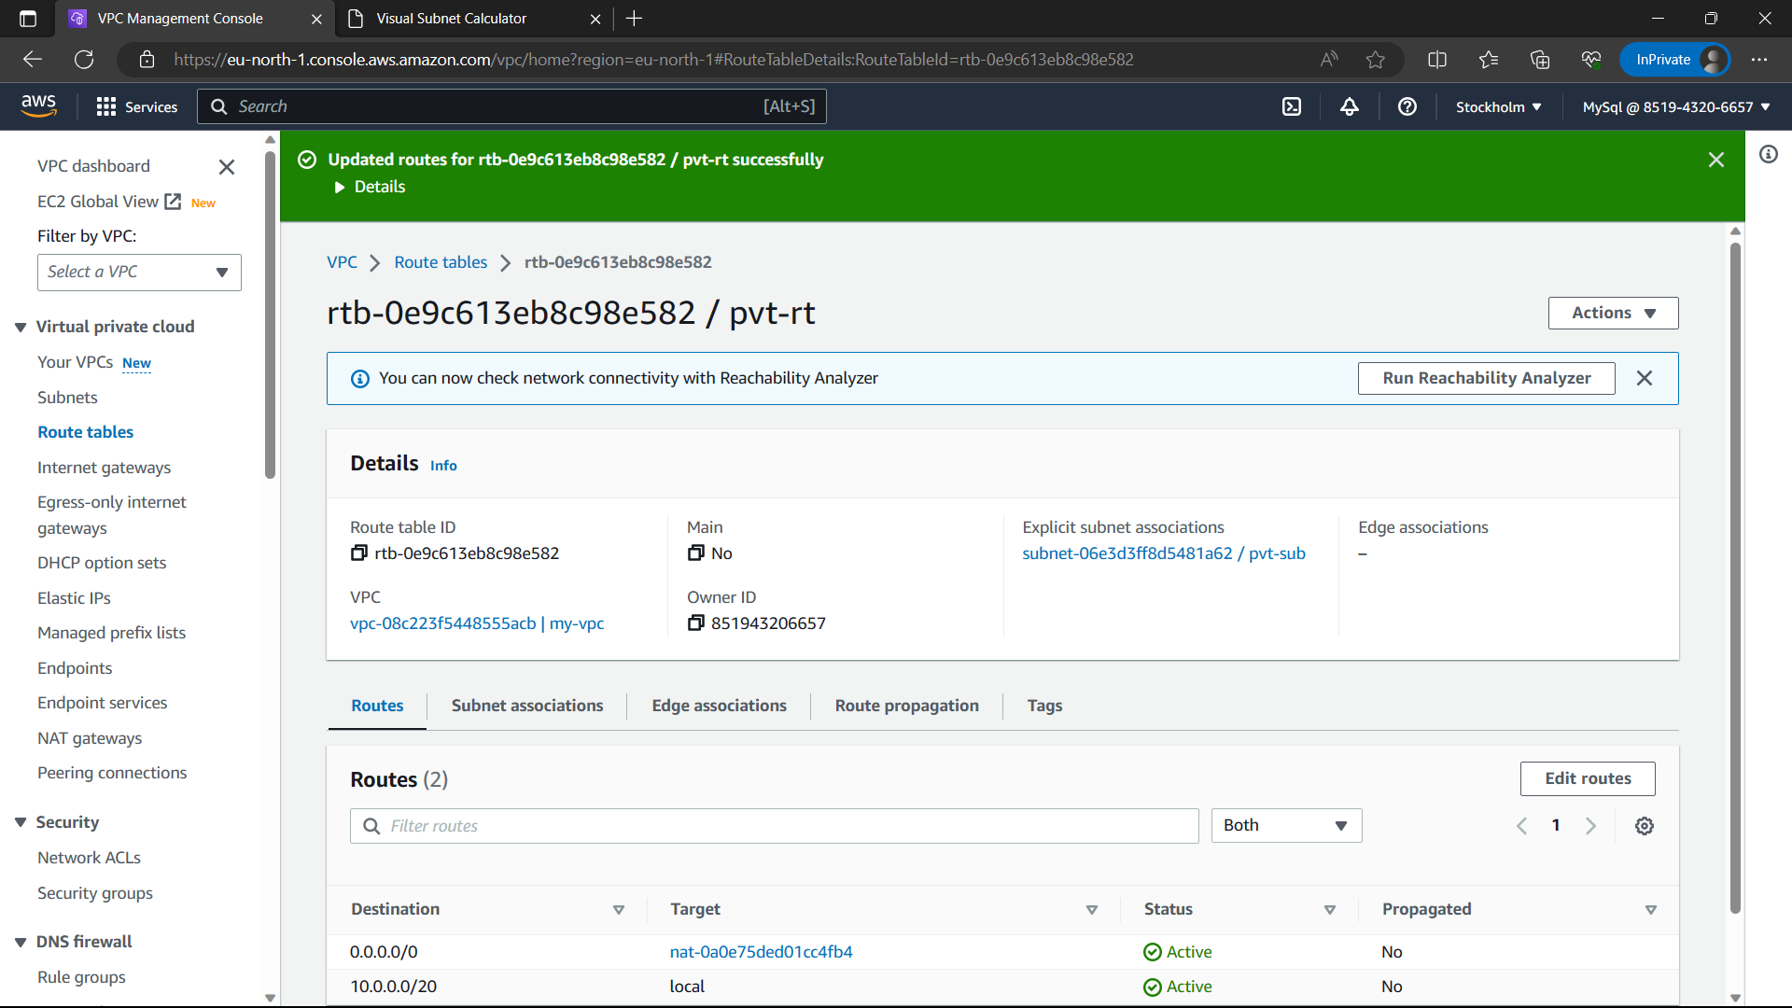

45)Go back to route tables select pub-rt and “routes”🡪”edit routes”.

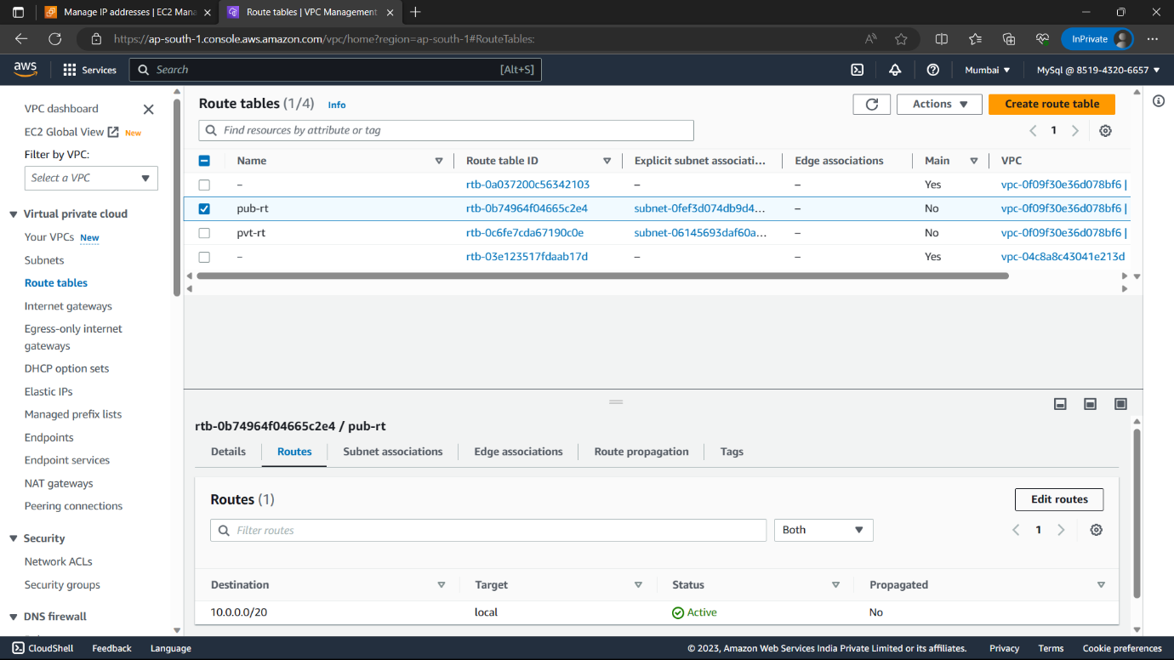

46)Click on “Add route” option.

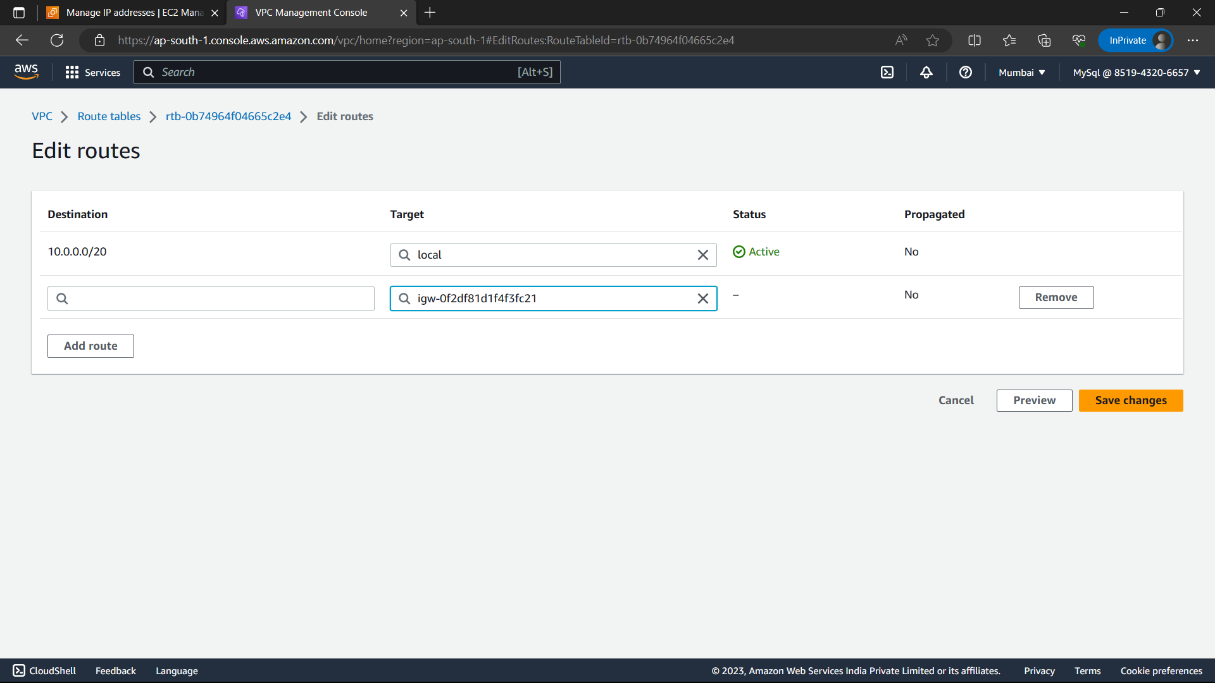

47)Destination-0.0.0.0/0, Target- internet gateway(you created) and click on “Save changes”.

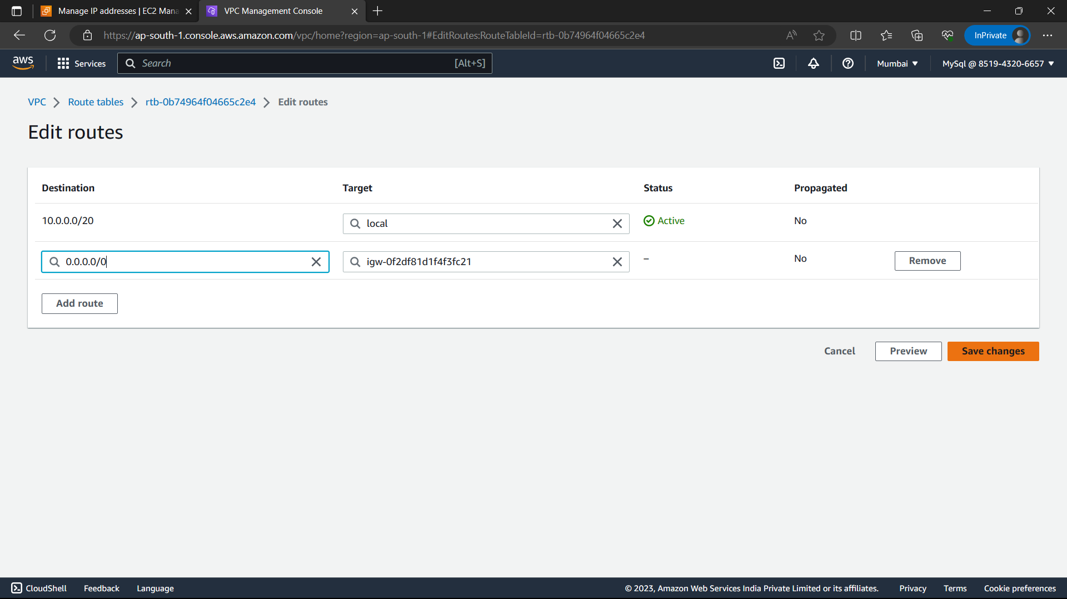

48)Type “EC2” and select the “EC2” option from below.

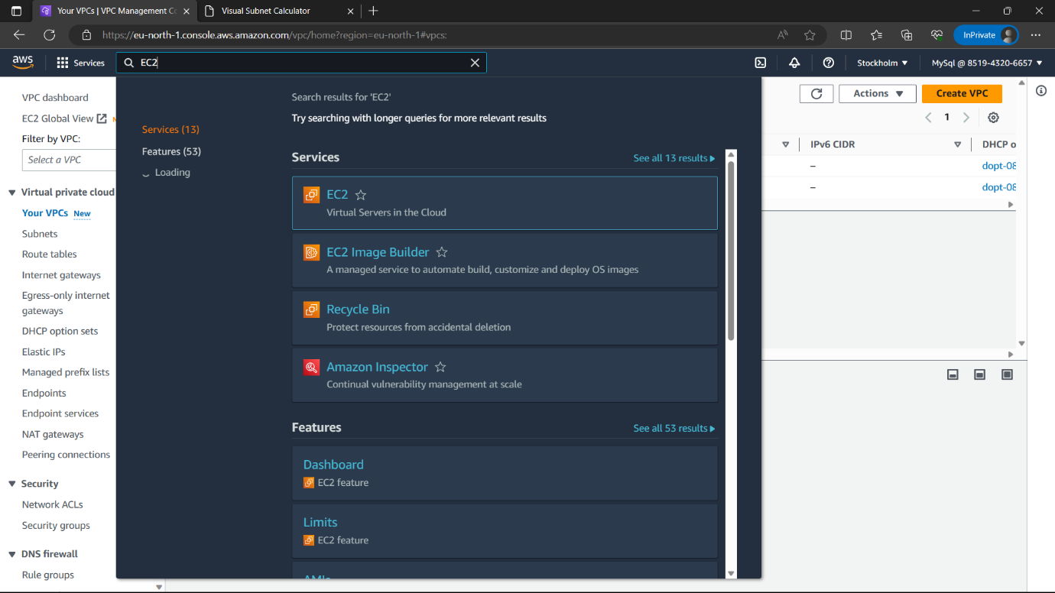

49)Click on “Launch instance” option which is in colour.

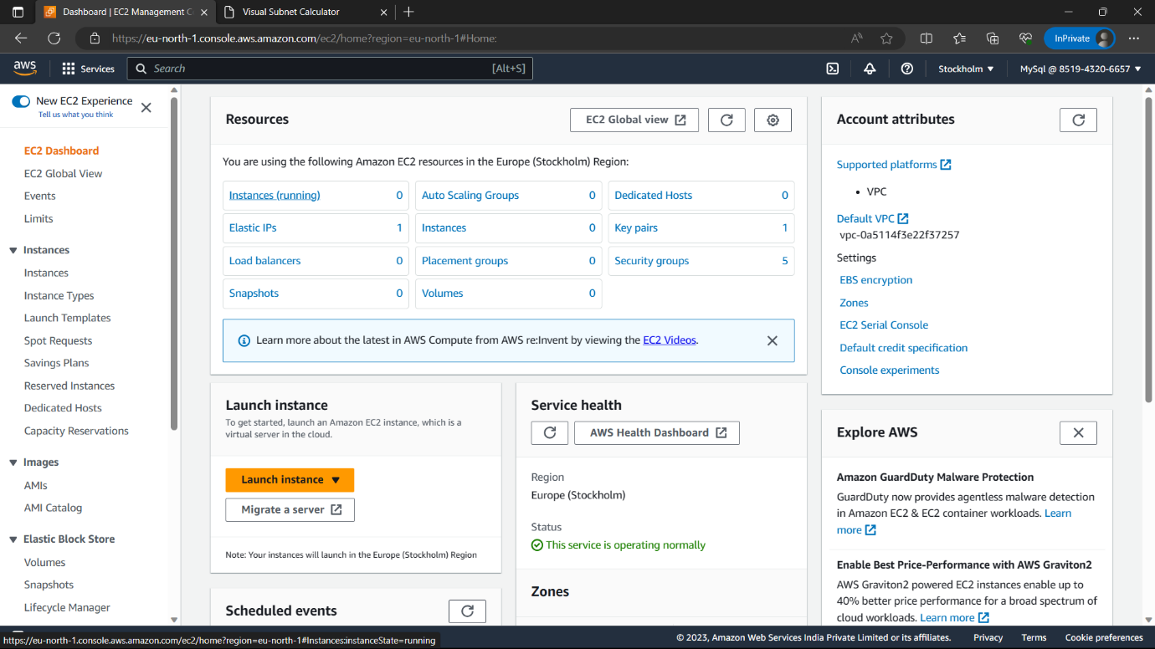

50)Name-“pub-inst”.

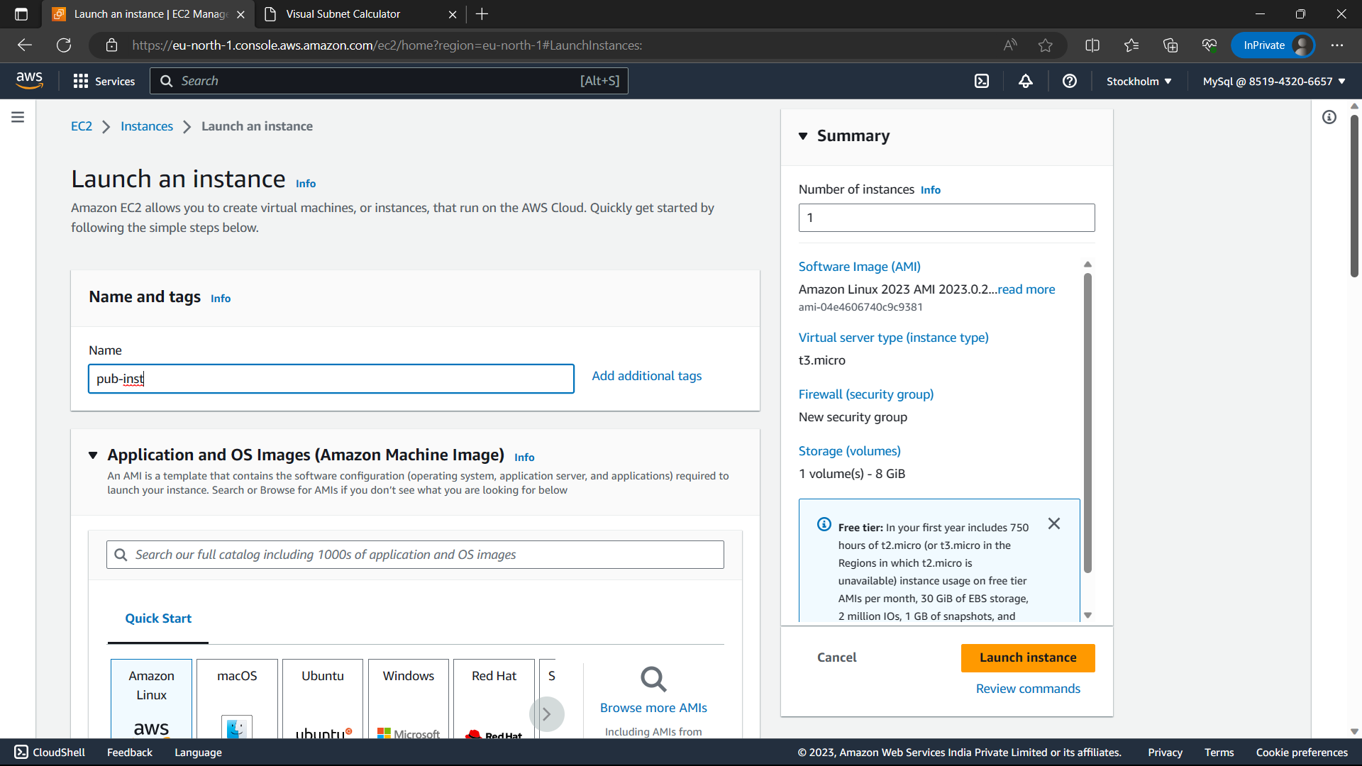

51)AMI-“Amazon linux”, Version-latest, Instance type-t3.micro(free-tier eligible).

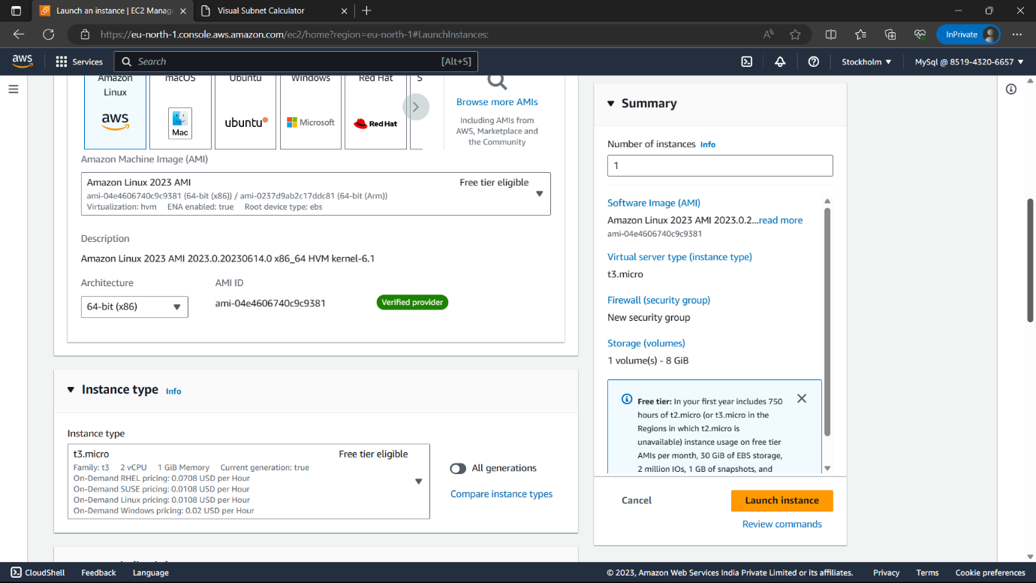

52)Select the key pair you have else click on “create new key pair”🡪name🡪Click on “create key pair” a copy of the key pair is downloaded in you local machine.

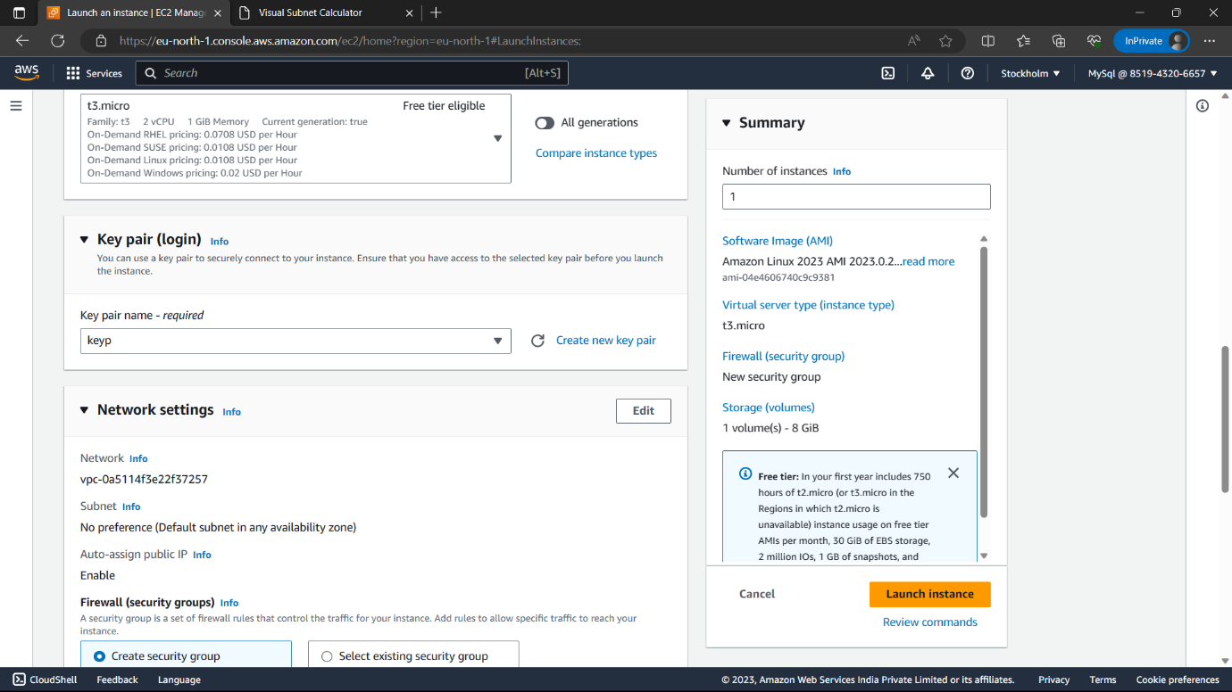

53)Enable “Allow HTTPS traffic” option and click on edit.

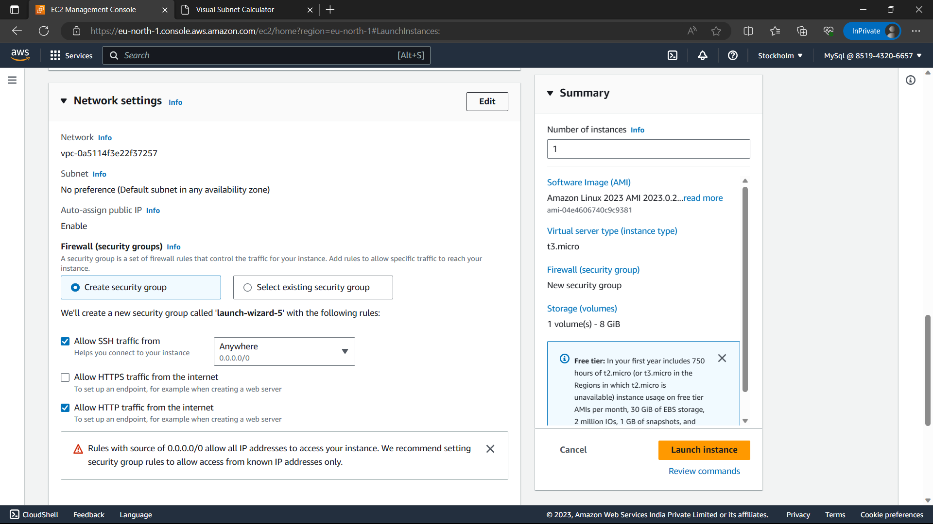

54)VPC-my-vpc(you created),Subnet-pub-sub,Auto-assign public IP-“Enable”.

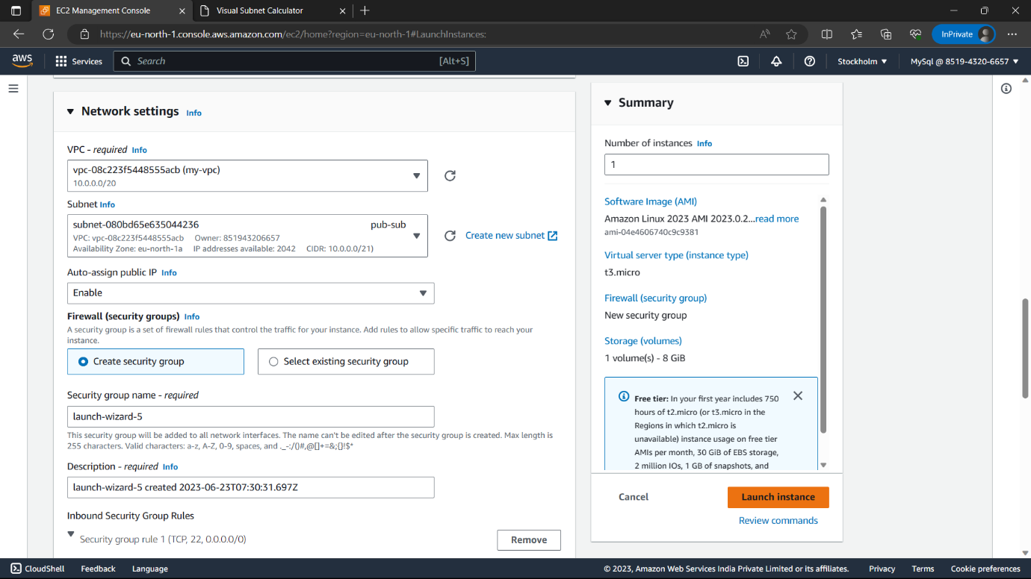

55)Review everything and click on “Launch instance”.



56) ”. Now the instance is created. Create another instance by clicking on “Launch instance” option. Name-“pvt-inst”, AMI- “Amazon Linux”

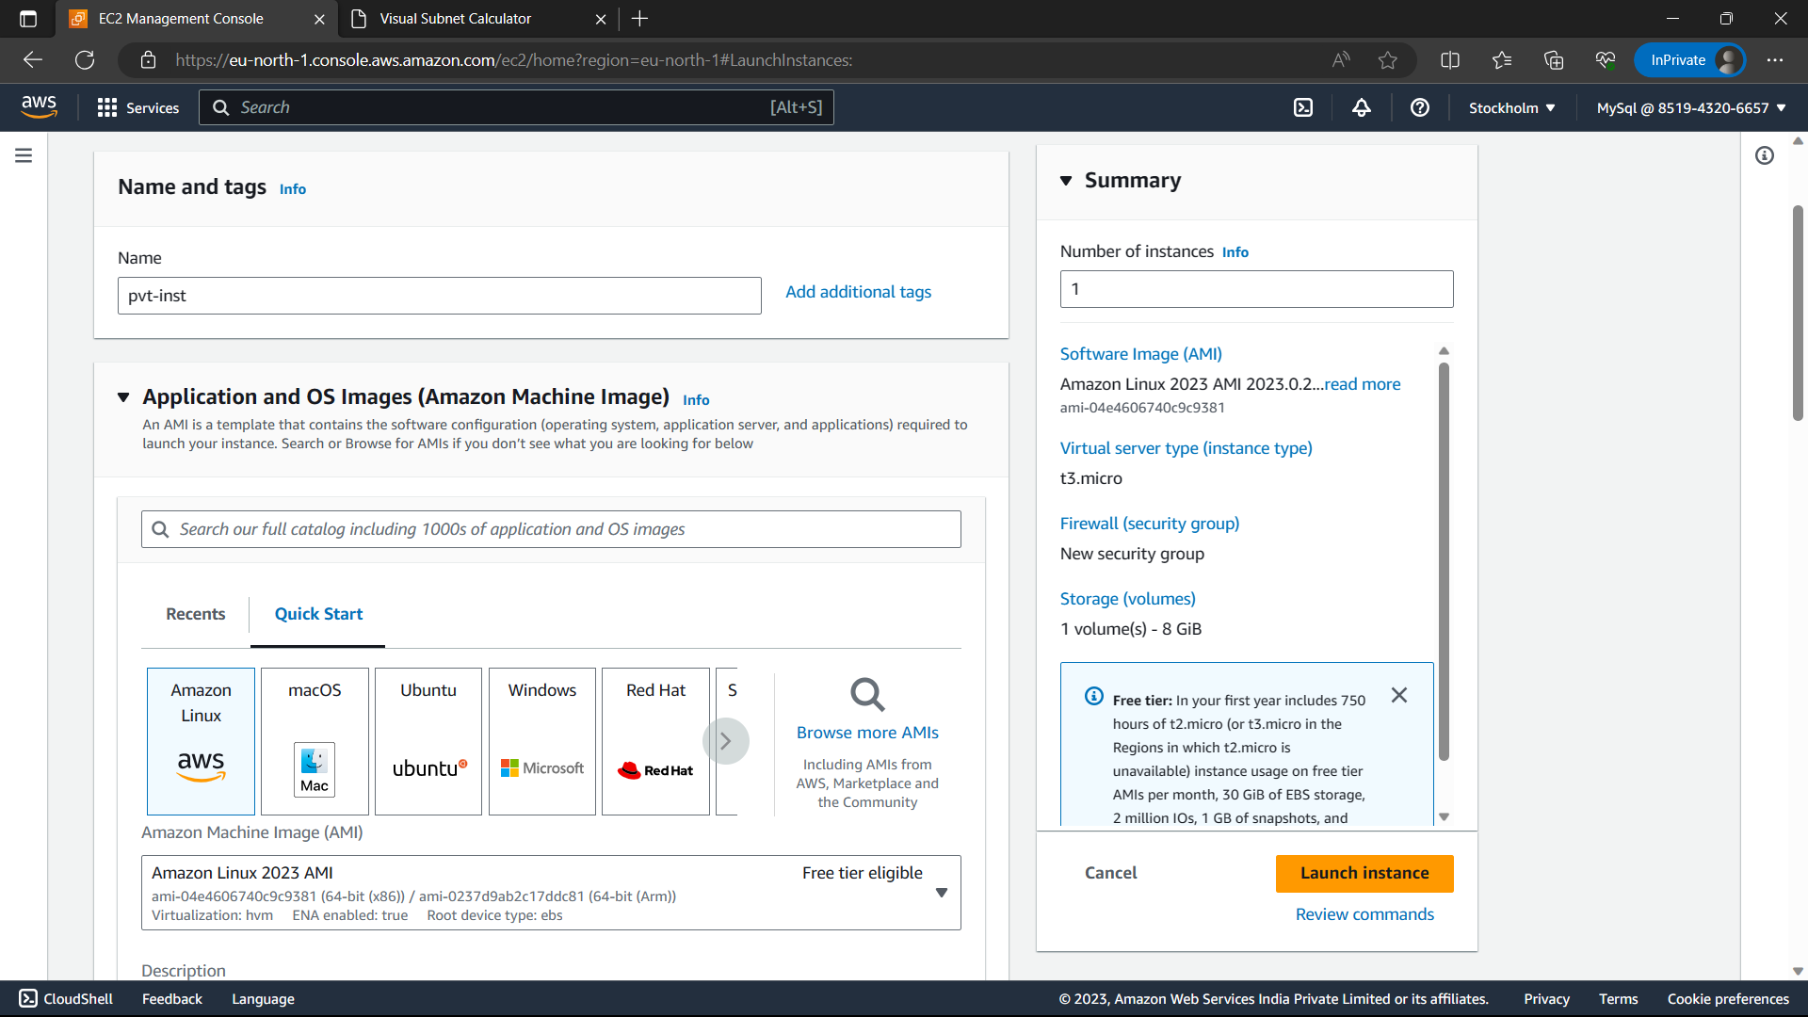

57)Instance type-t3.micro(free-tier only), key-pair-Select the key pair you have.

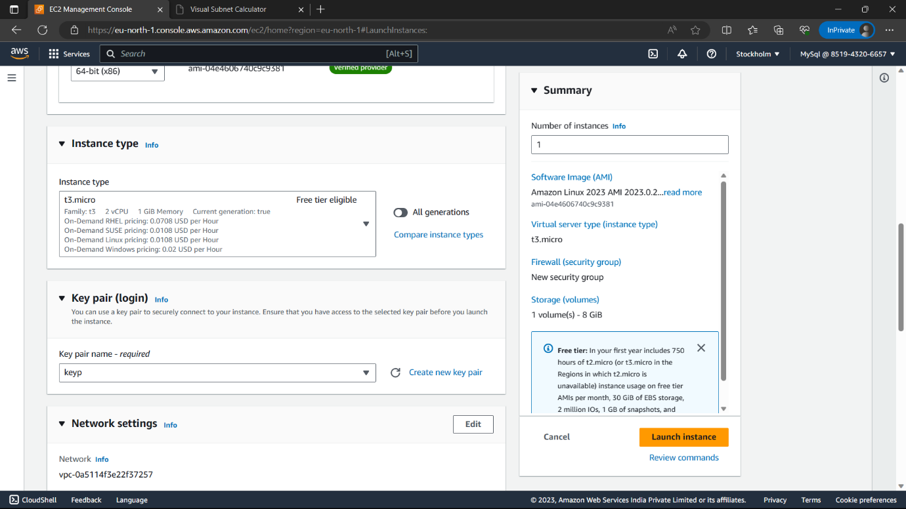

58)Enable “Allow HTTPS traffic” option and click on “Edit”.

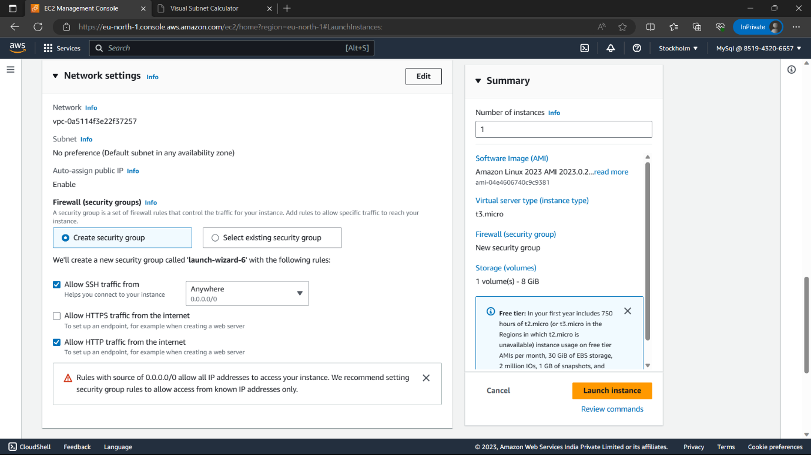

59)VPC-my-vpc(you created),Subnet-:pvt-sub, Auto-assign public IP-Disable.

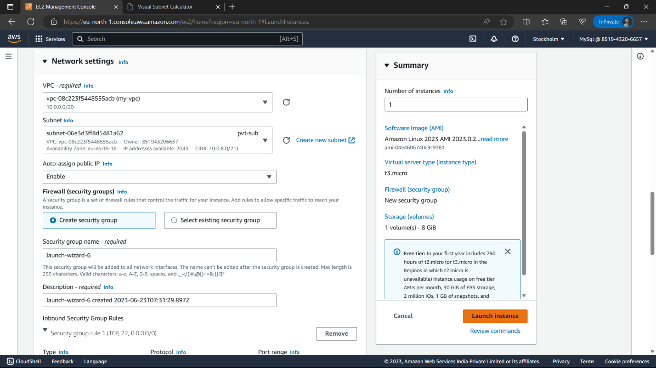

60)Review everything and click on “Launch instance” option.



61)Now the instances are created.

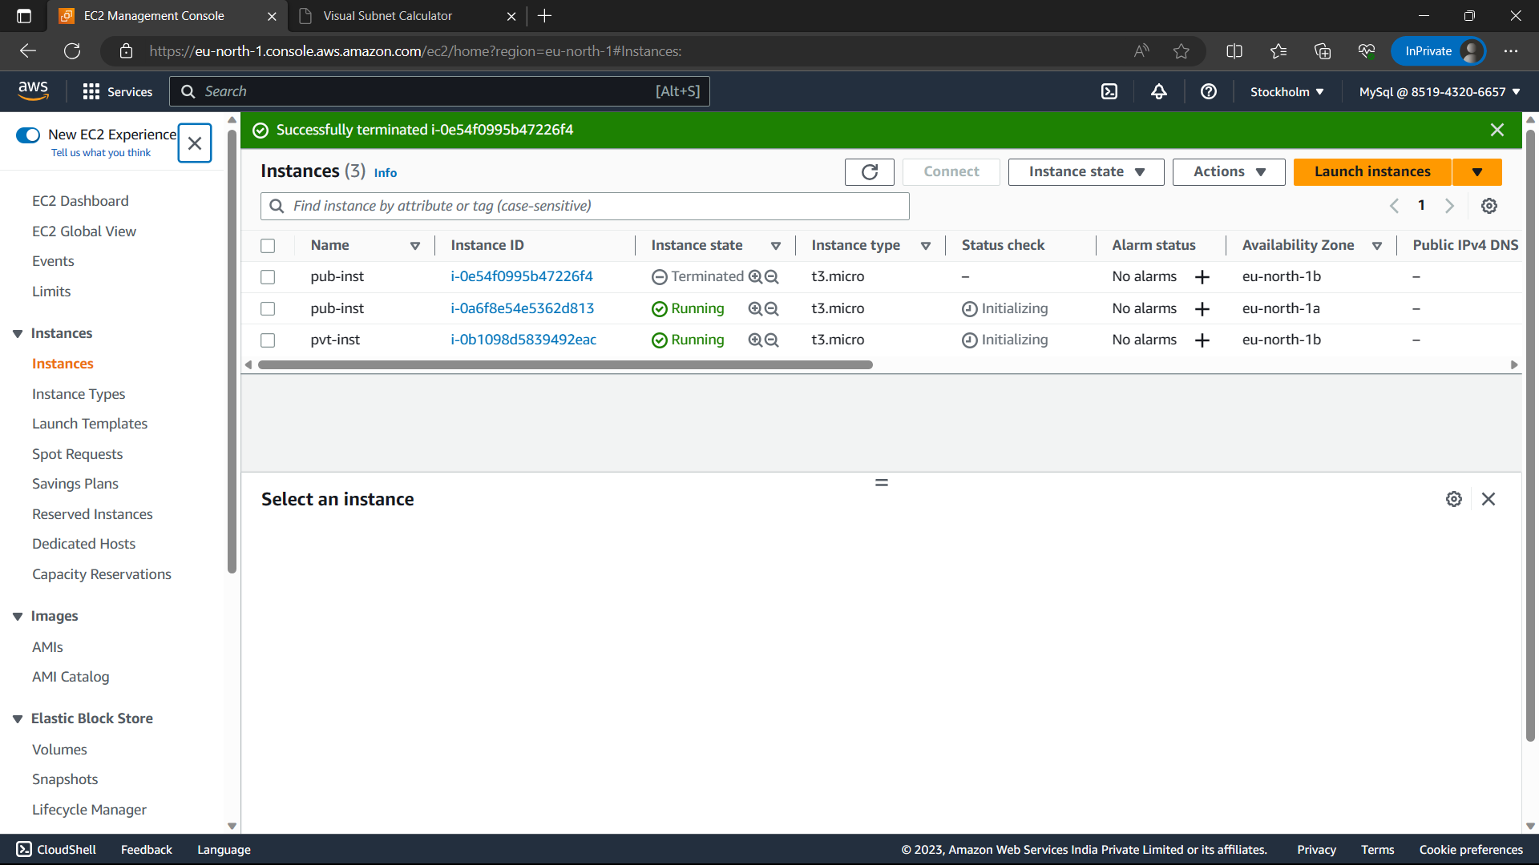

62)Type “RDS” in search bar and select “RDS” option from below.

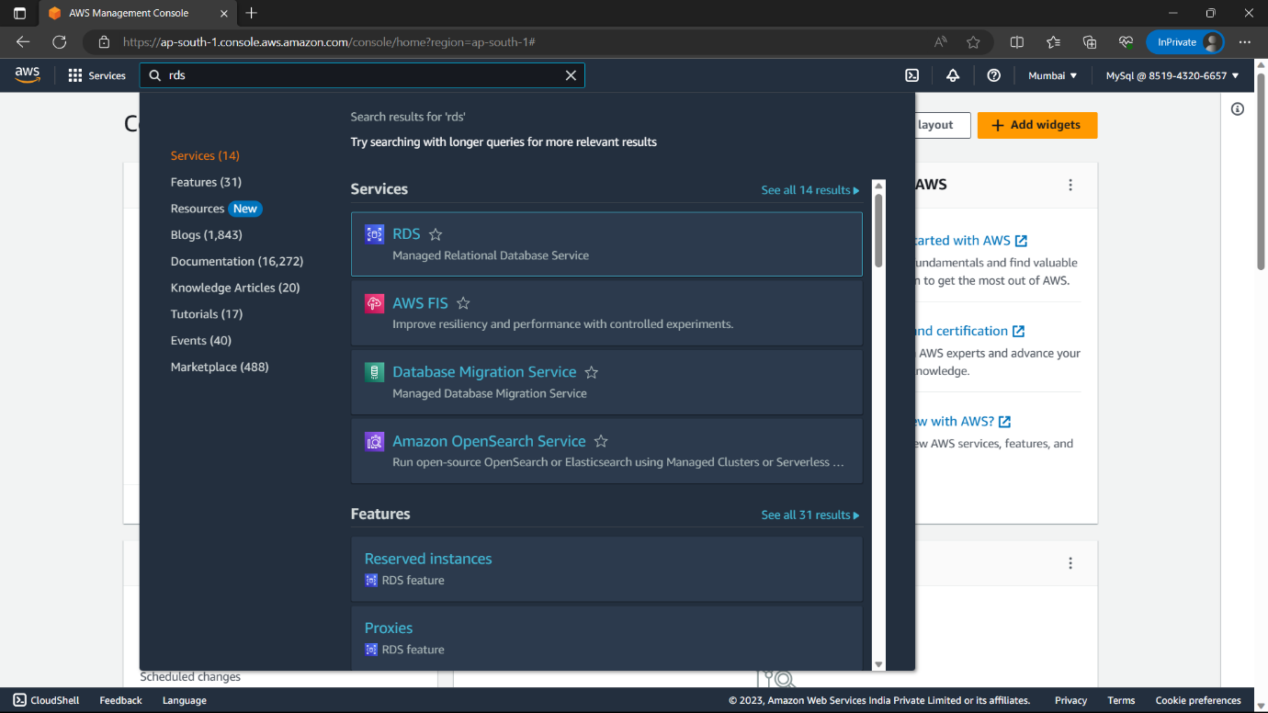

63)Click on “create database” option which is in yellow colour.

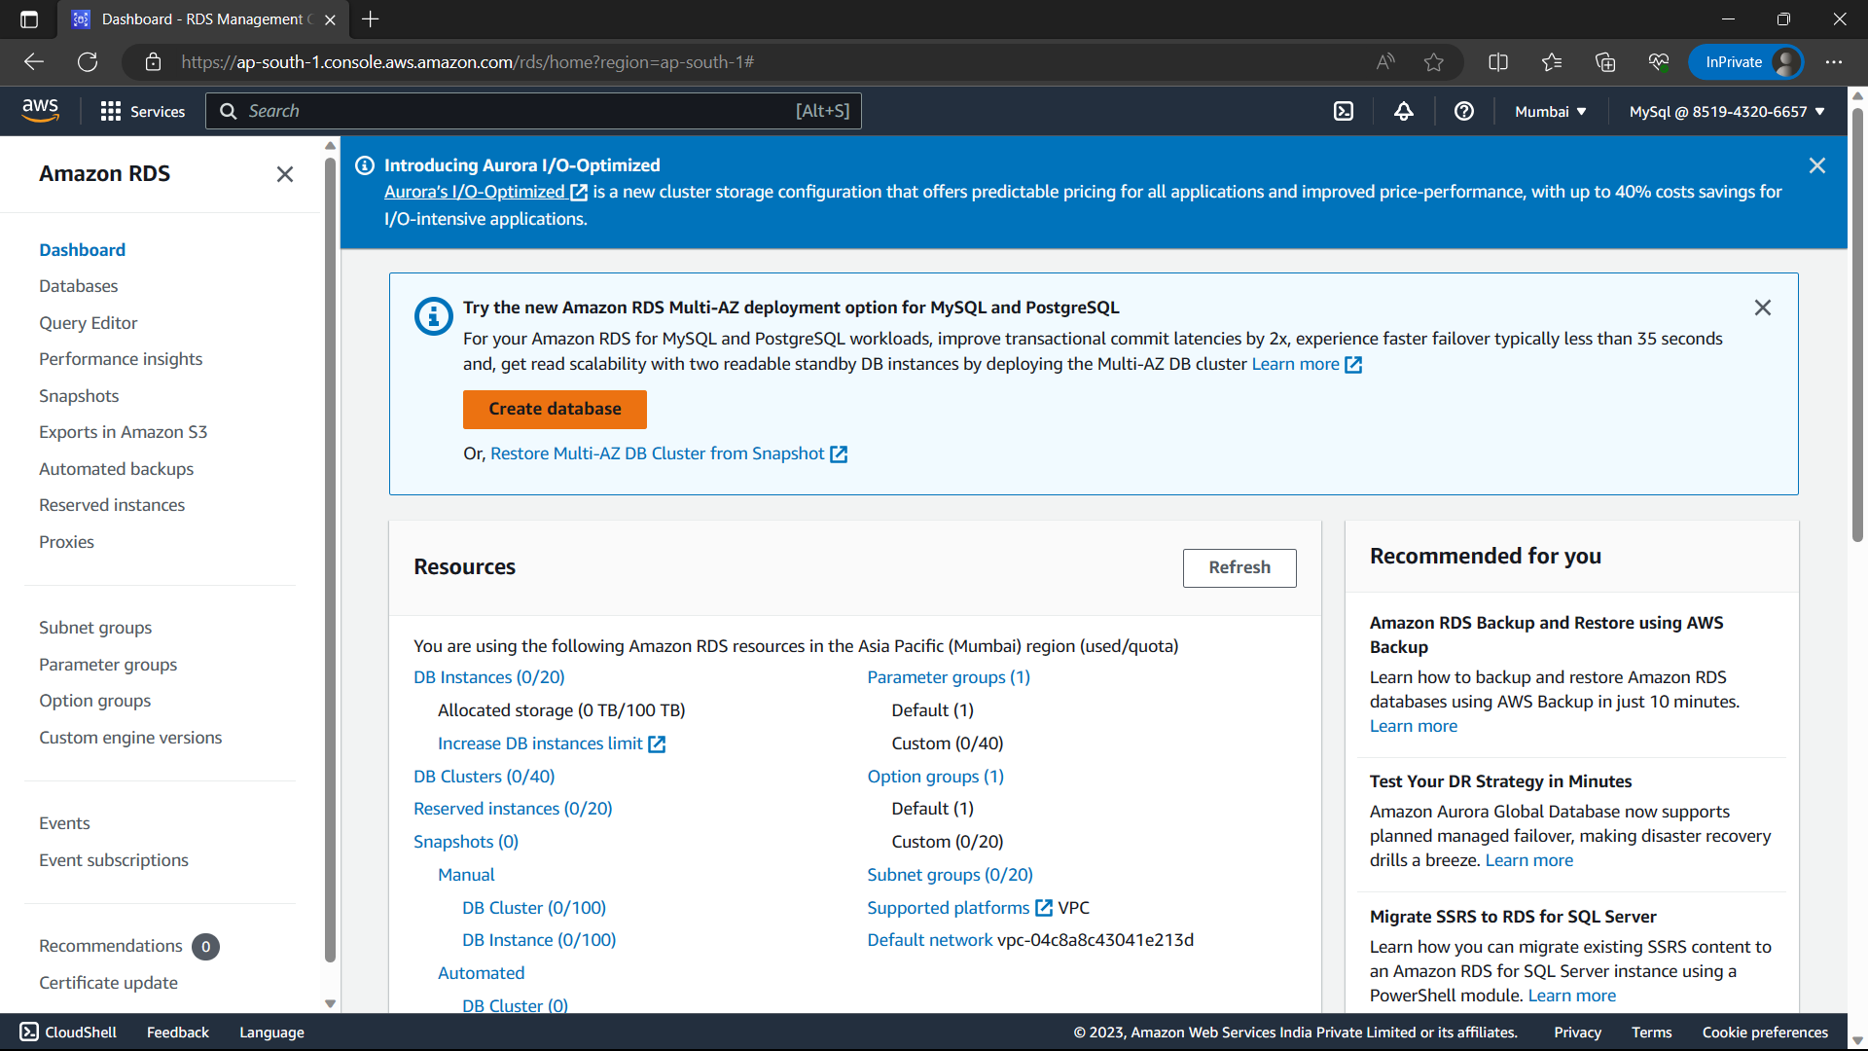

64)Database-“Standard create”, Engine option-“MySQl”.

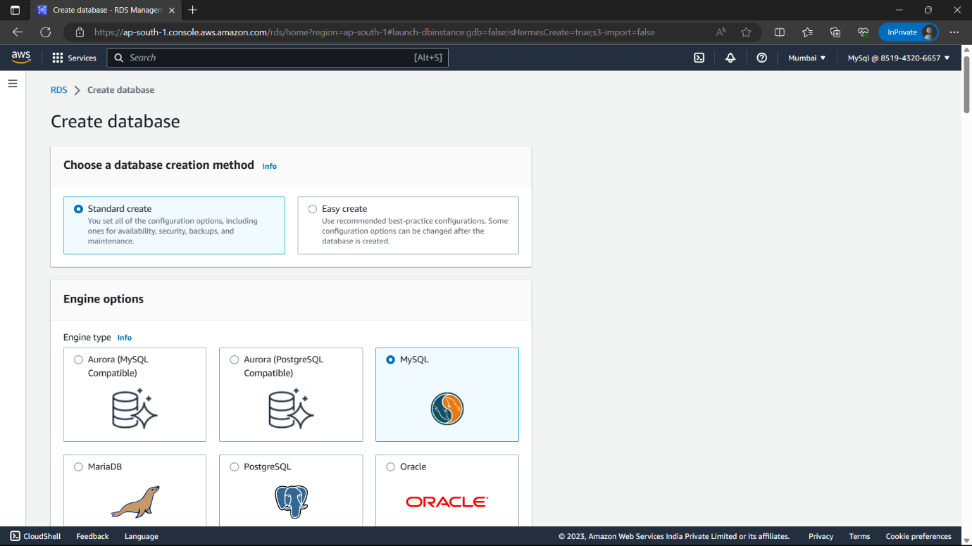

65)Version-default(or)according to requirments, Templates-“Free tier”.

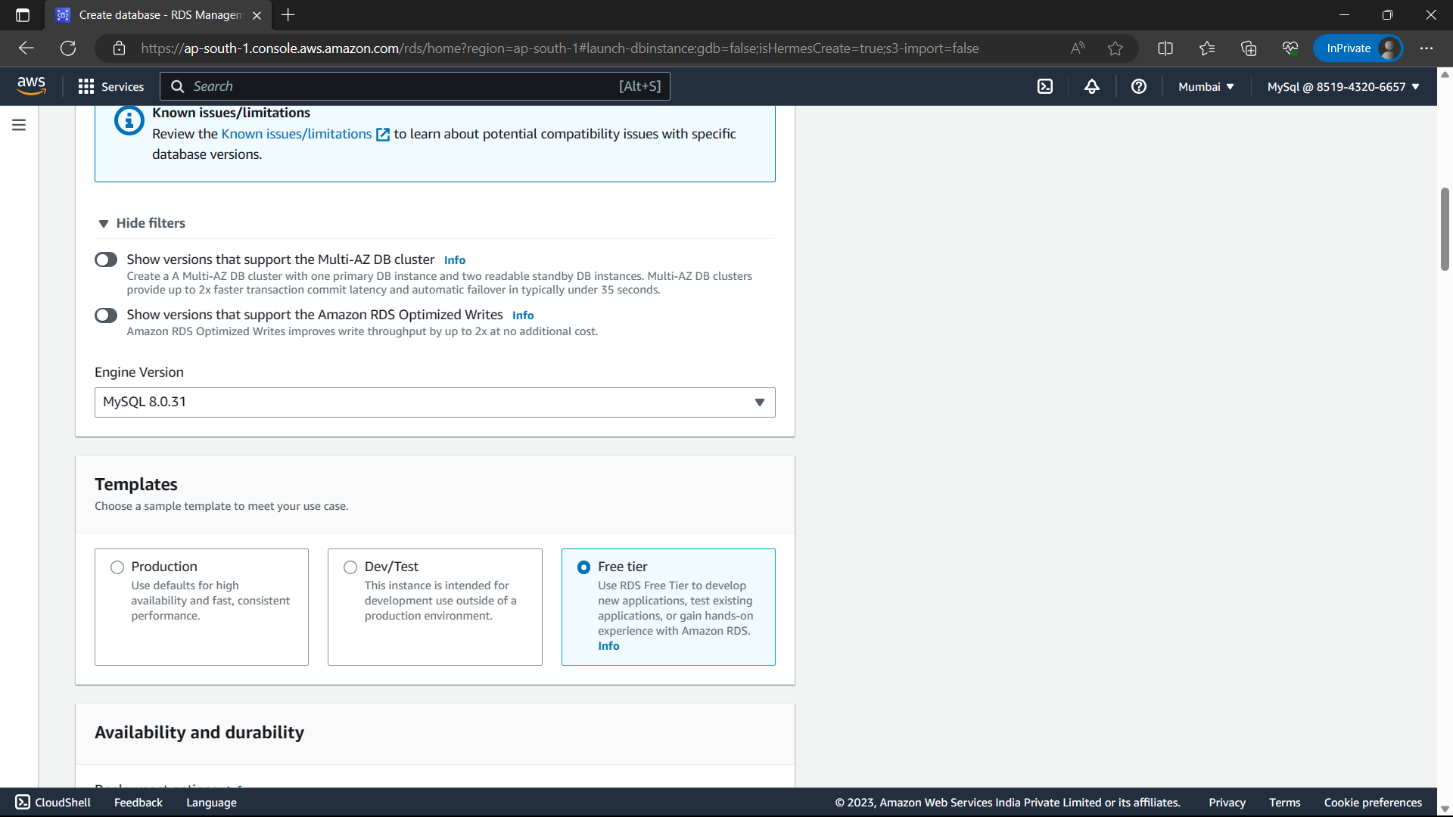

66)Credential settings-: give a password to the account(admin) in “Master password”.

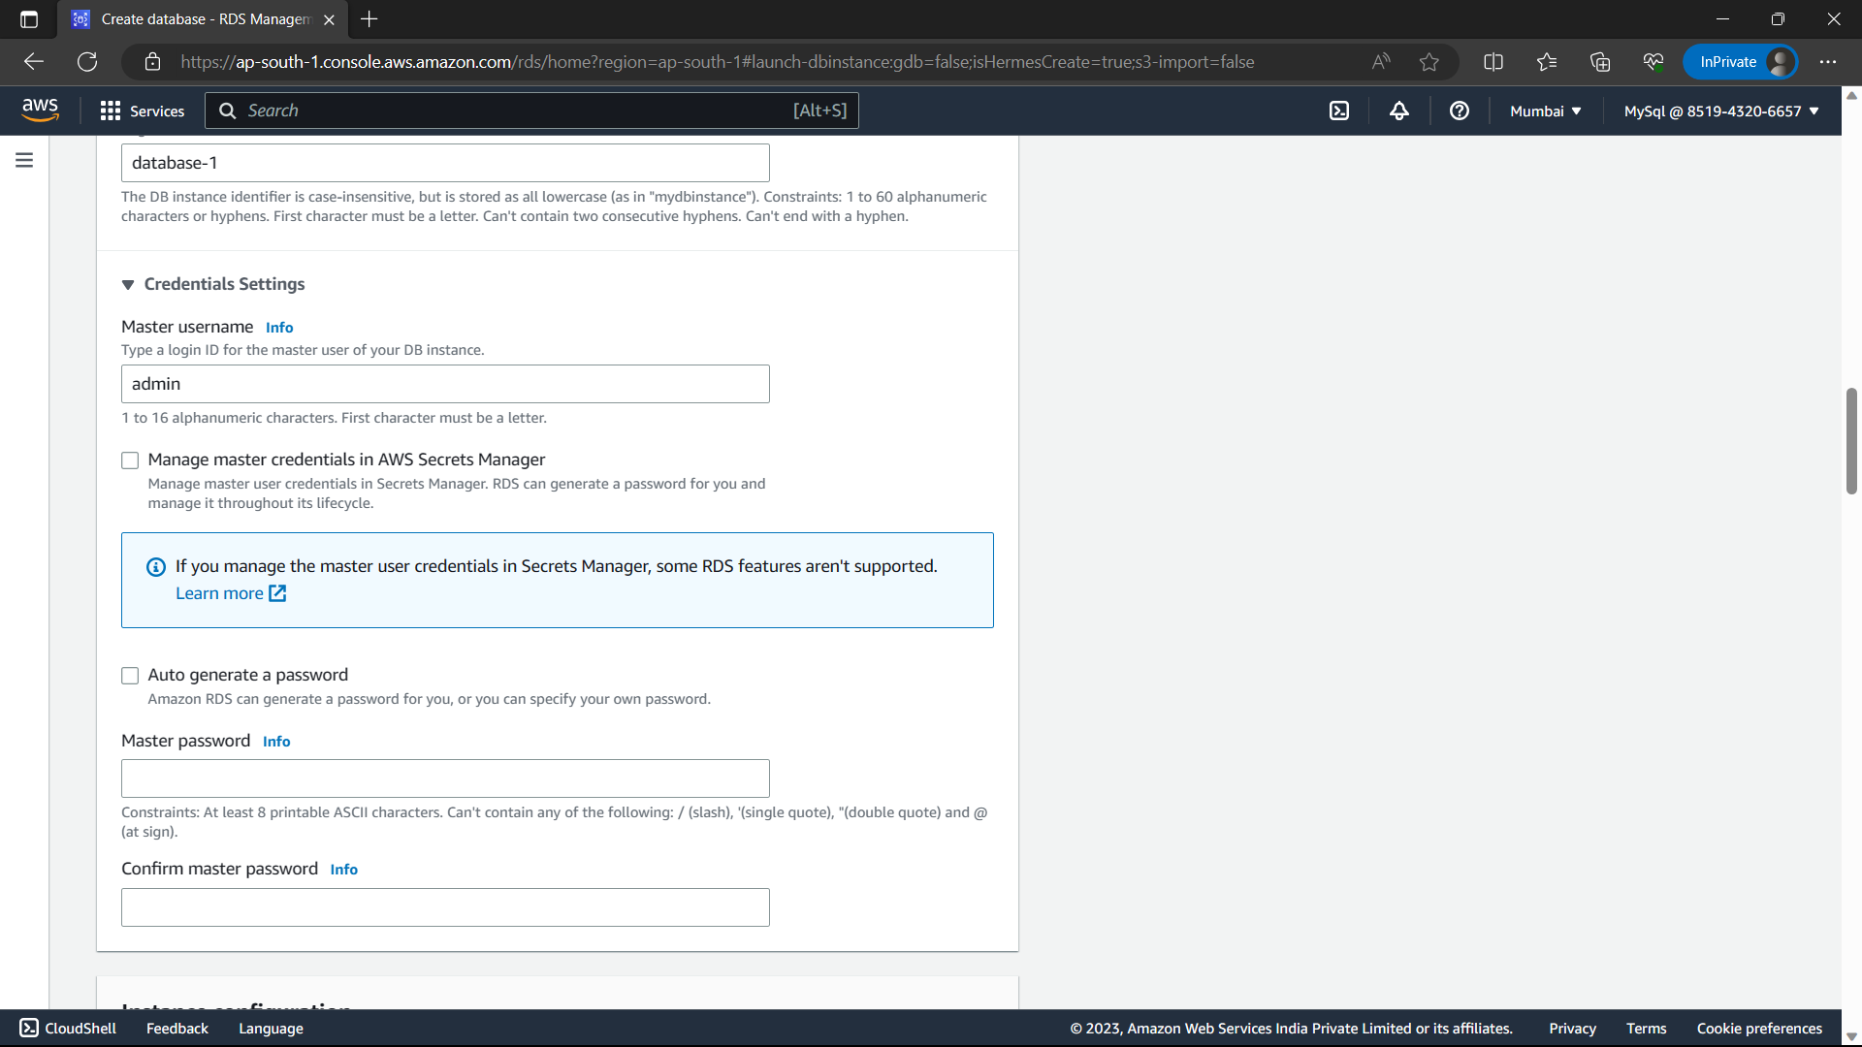

67)Instance configuration-“Burstable class”.

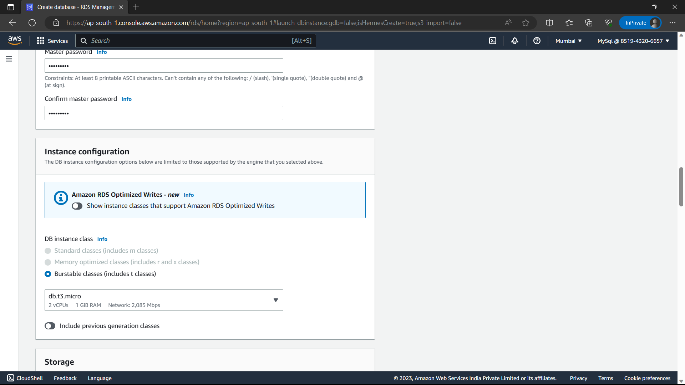

68)In Storage let everything be default.

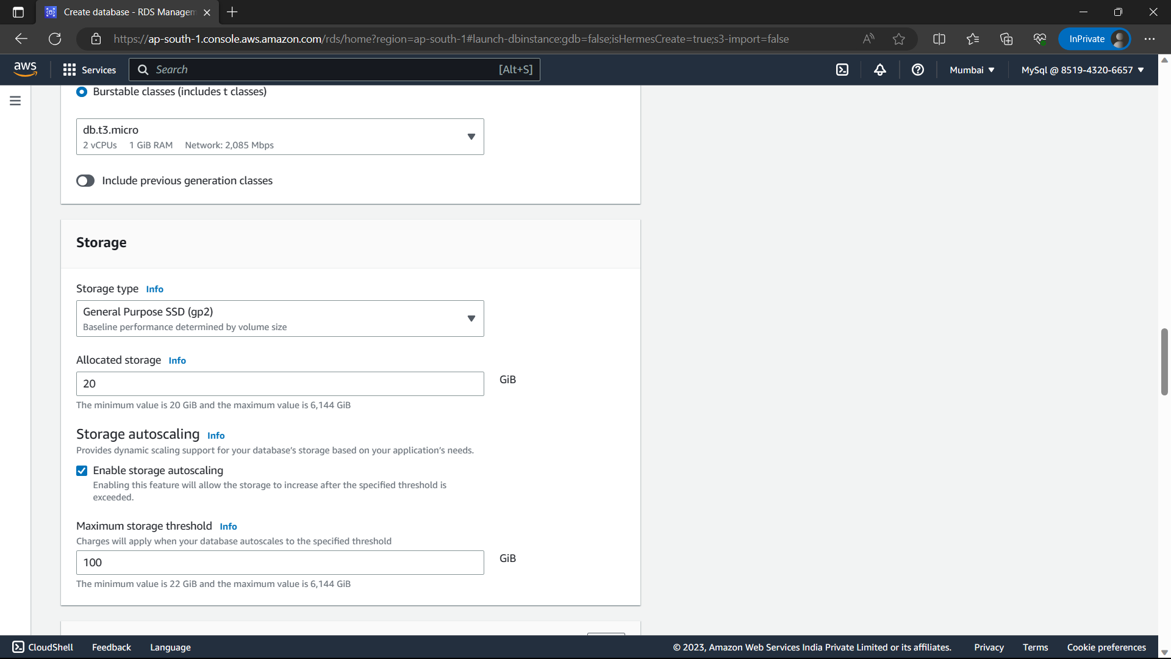

69)In Connectivity ::- Compute resource- “Don’t connect to EC2”,Network type-IPV4,VPC- my-vpc(VPC you created).

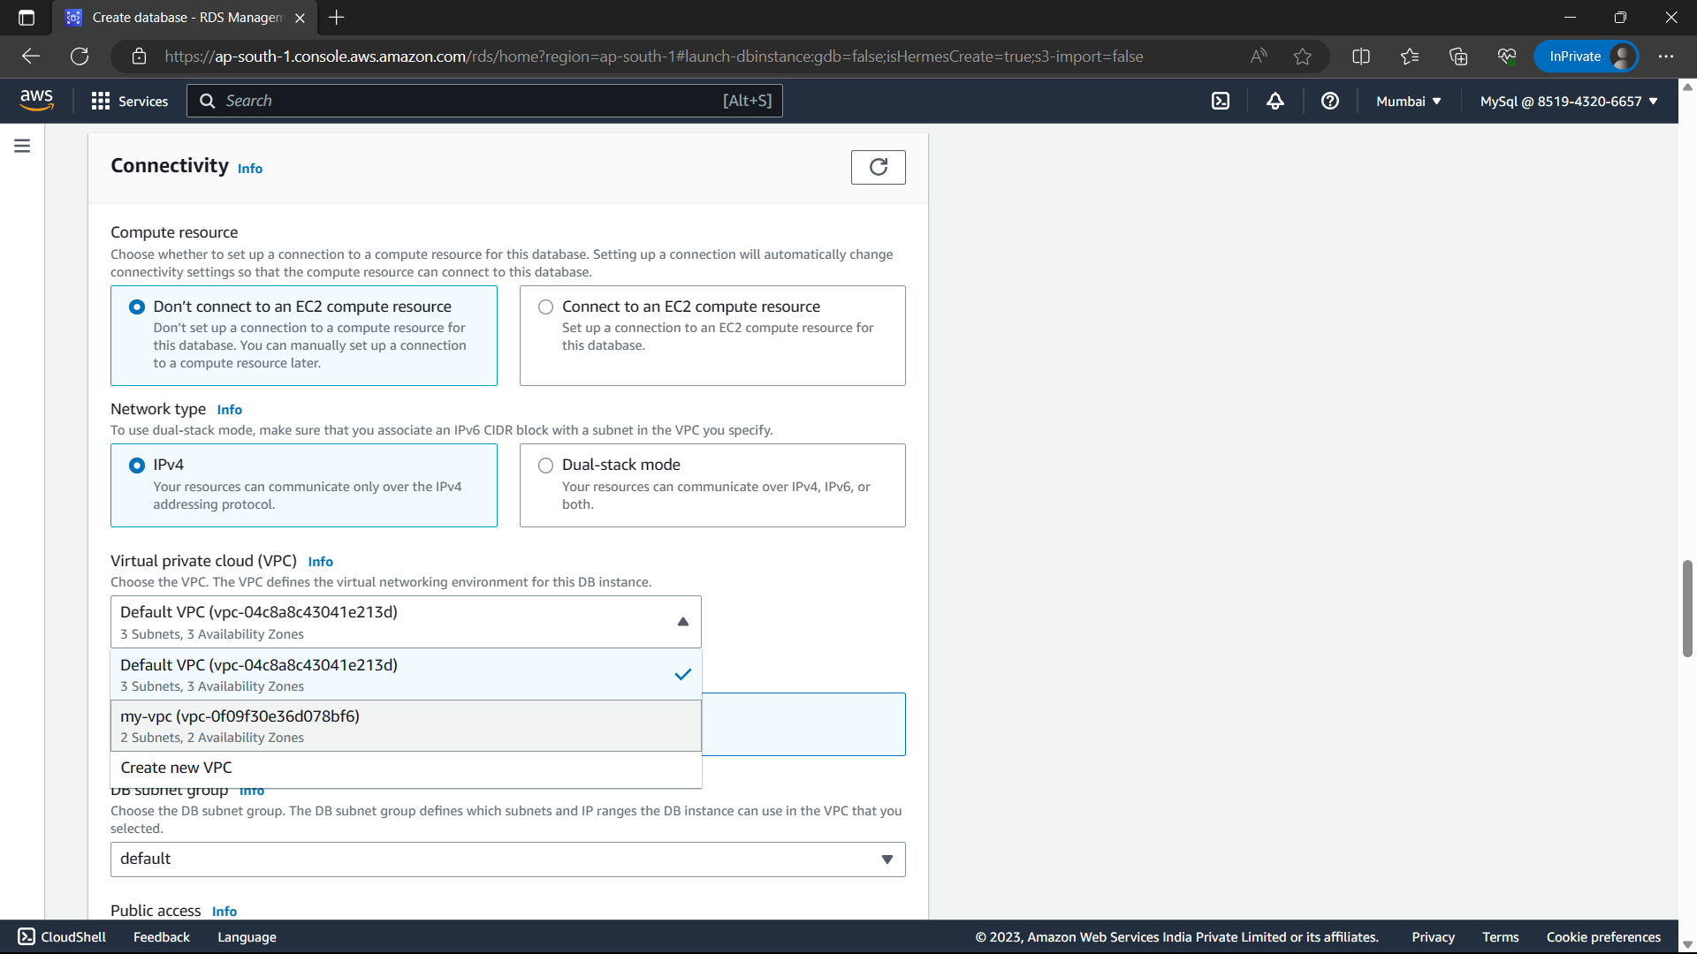

70)Launch wizard, Availability zone should be the private instance zone, launch wizard if you didn’t create EC2 then add it after creating the instances.my private instance security group is “launch-wizard-6” add in security groups.

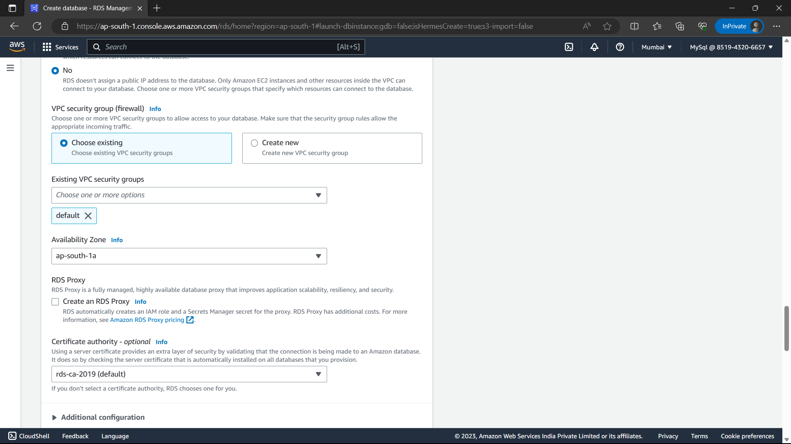

71)Let everything be default and click on “Create database”.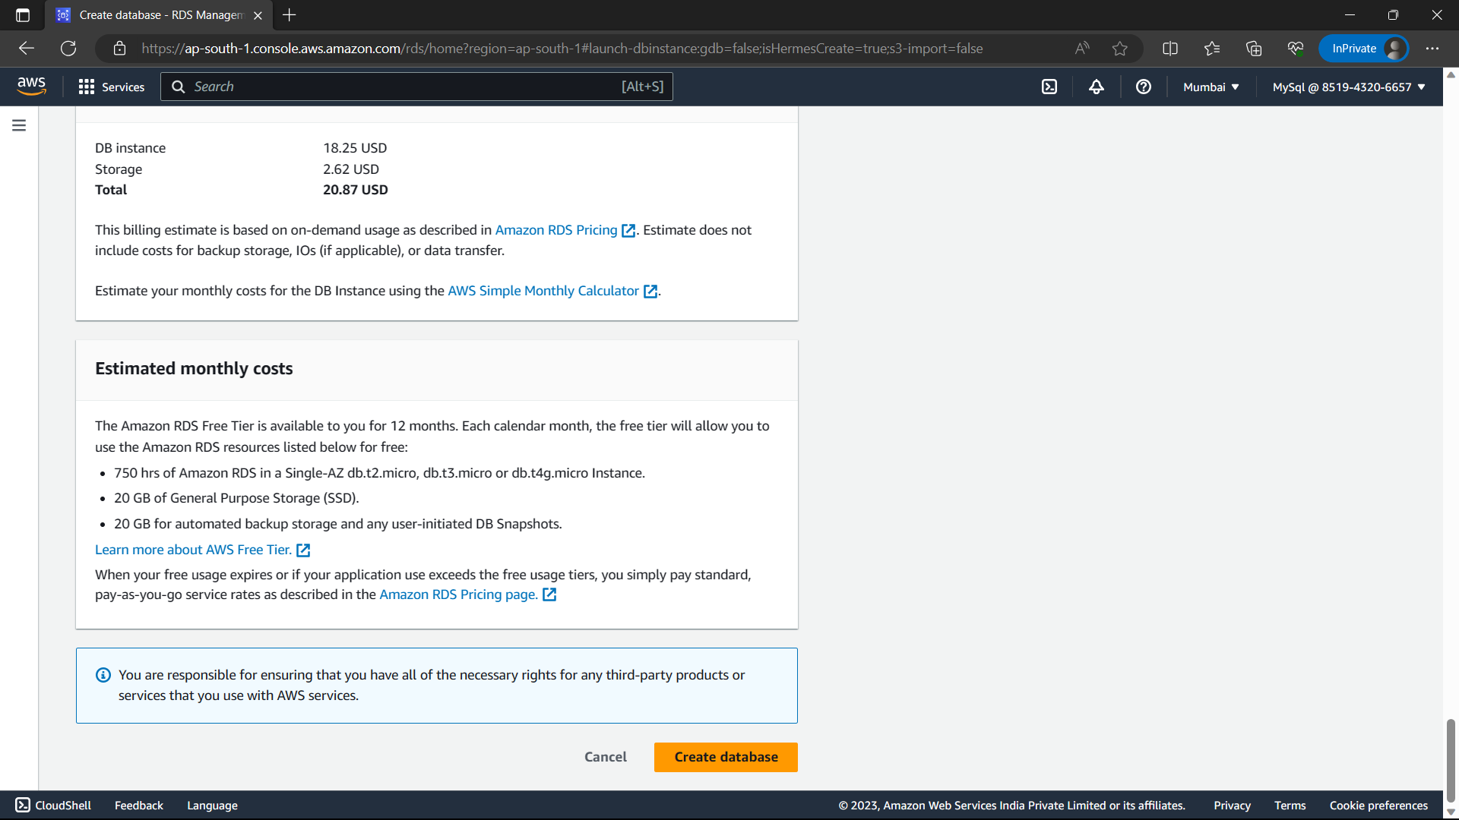

72)The database has been created.

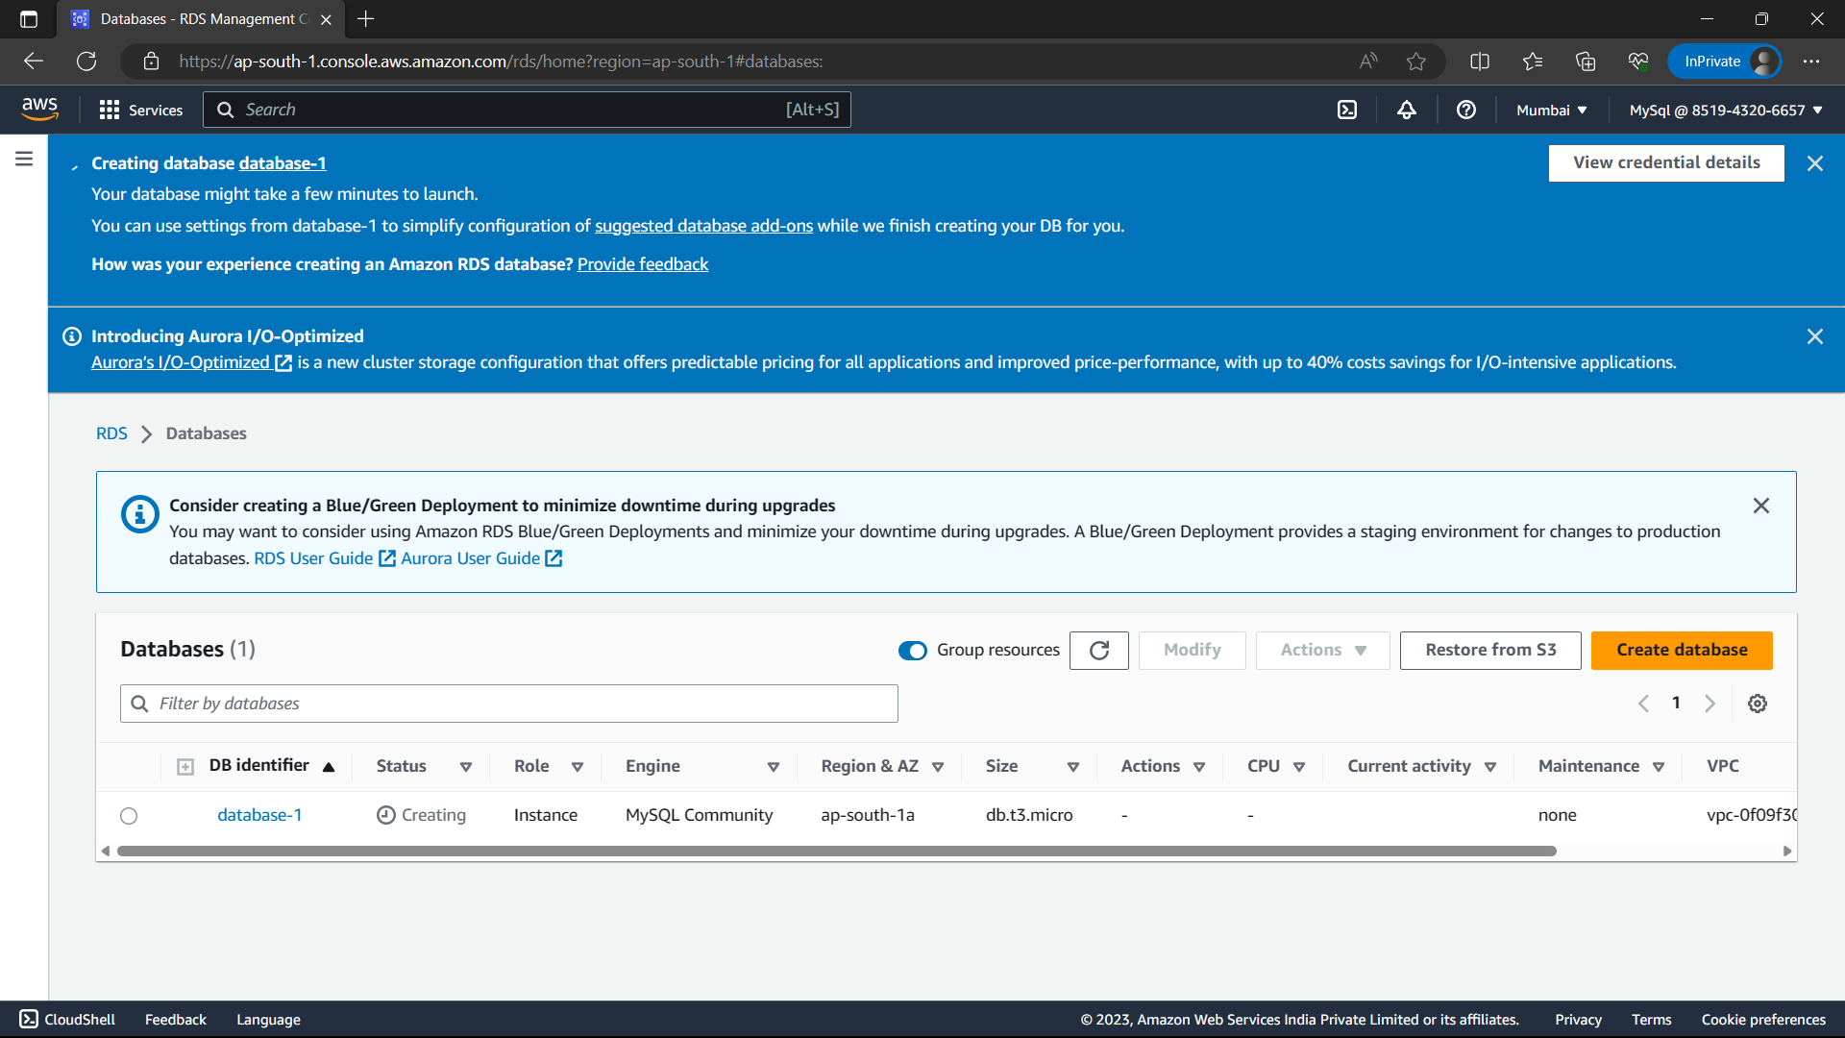

73)Type “EC2” in search bar and select “EC2” option from below.

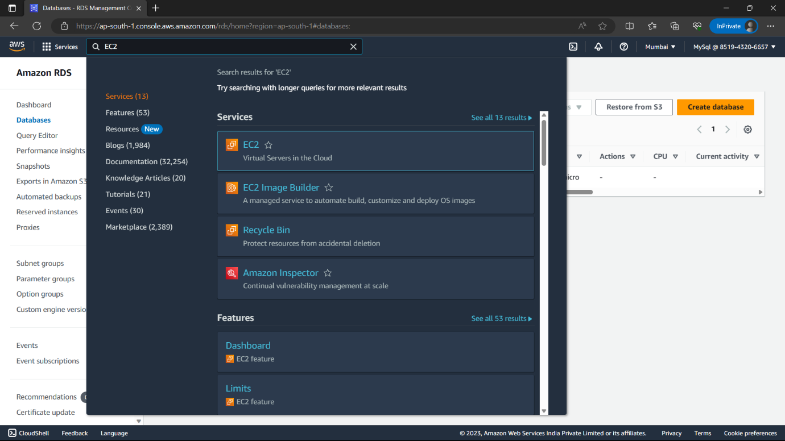

74)Click on “Instance(running) option from above options.

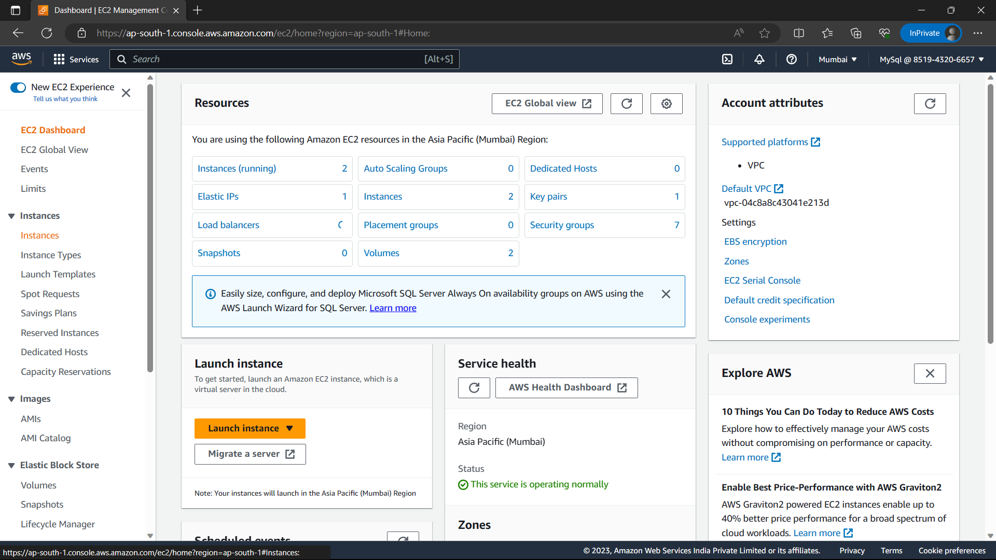

75)Select “Pvt-inst” and navigate “Security” and click on security groups.

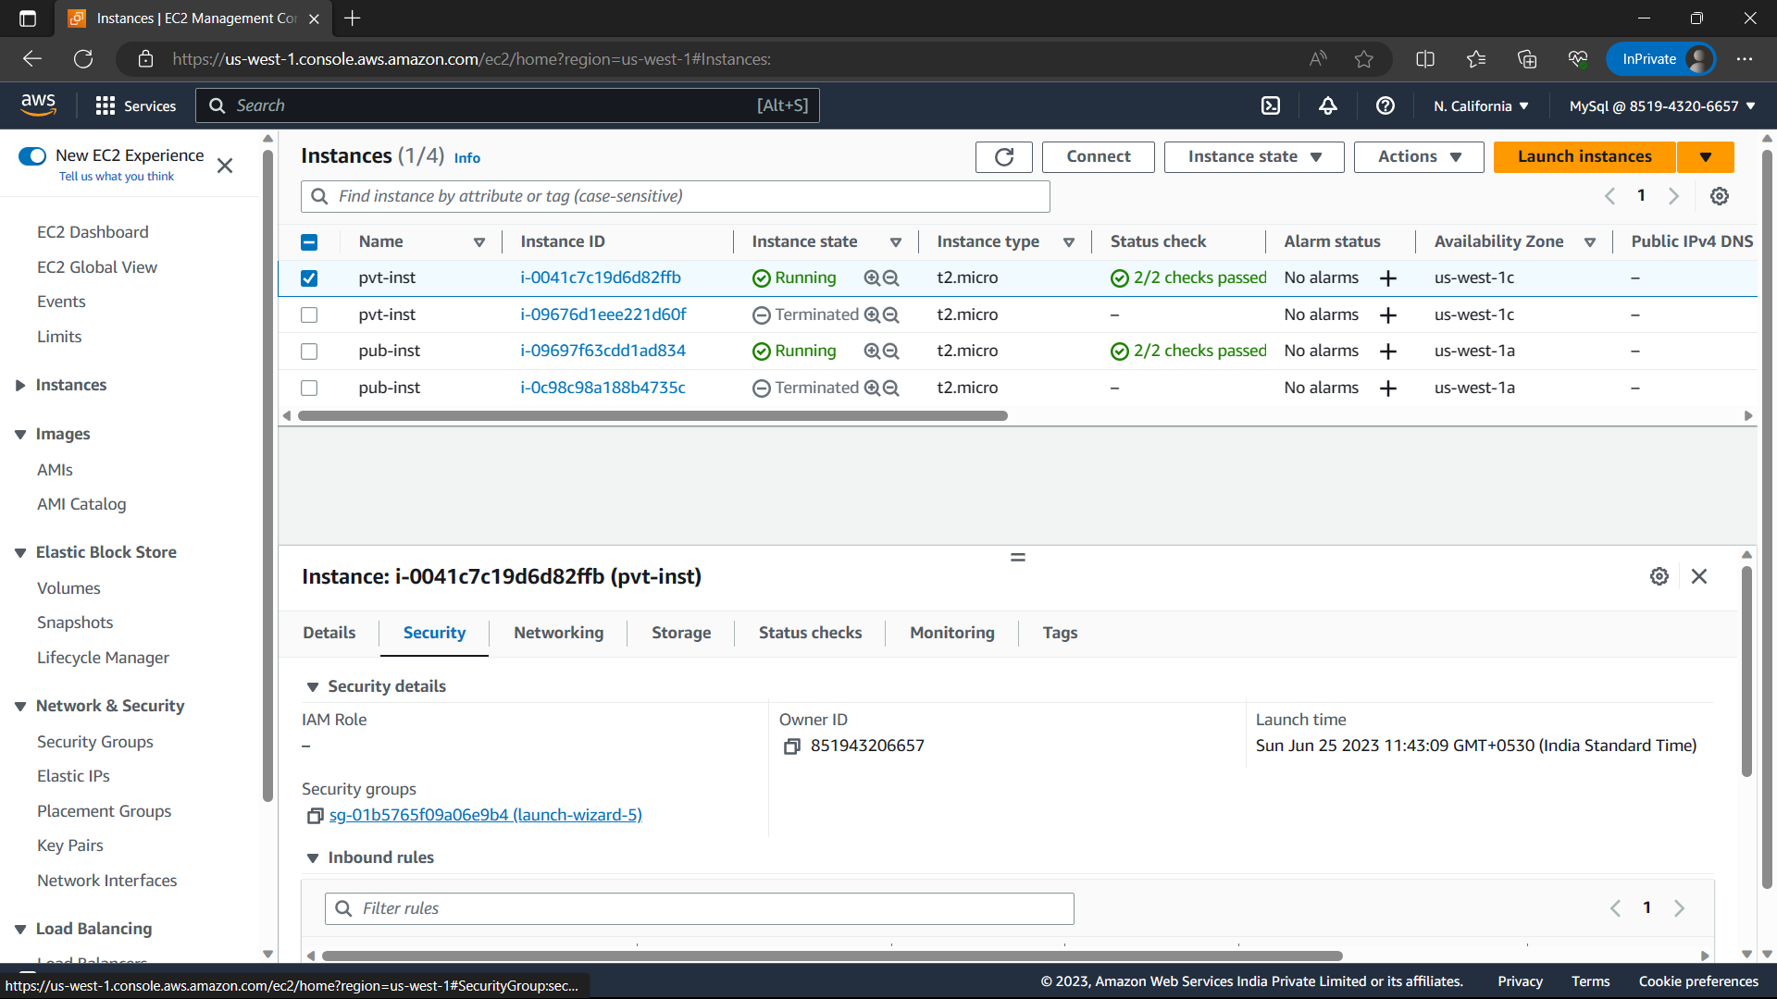

76)Click on “Edit inbound rules” option.

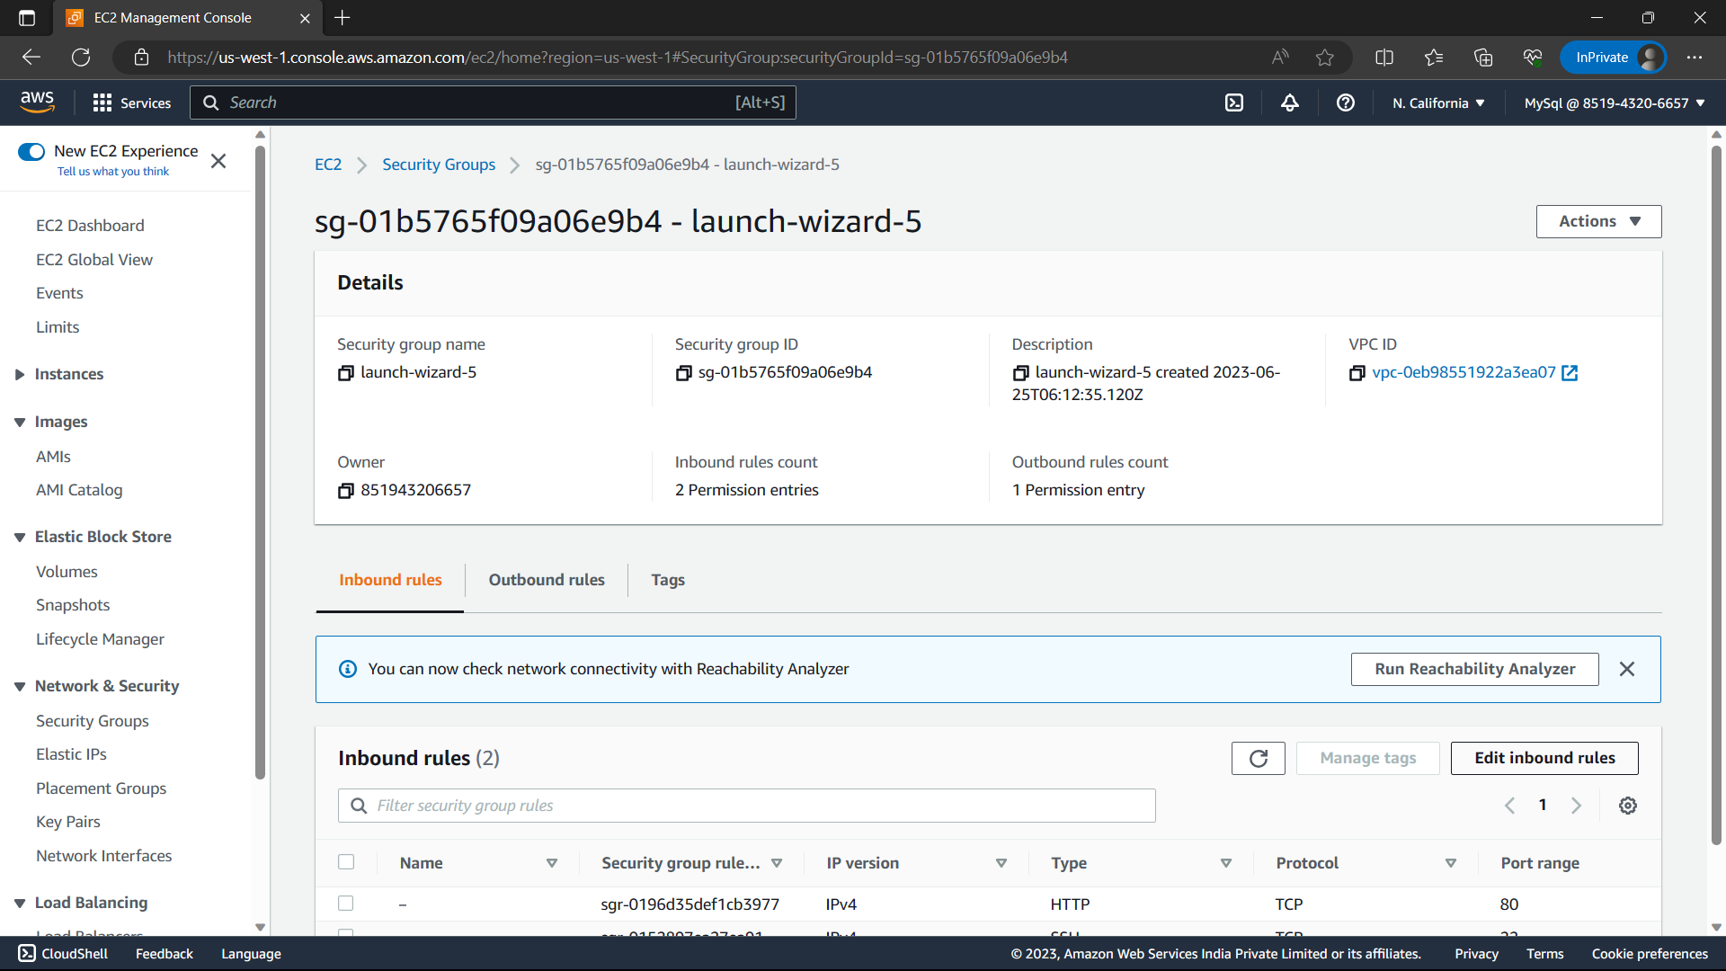

77)Click on “Add rule”.

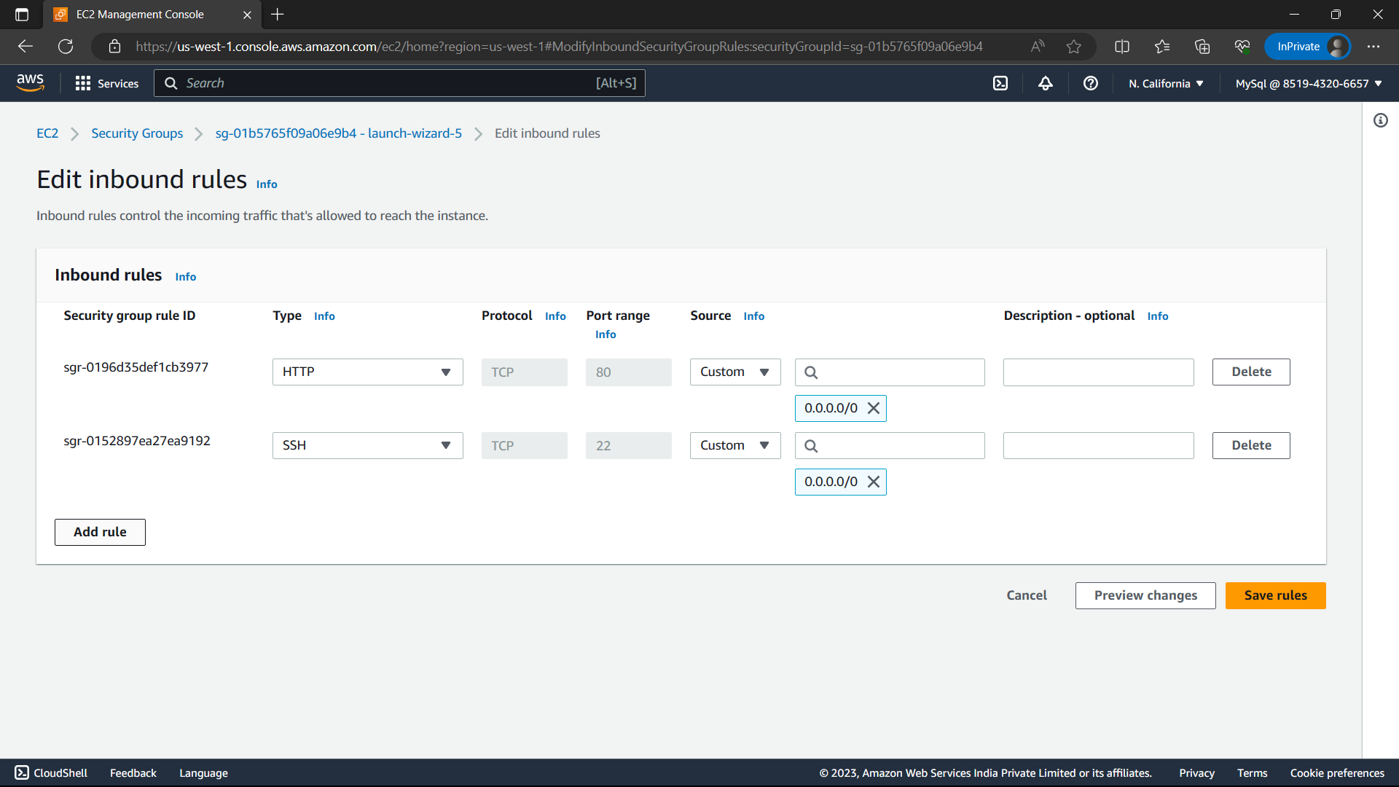

78)Type-“Custom TCP”, port range-“3306”, CIDR-0.0.0.0/0 and click on “Save rules”.

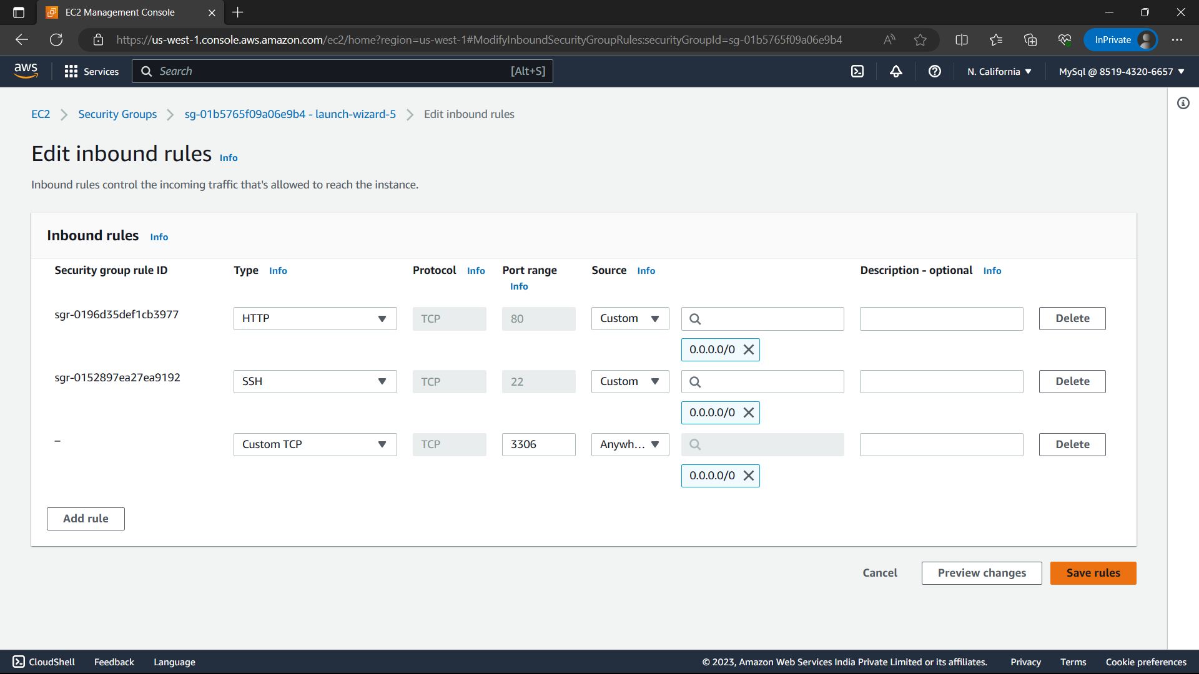

79)Select the pub-inst and click on “connect” option.

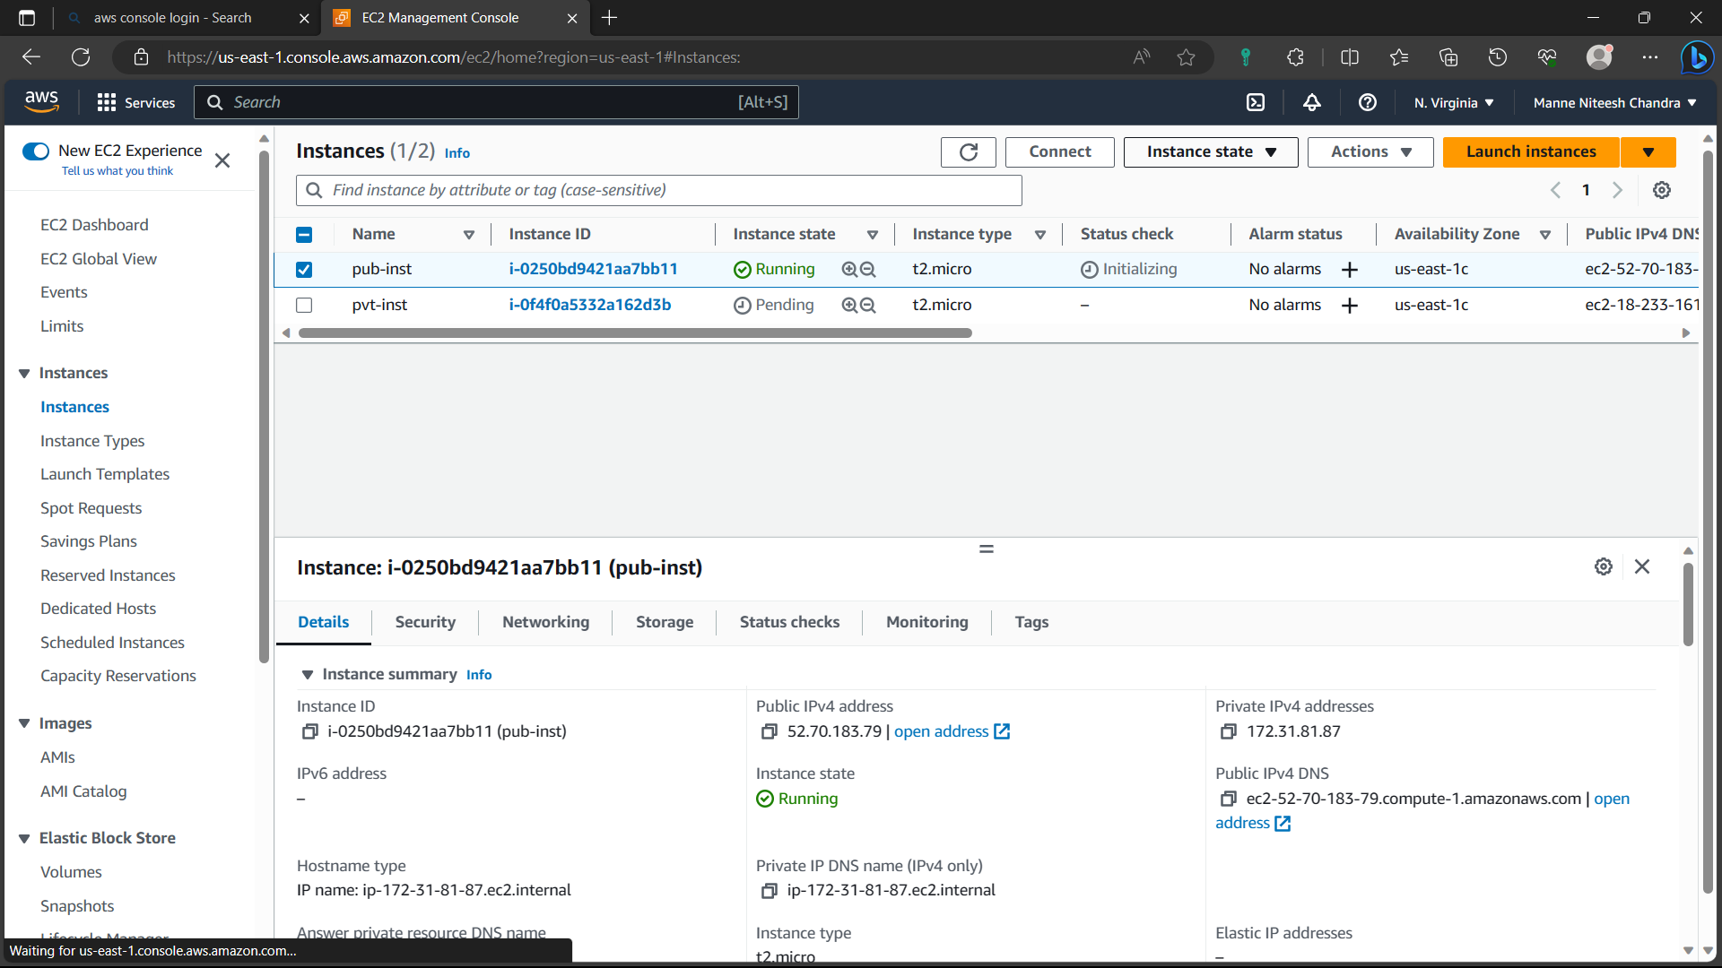

80)Navigate to “SSH client” and copy the command below “Example”.

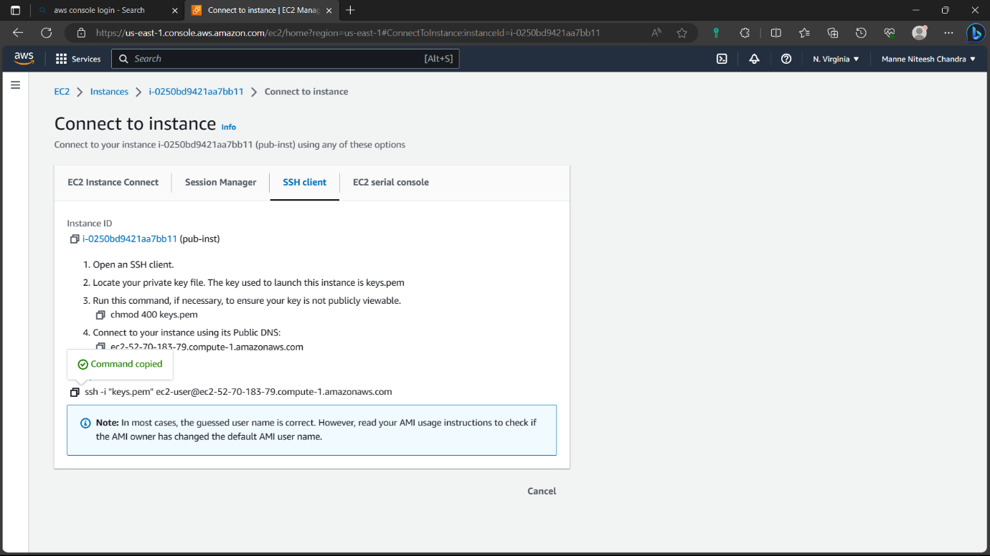

81)Go to your local machine and open command prompt.

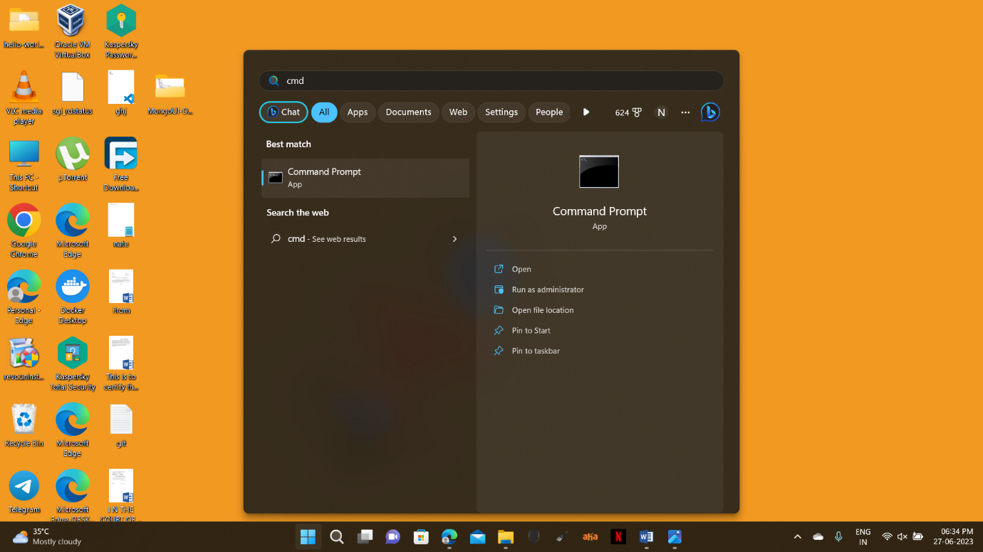

82)”cd path” path: where the pem file is located given at the time creating instance

“cd downloads”.

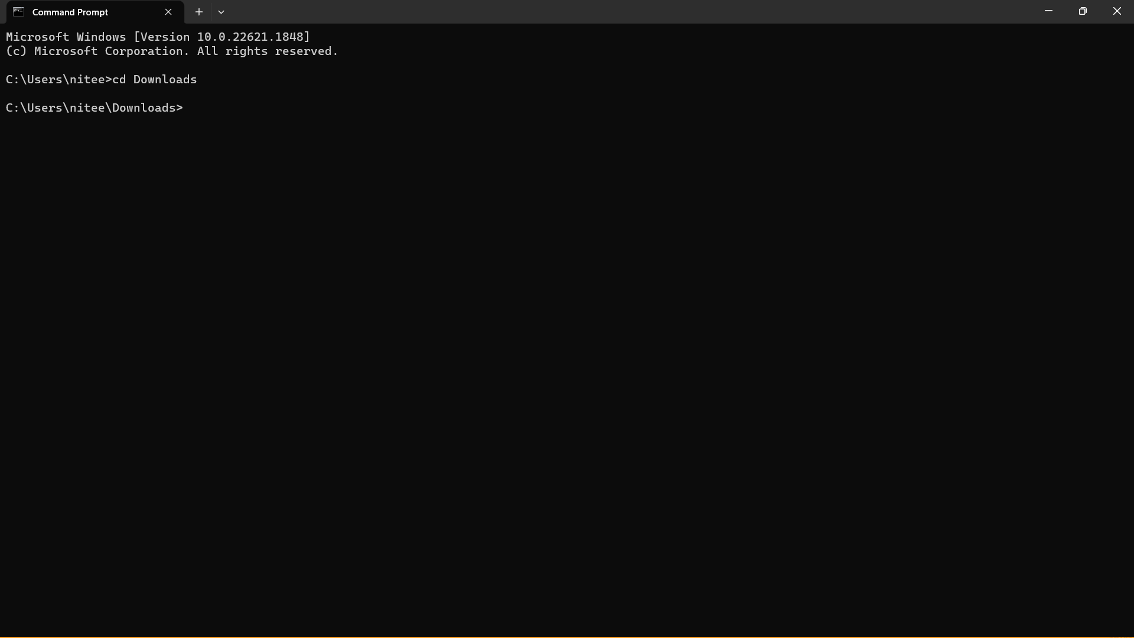

83)Now paste the command i.e., copied from SSH client click on enter.It will ask yes or no, type “yes” and click enter. now you are connected to instance with local machine.

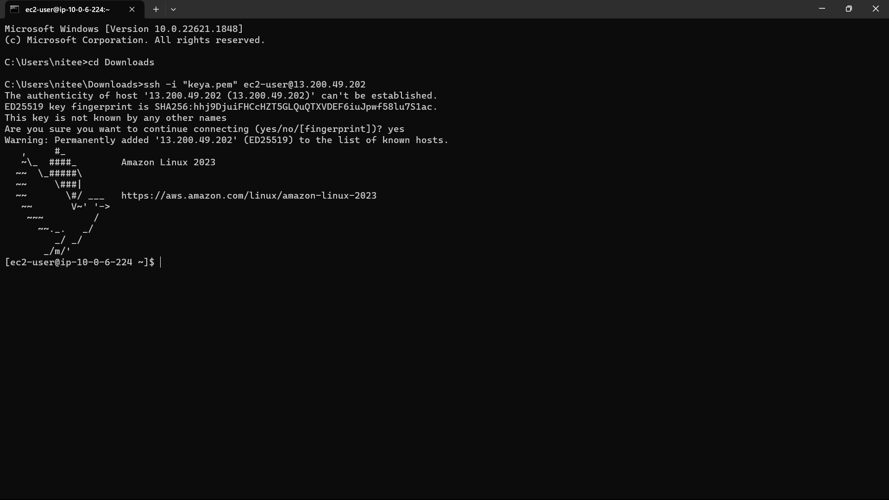

84)Open another command prompt and type the commands “cd downloads”

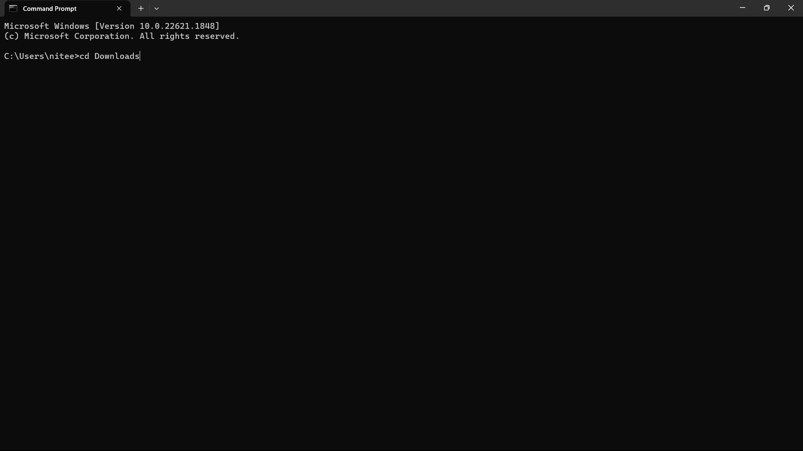

85)Type the “scp -I pemfil pemfile username@publicipv4address” i.e.,“scp -i keya.pem keya.pem [ec2-user@13.200.49.202](mailto:ec2-user@13.200.49.202)”.

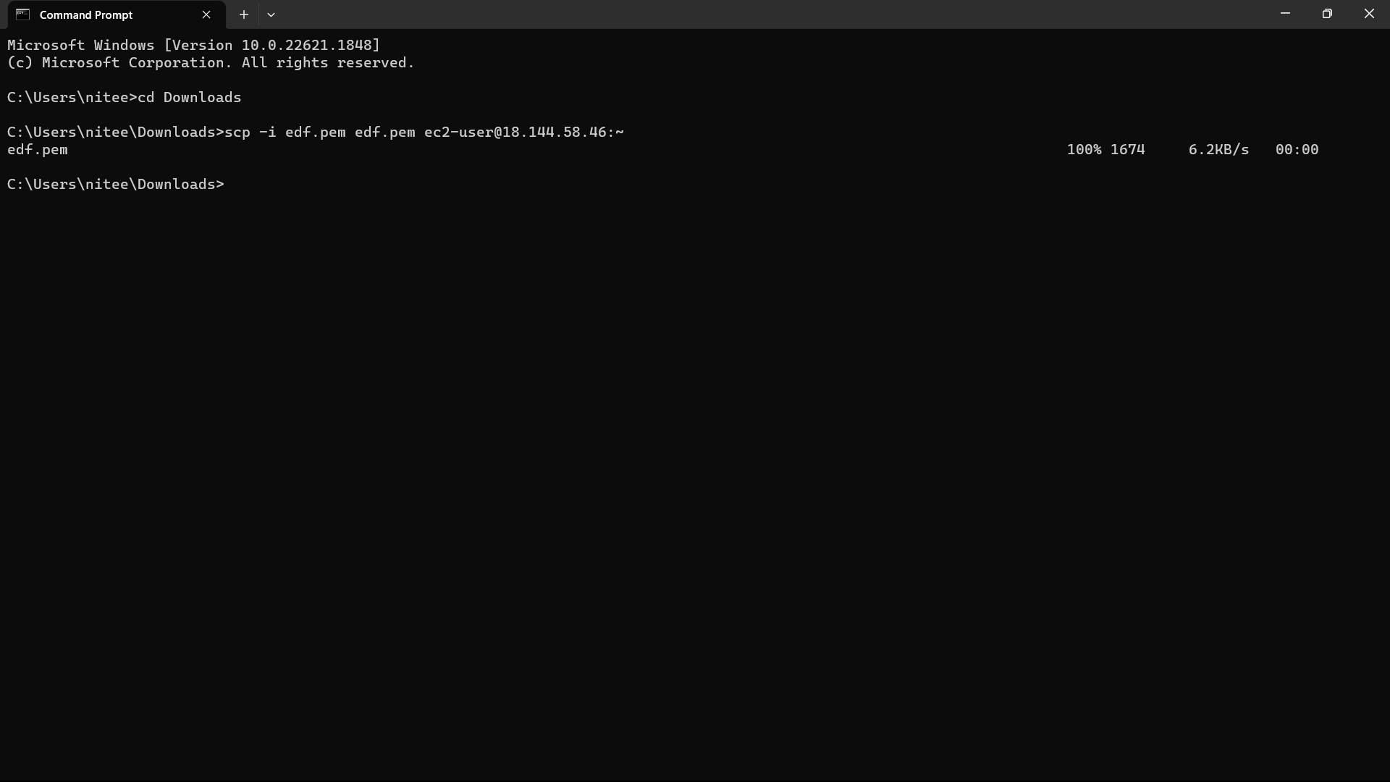

86)Now go to the instance and type command “ls”, now you can see the pem file in our instance now we have to change the permission of the file, the command “chmod 400 keya.pem”. now the permissions are changed. You can check it by using the command “ll”, Now go to the instance select the pvt-inst and click on “connect”, copy the command below “Example” and paste it in the instance and click on enter, type “yes” and click on enter, now we are connected to private instance.

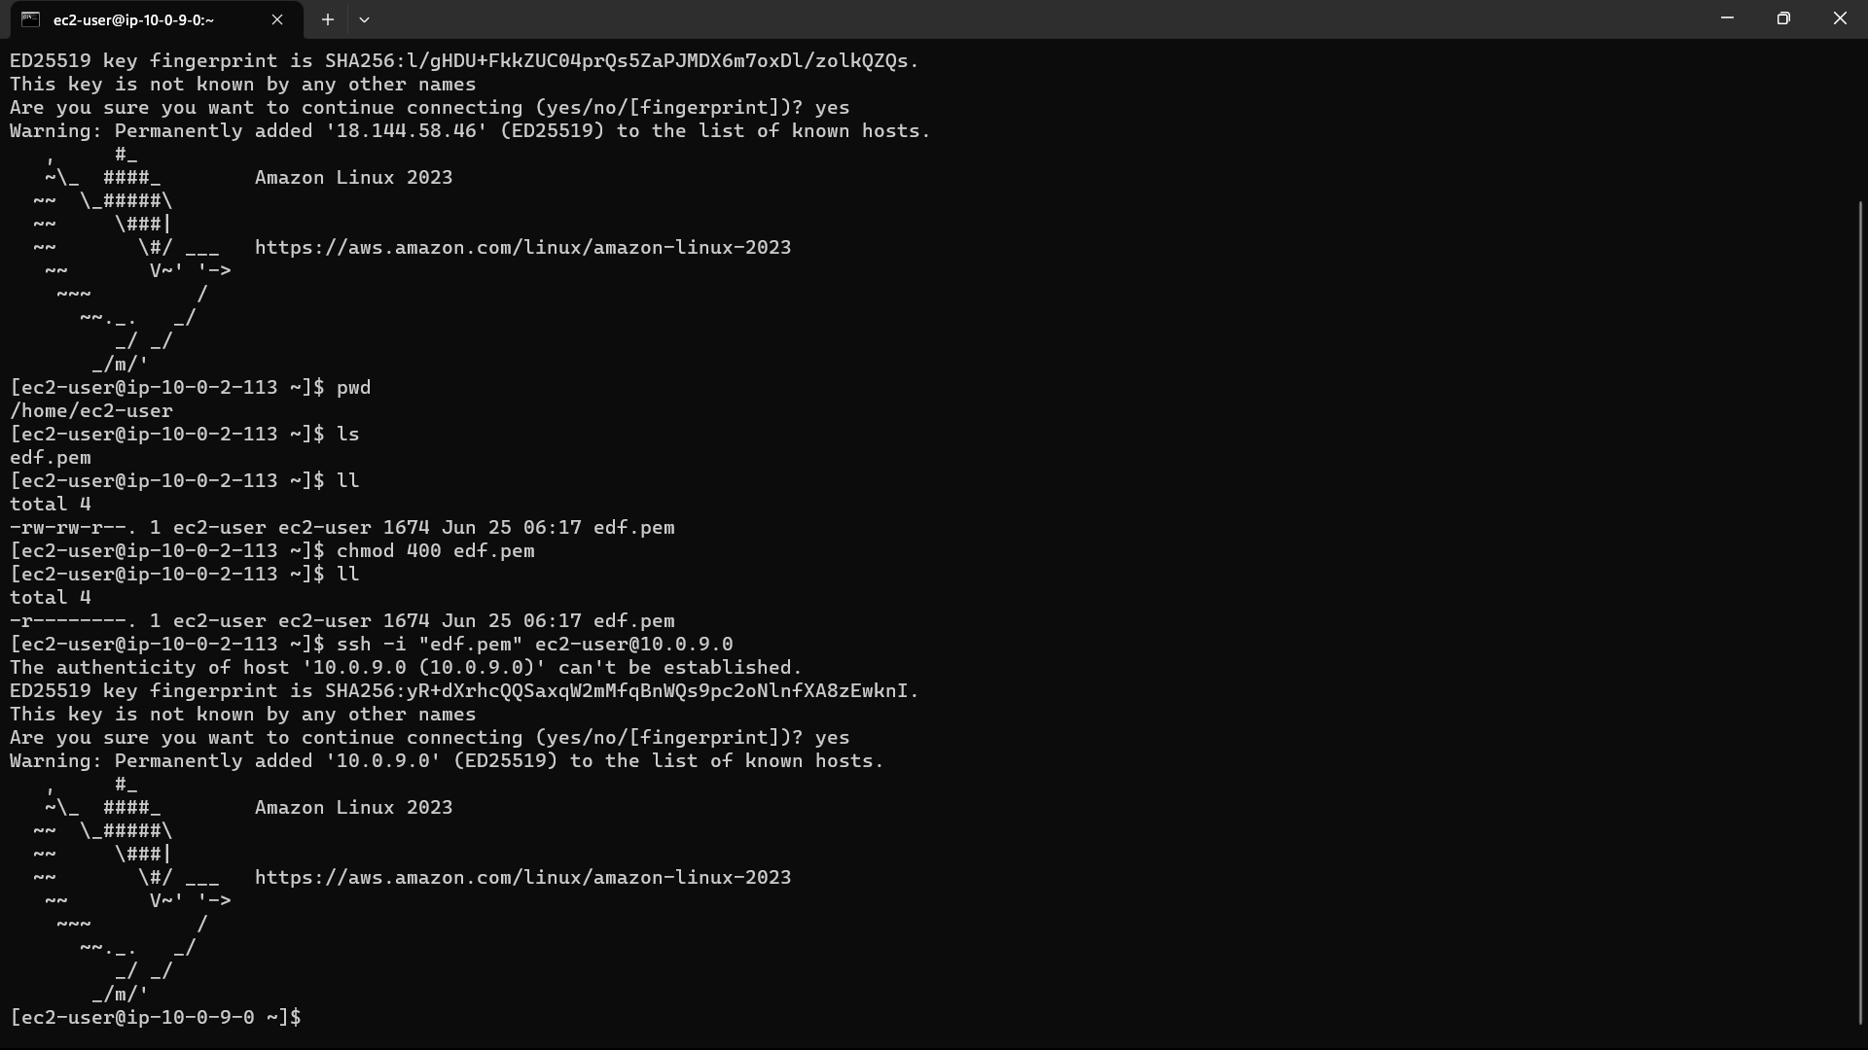

87)Install mysql in private instance you can get the commands form below link:“ [Connecting to a DB instance running the MySQL database engine - Amazon Relational Database Service](https://docs.aws.amazon.com/AmazonRDS/latest/UserGuide/USER_ConnectToInstance.html)” . install mysql using the commands “sudo dnf install mariadb105”.

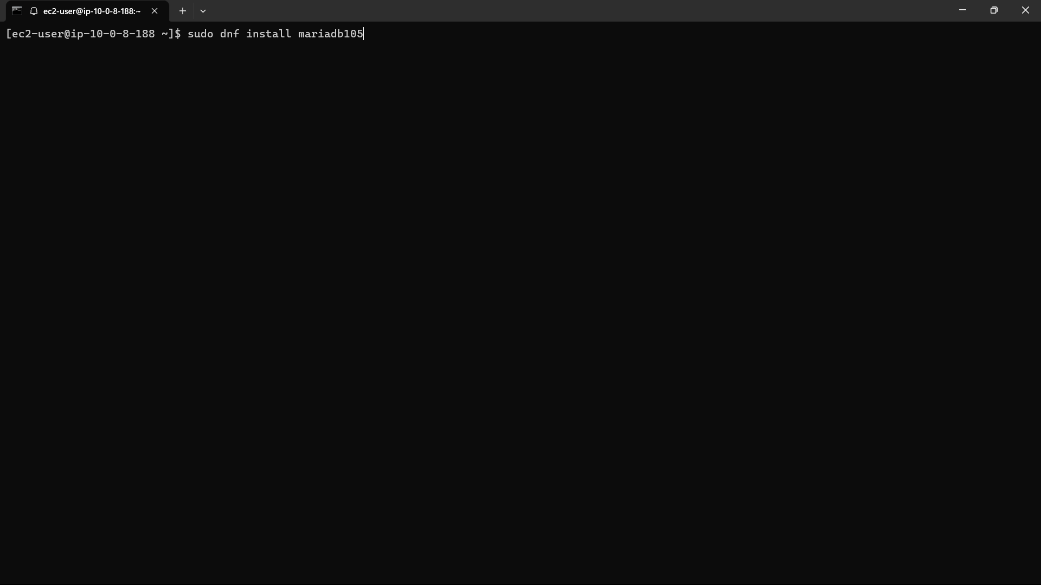

88) Go to database and select the database you created,On the **Connectivity & security** tab, copy the endpoint. Now type the command

mysql -h mysql–instance1.123456789012.us-east-1.rds.amazonaws.com -P 3306 -u mymasteruser -p.

after “-h” you to give your endpoint and after “-u” you have to give the username you give at “credential settings at the time of creation”.

And click on enter it will ask for password type the same password which is given in credential settings and click on enter.

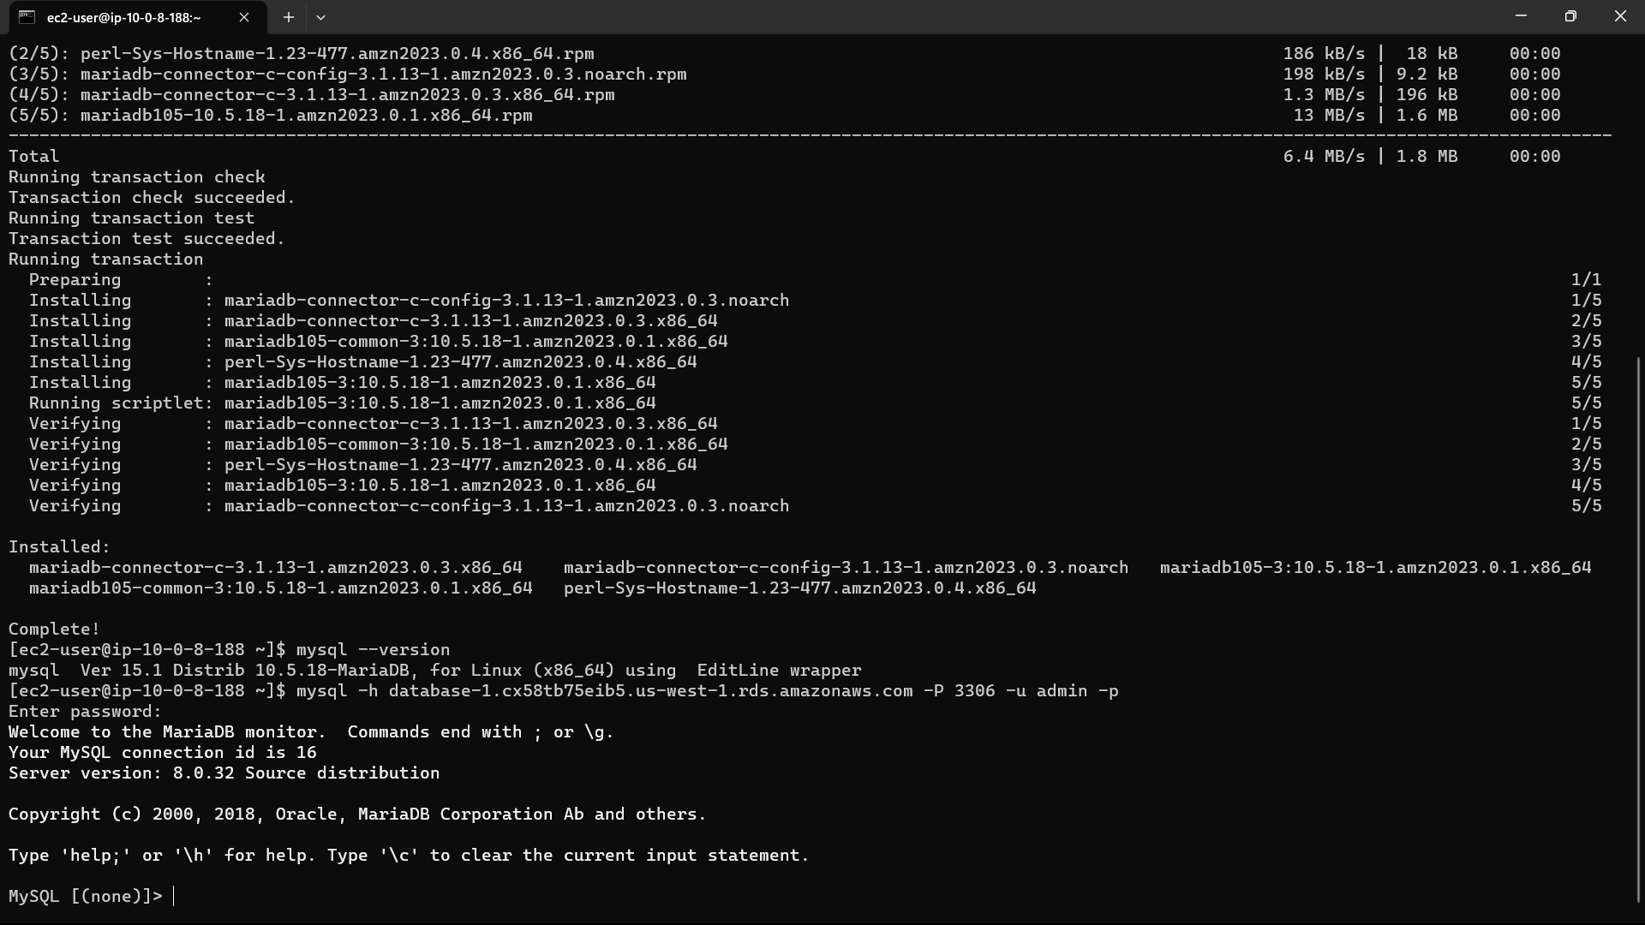

89)Type the mysql i.e., required to creat the user and grant privileges to the user. The required commands are also in the image.

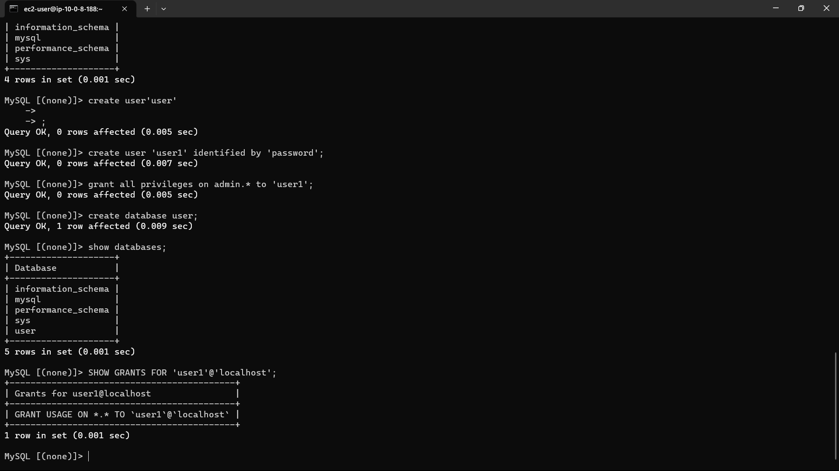

90)Now exit from the private instance by typing “exit”. Now we are in public instance.

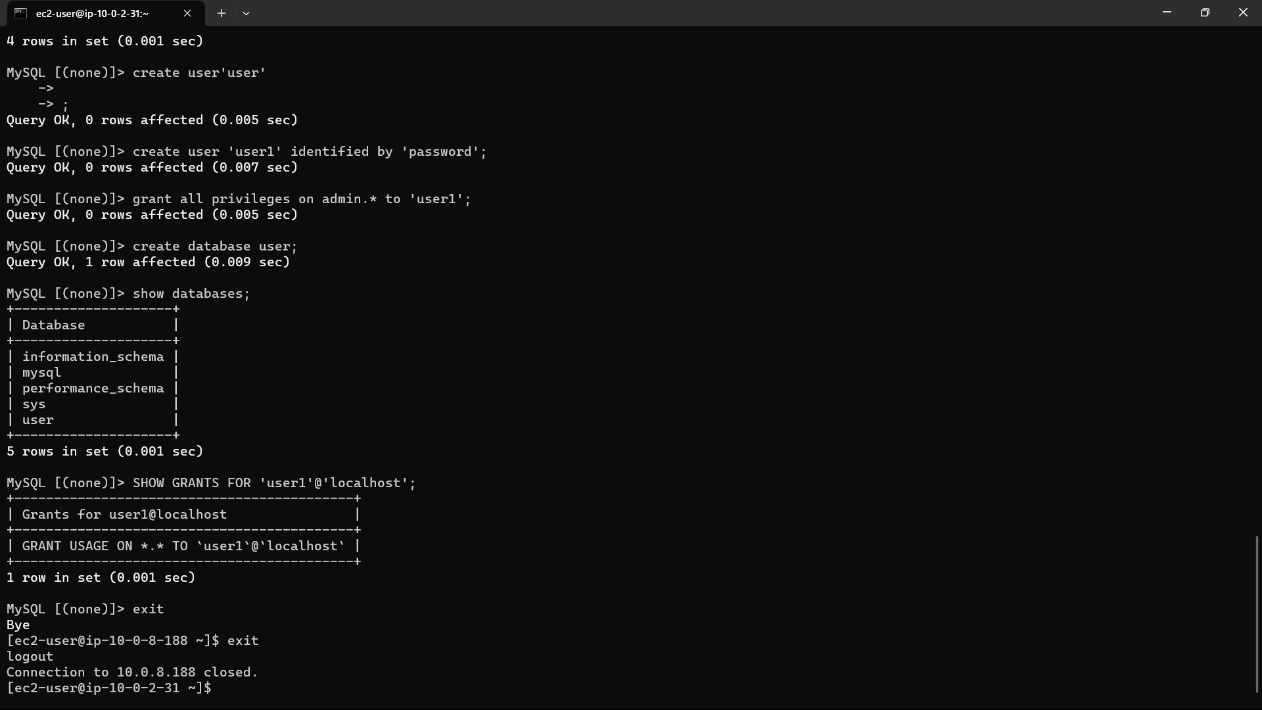

91)Copy the commands from below link and pste in pub-inst for installation and extraction of file.

<https://docs.aws.amazon.com/AWSEC2/latest/UserGuide/hosting-wordpress.html>.

And navigate to the extracted file using the commands “cd reponame”

“cd wordpress”.

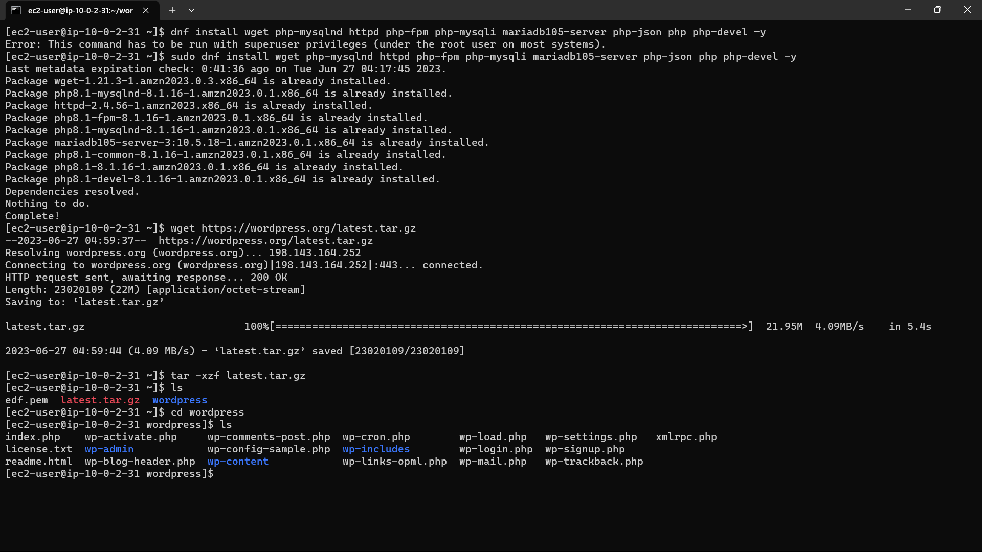

92)Now copy “wp-sample-config.php” to another new file “wp-config.php”

By using the command in the image below. Before using the commands using “cd” and after using the commands navigate to repo again using “cd wordpress”.Before going to the wordpress install httpd in the instance using below commands:

“sudo yum install -y httpd”

“sudo systemctl start httpd”

“sudo systemctl enable httpd”

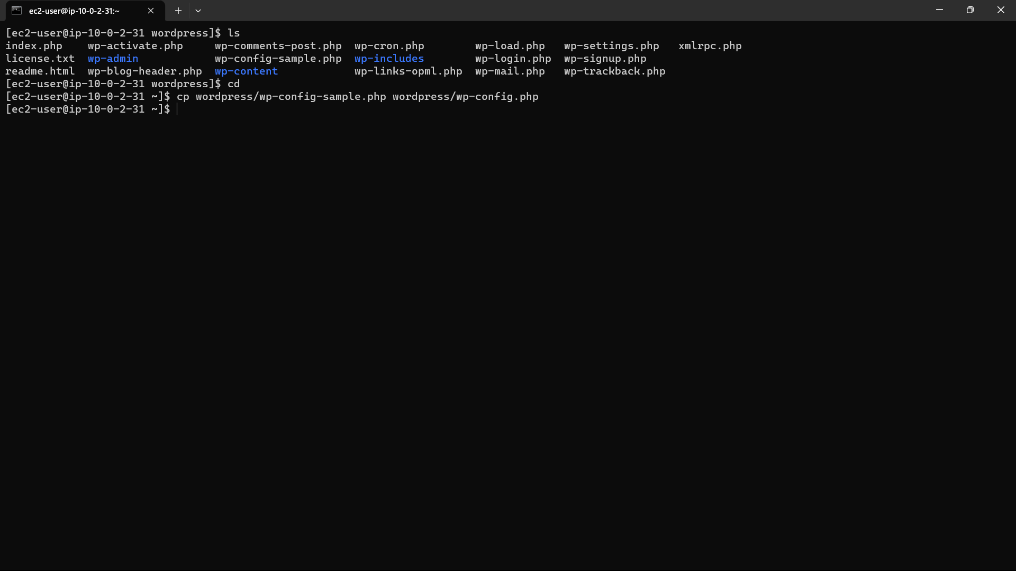

93)Type the command “vi wp-config.php”. and click on “Insert” button form keyboard.

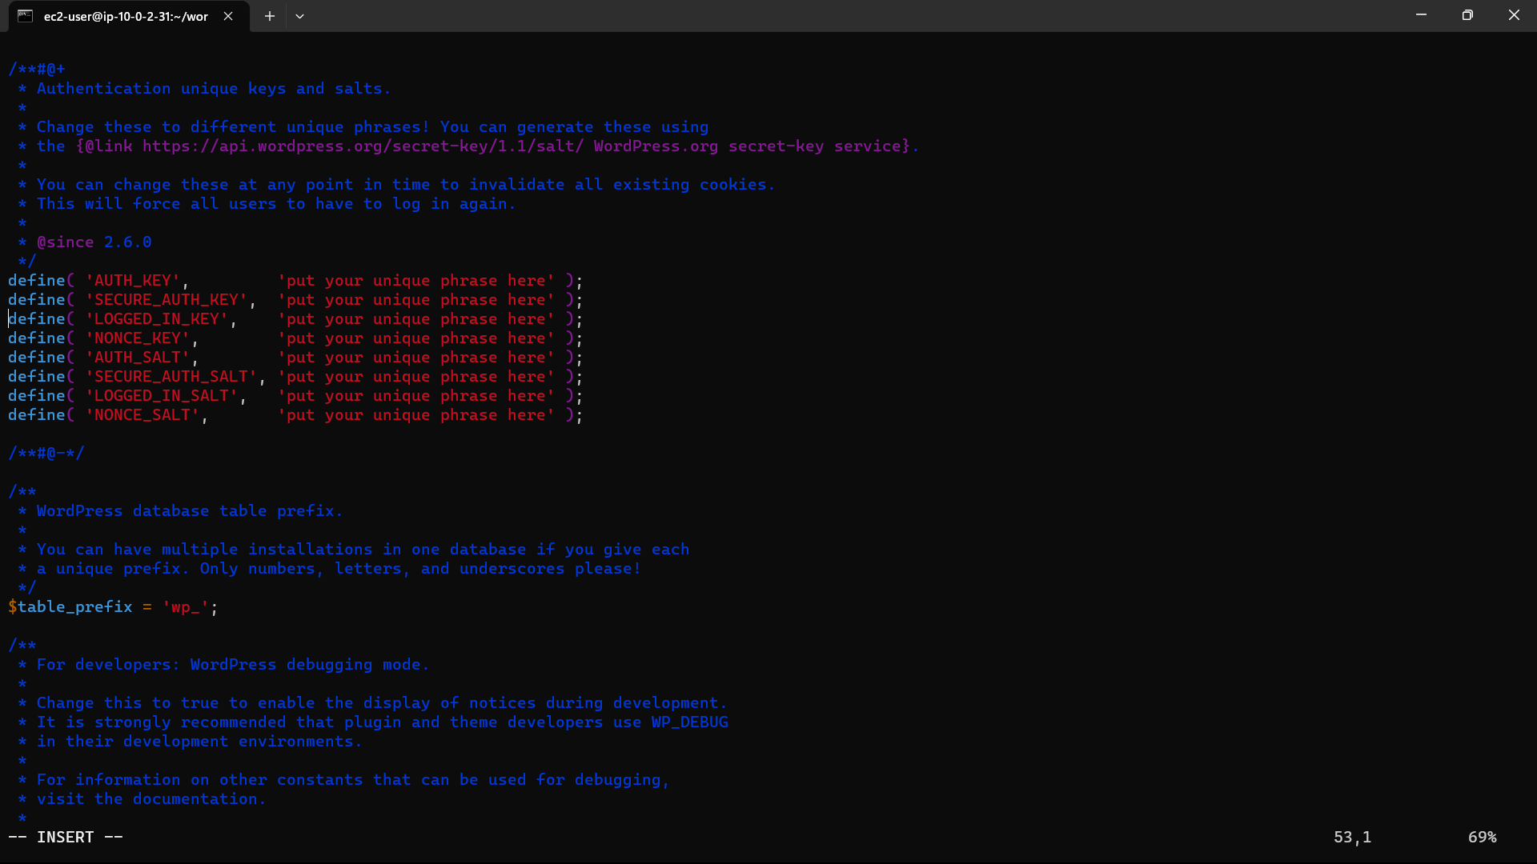

94) Copy the content from the link:[api.wordpress.org/secret-key/1.1/salt/](https://api.wordpress.org/secret-key/1.1/salt/) and replace the lines blow the “*/” to “/**#@-*/”. Click on “esc” button and shift+:wq and click on enter from keyboard.

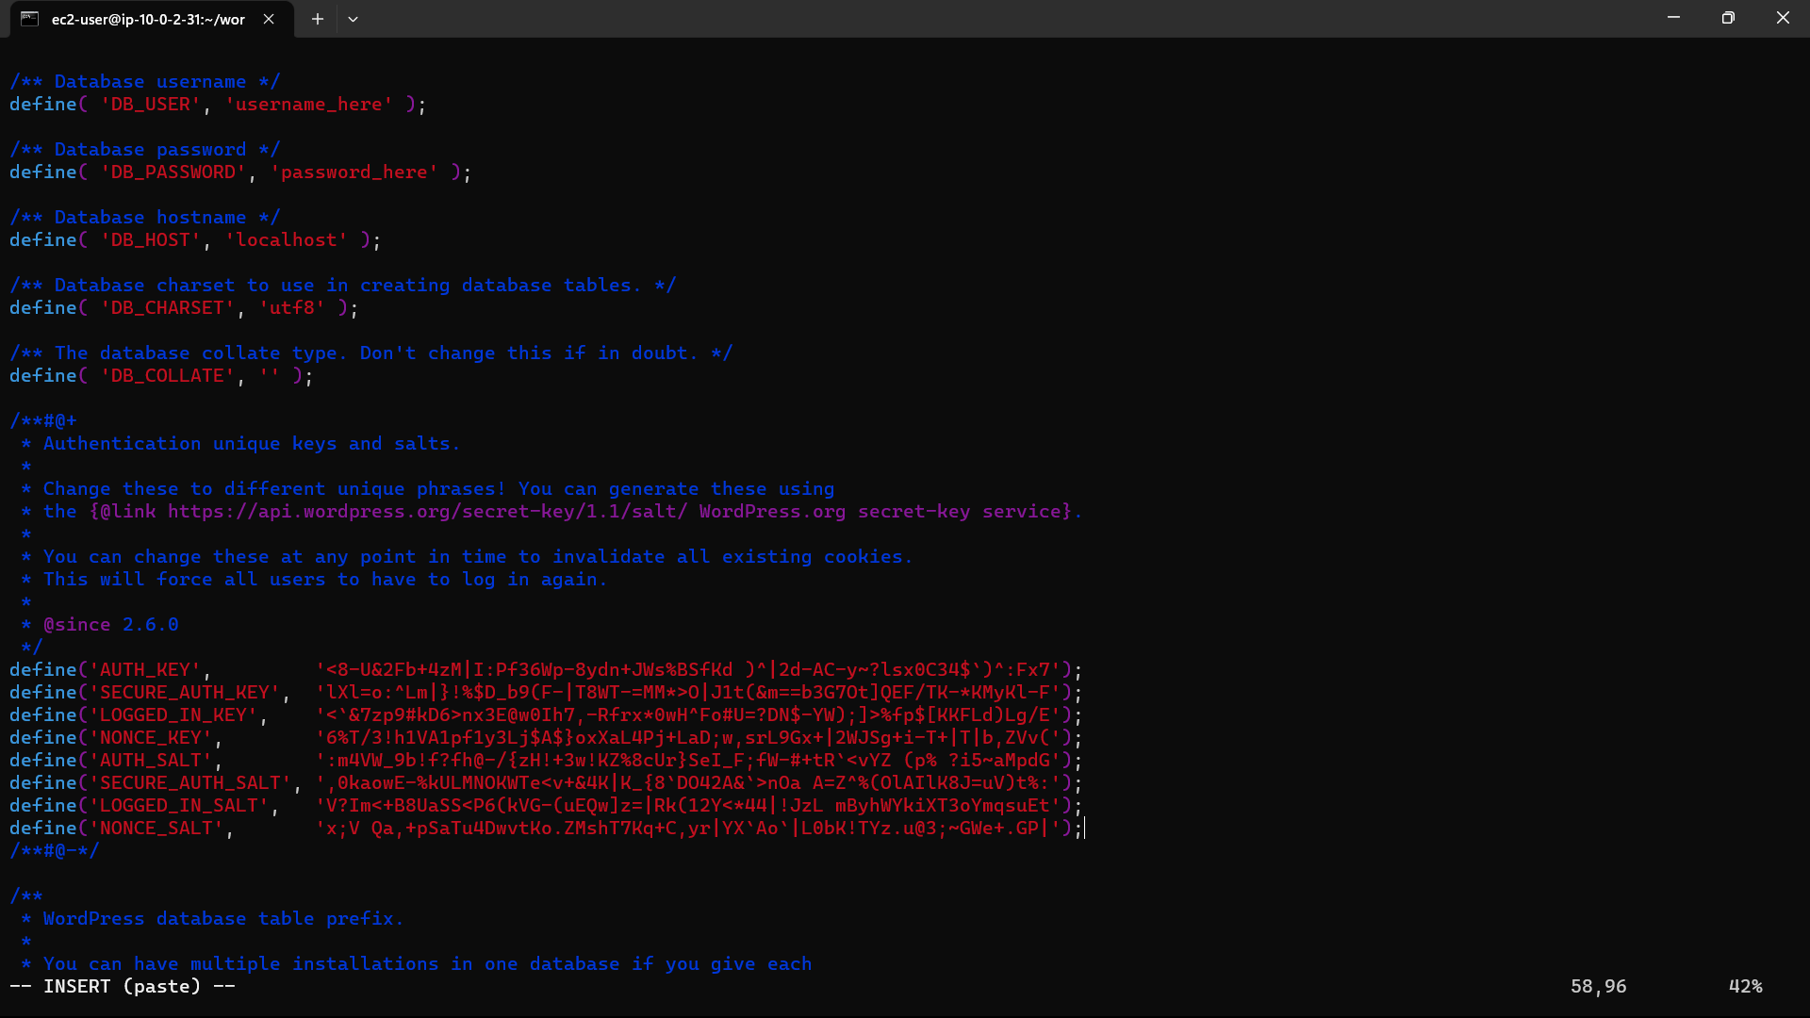

95) Now copy all the files to https default path “/var/www/html” by using the command

“sudo cp -r * pathname” -: “sudo cp -r * /var/www/html”.

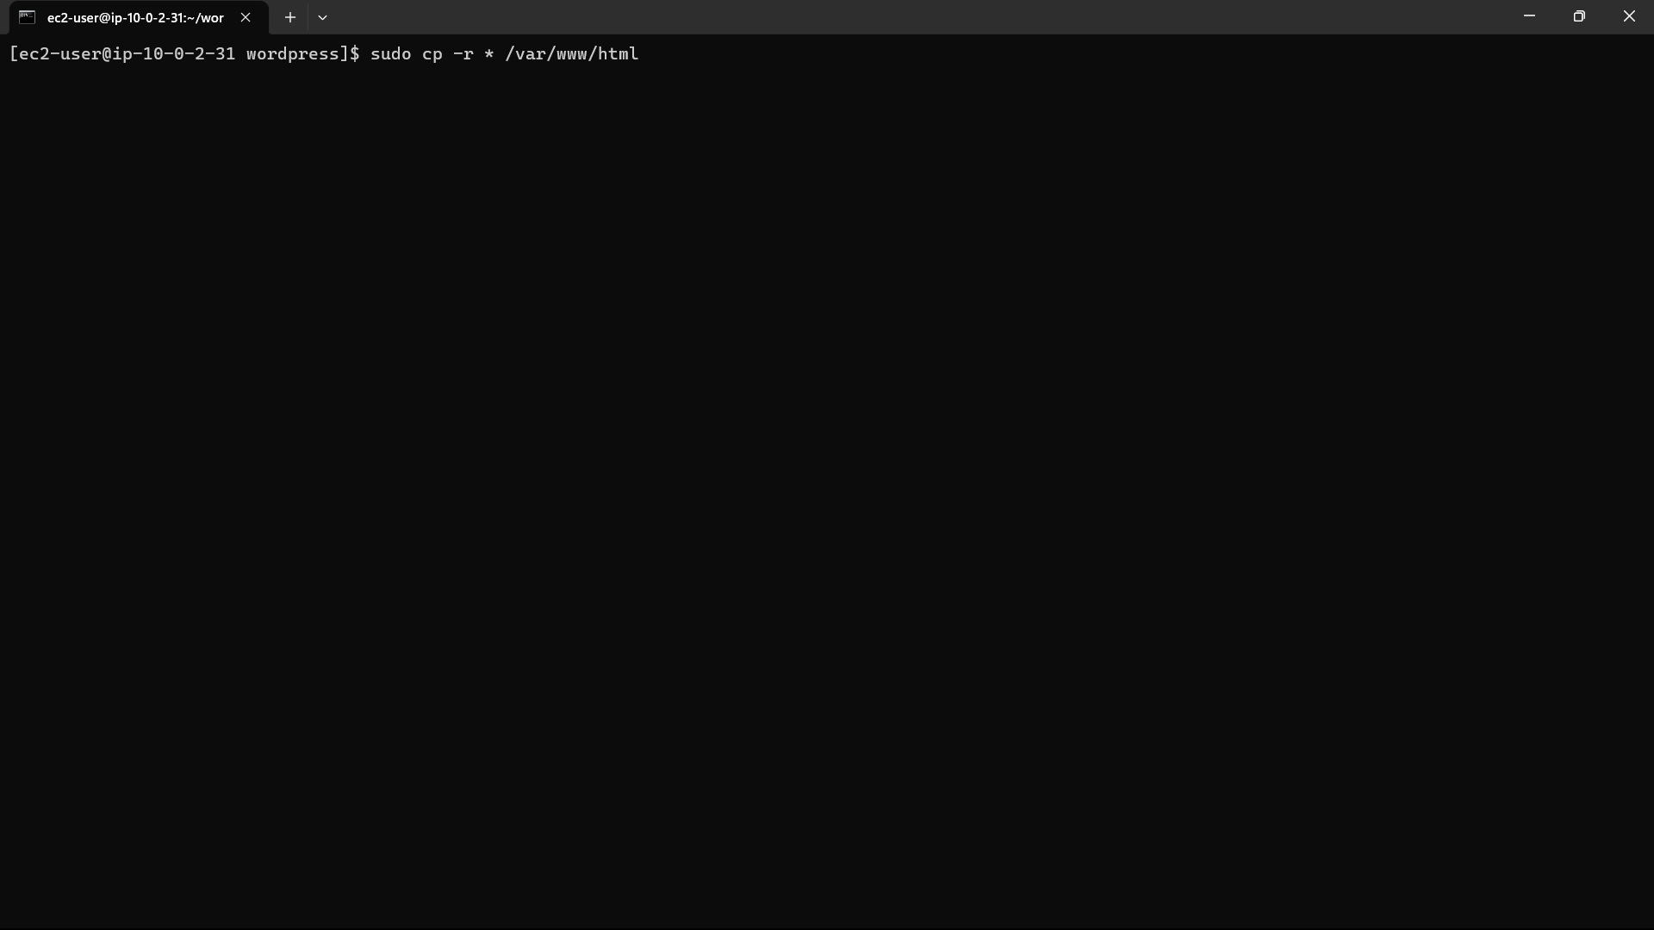

96)Now go the path and check whether the file are copied or not ny using the commands below: ‘cd /var/www/html”

“ls”

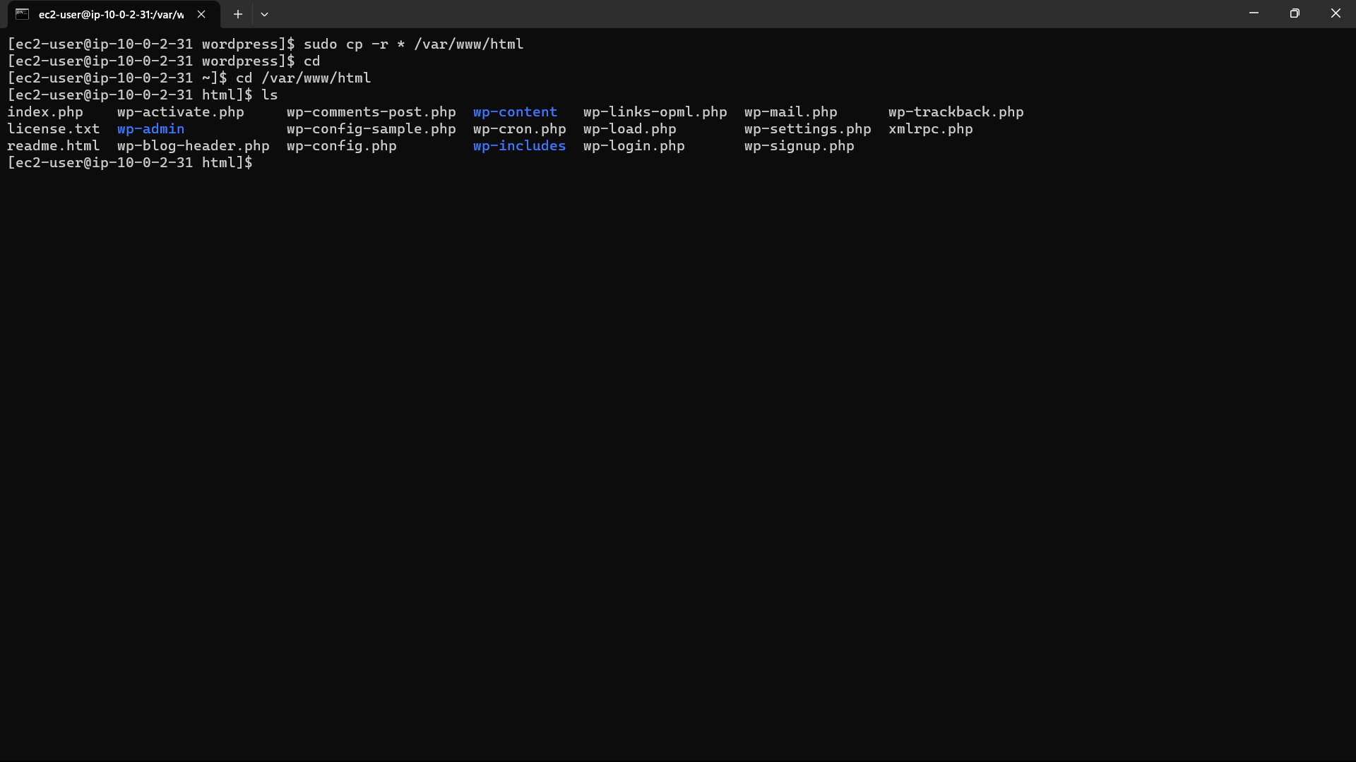

97)Go to instances and copy the publicipv4 address of “pub-inst” and paste it in a browser. If you get error add “:80” to the address. Now you can see the wordpress web page.

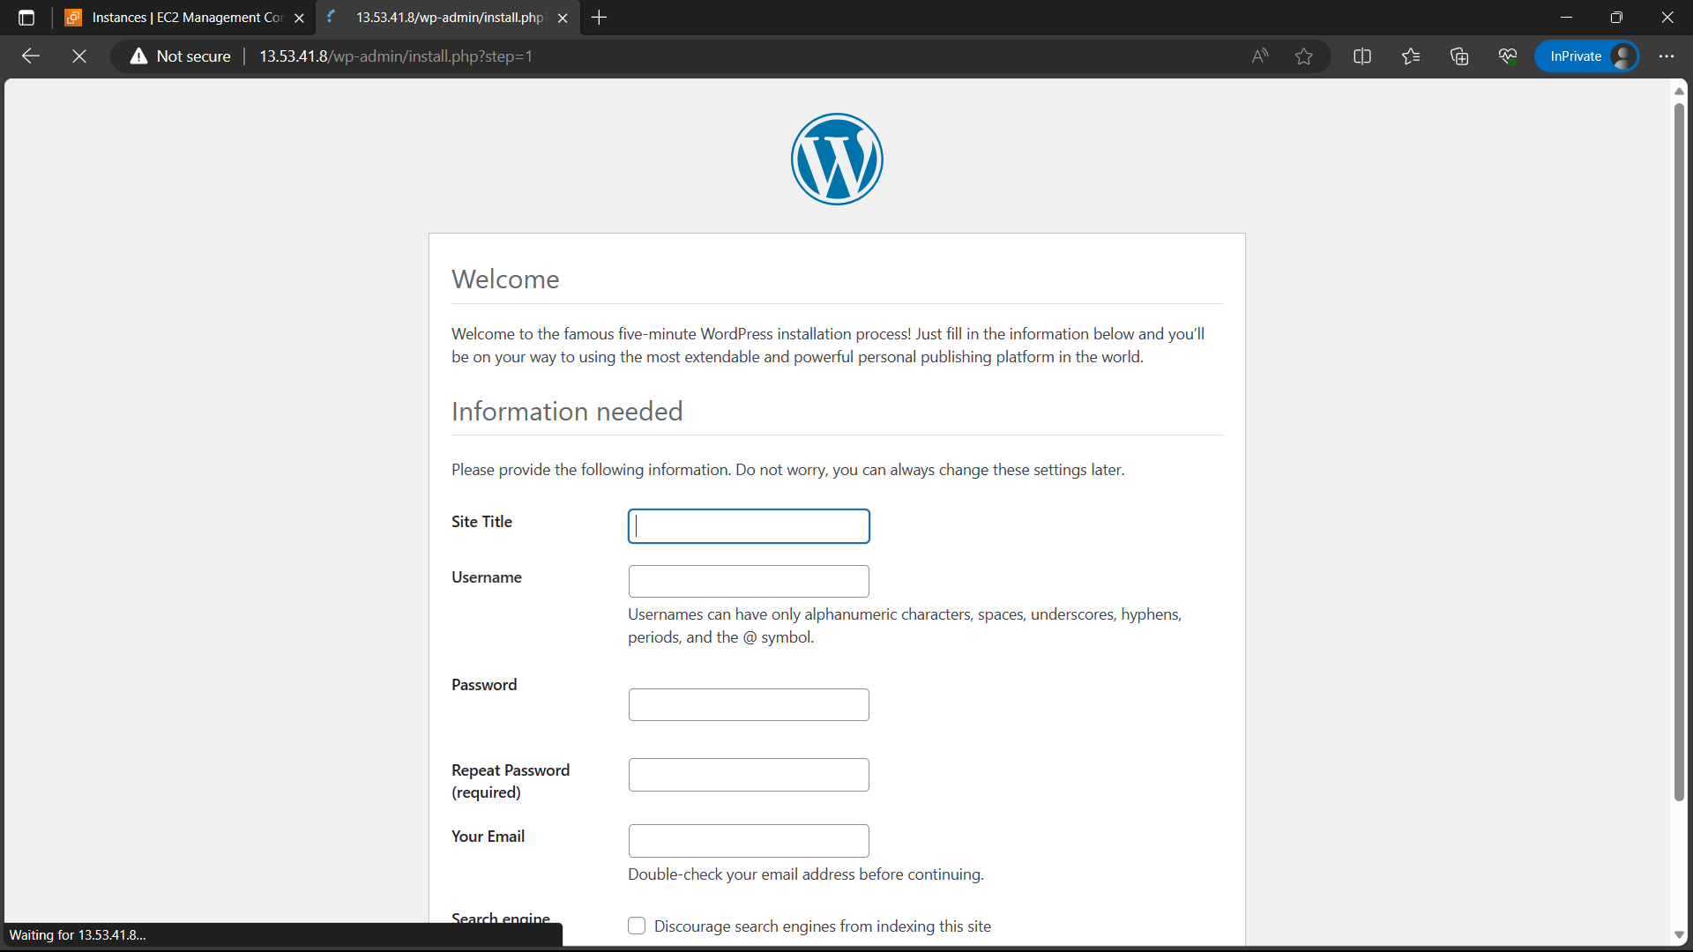

98)Install git in instance using the command “sudo yum install -y git”.

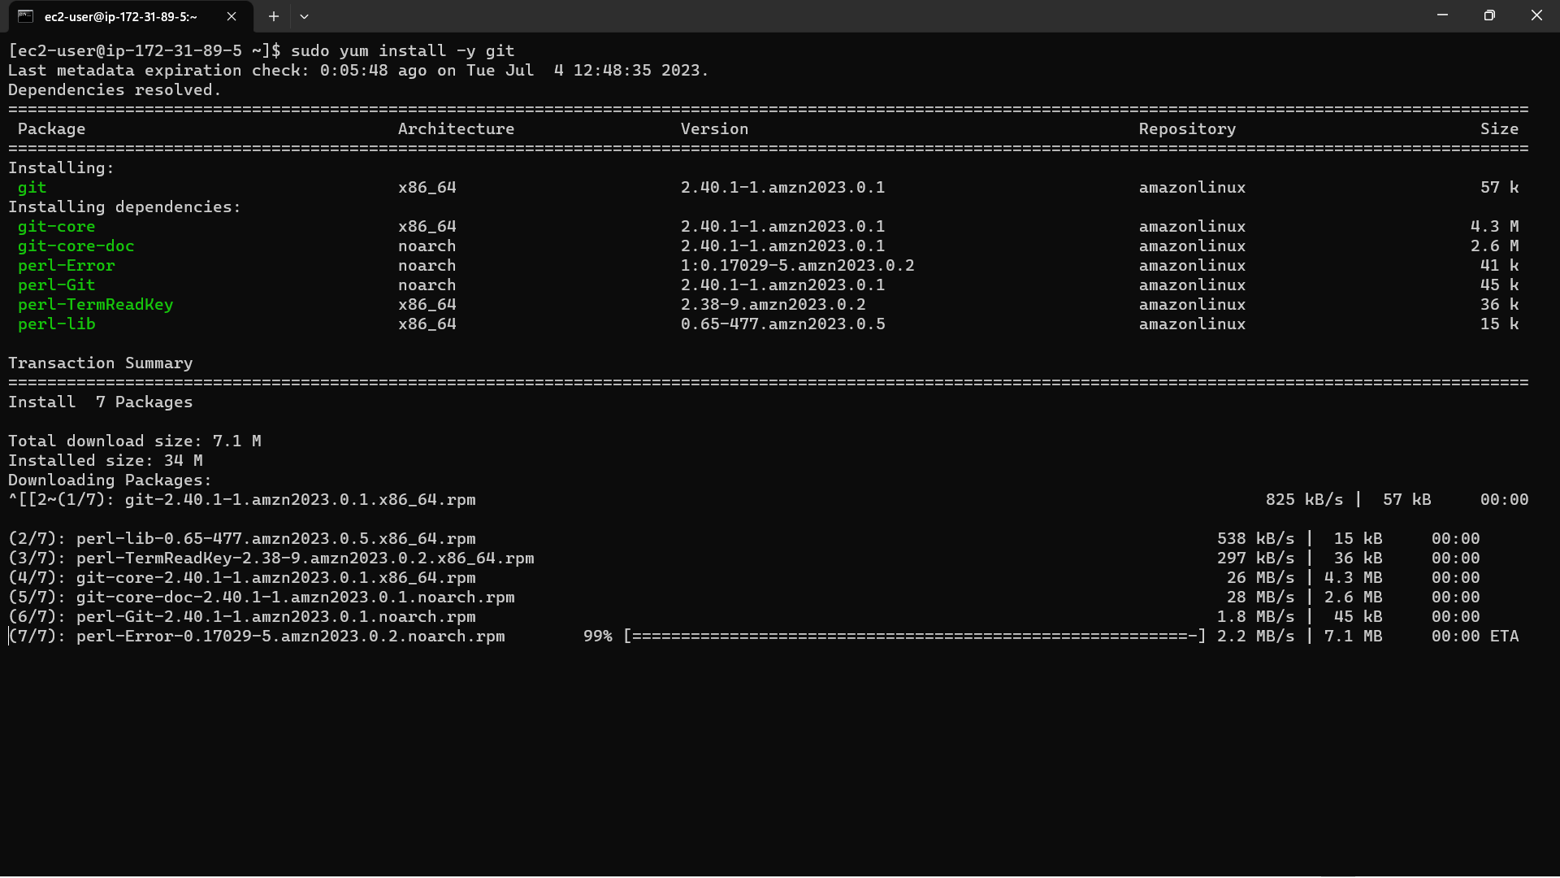

99)Login to Github and create a new repository, give name to the repository and click on create repository

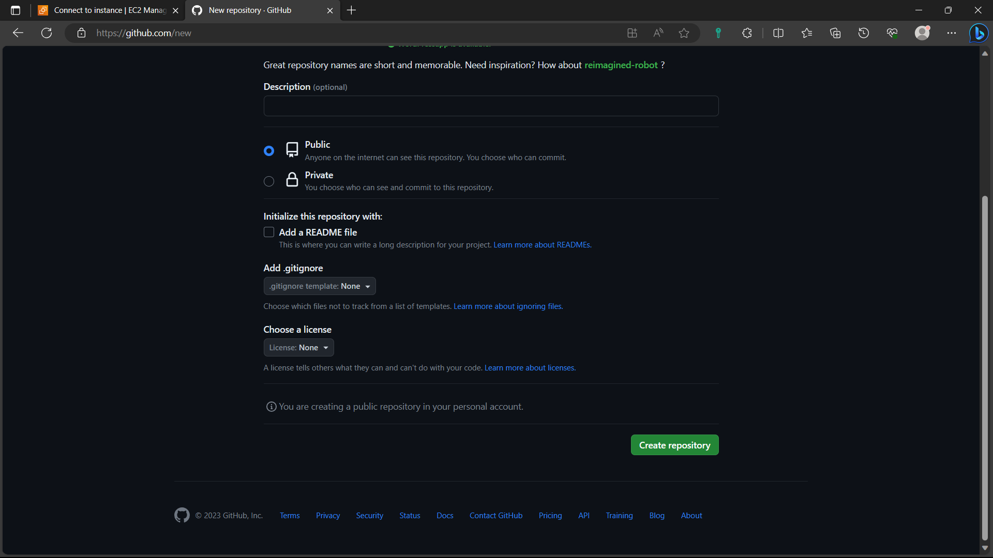

100)Clone the environment in your local machine using the command “sudo git clone repo URL”

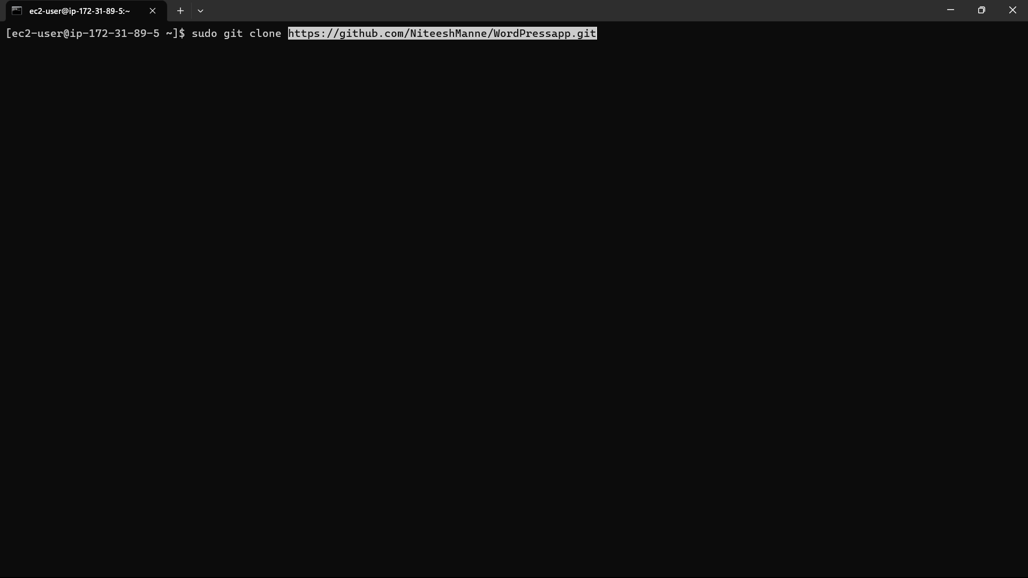

101)Initialize it using the command “git init repo” and move the file from wordpress to git repo in your local machine using the command in below image.

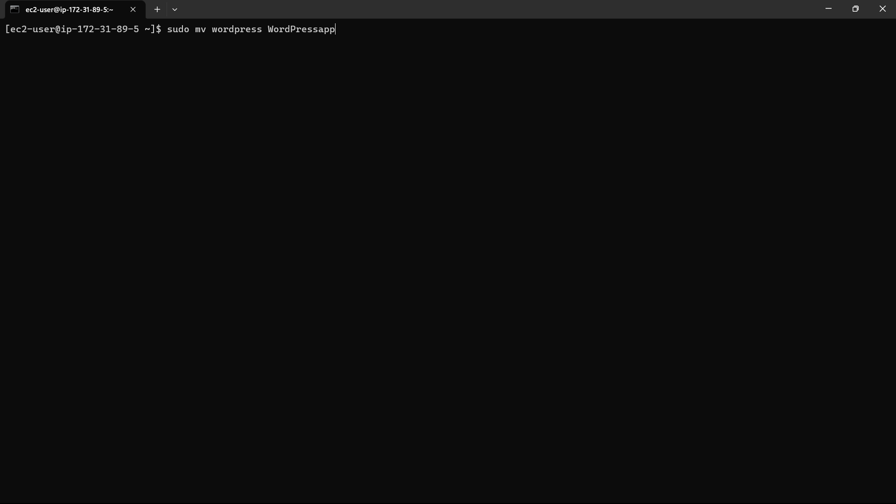

102)Now push the files to github using the commands below.

Git add <filename>

Git commit -m “message”

Git push -u origin main

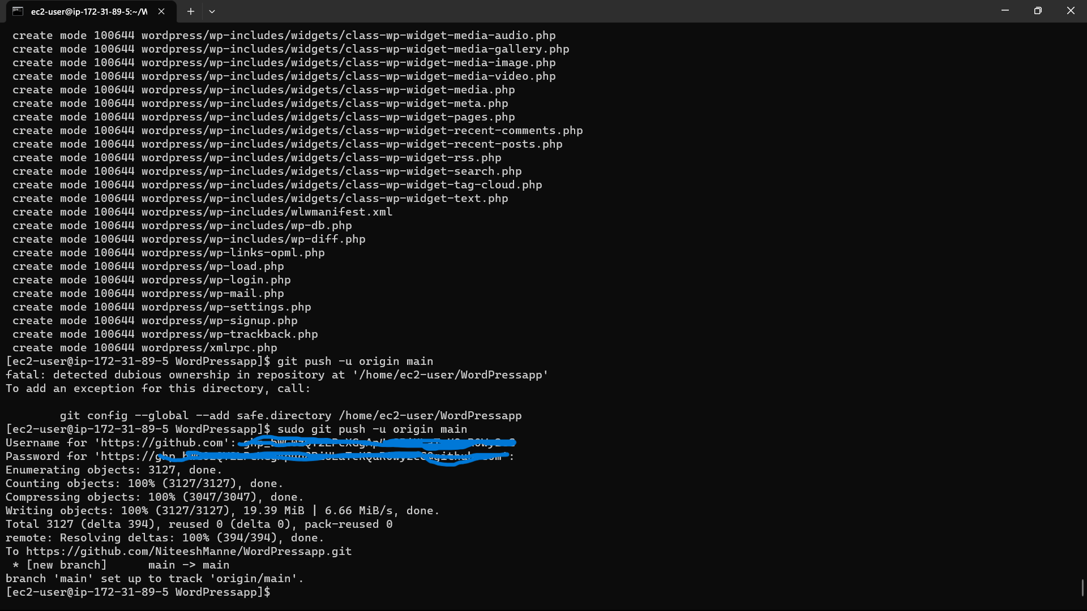

103)Now refresh the github page you can see the files in github.

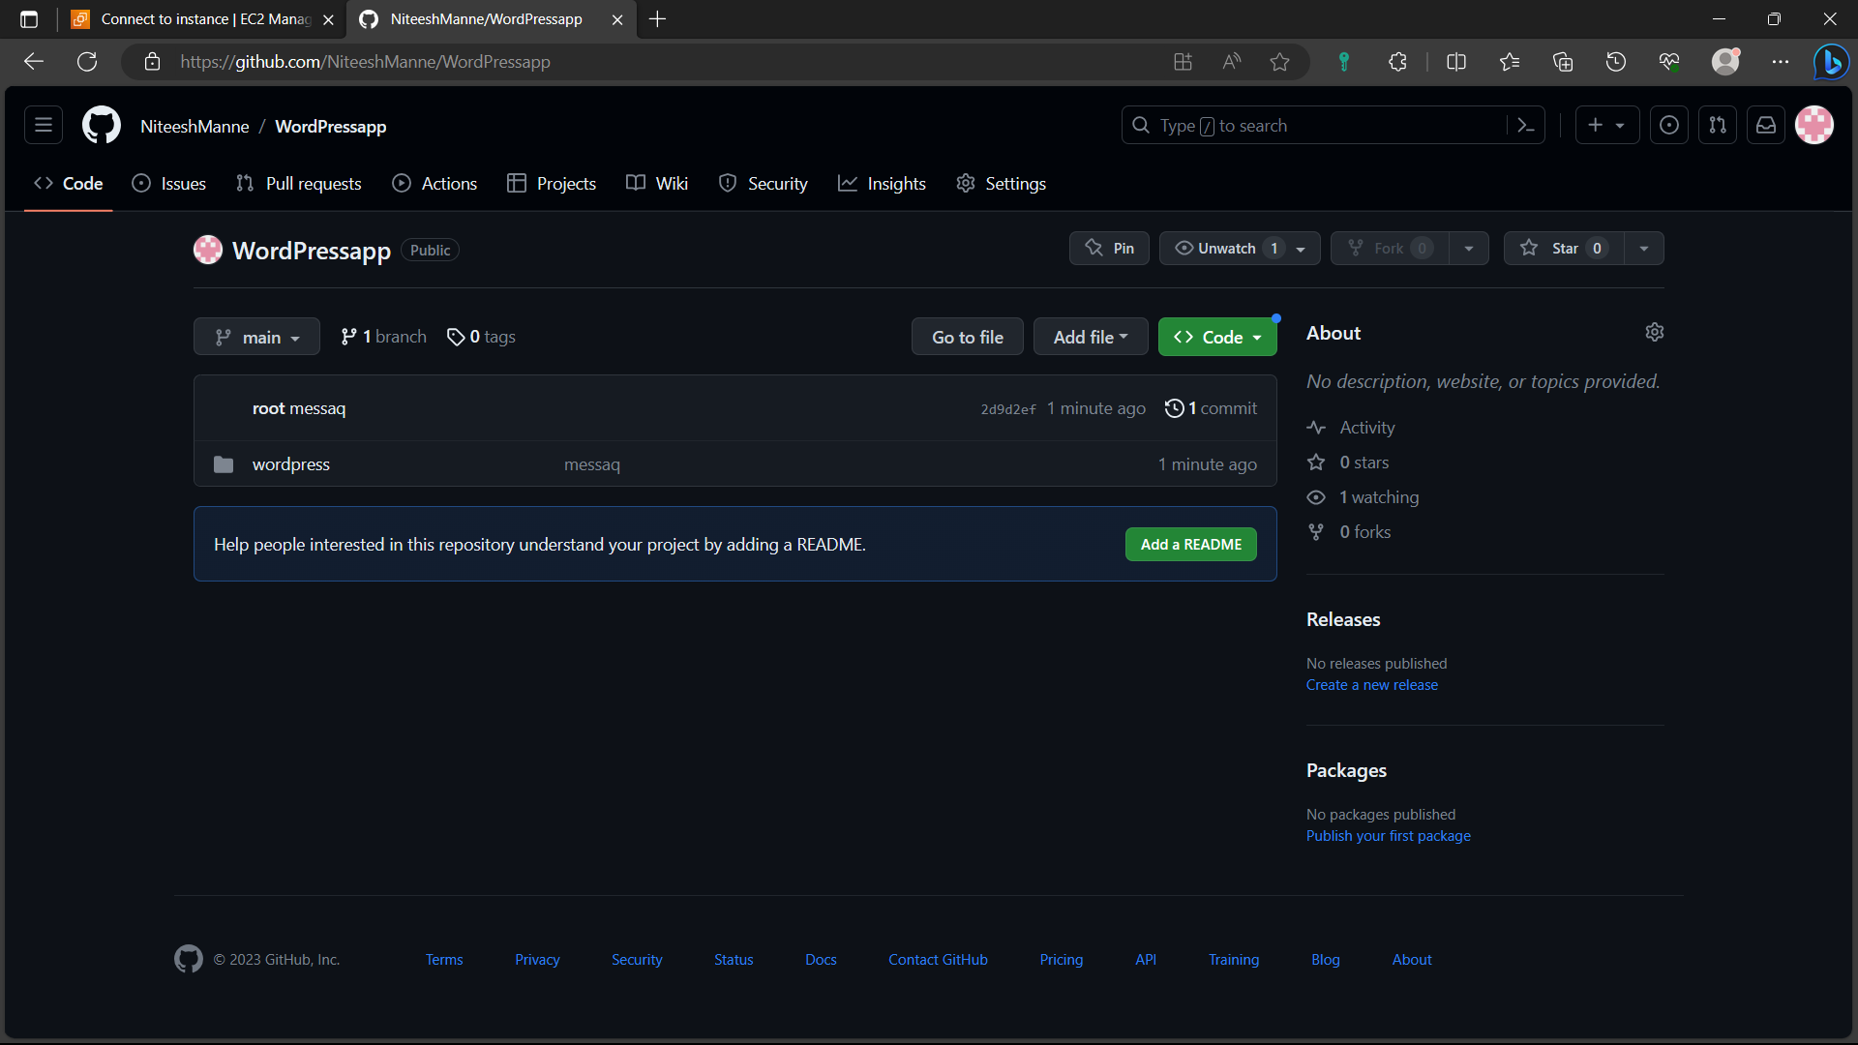

104)Create another instance in AWS by following the steps:(49-55).

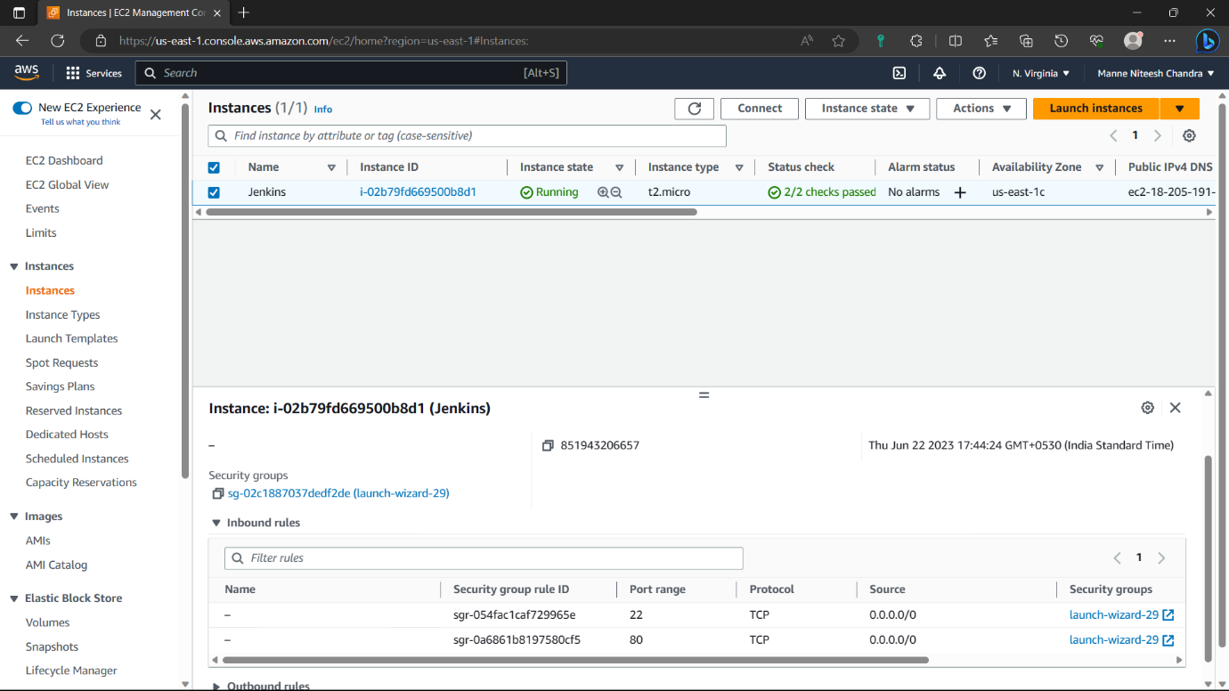

105)Access the instance in you’re local machine by following the steps : (79-83)

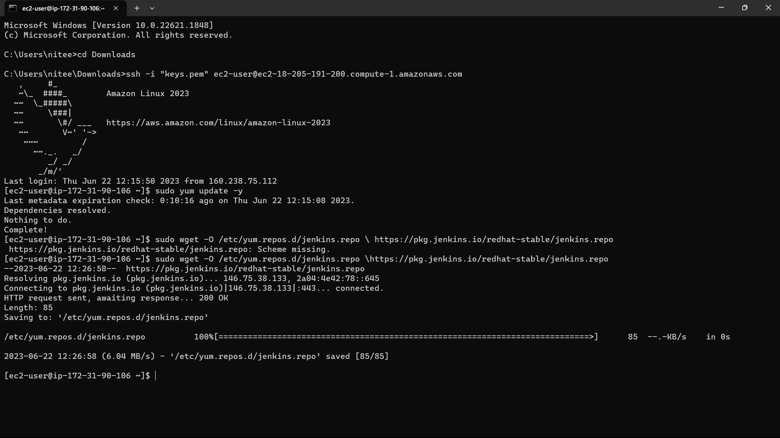

106) <https://www.jenkins.io/doc/tutorials/tutorial-for-installing-jenkins-on-AWS/>. Paste this link in the browse and copy the installation commands and paste in you’re instance.

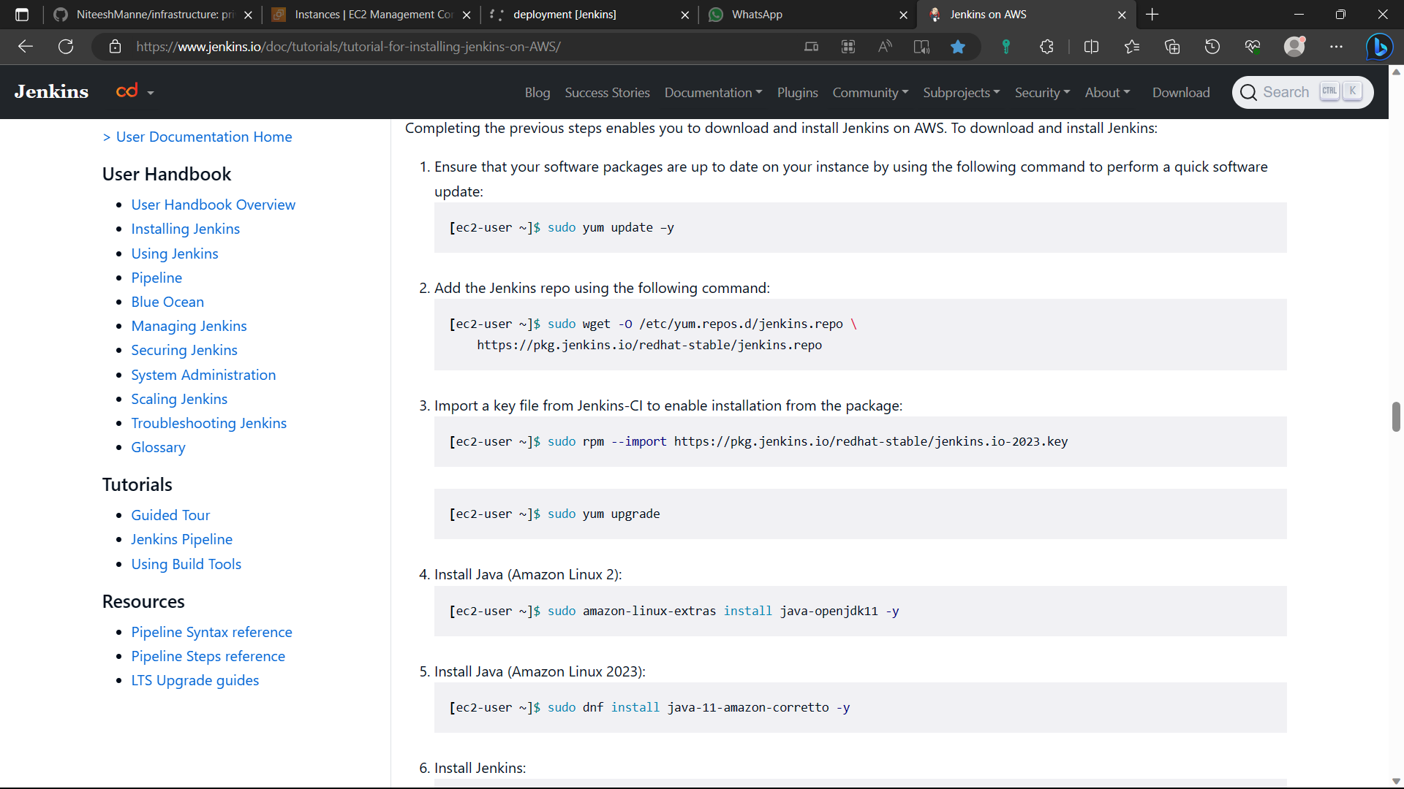

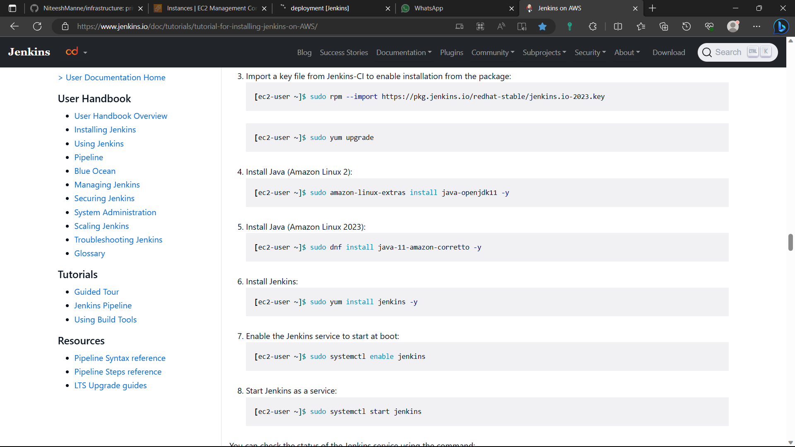

107)The Jenkins is installed in the instance.

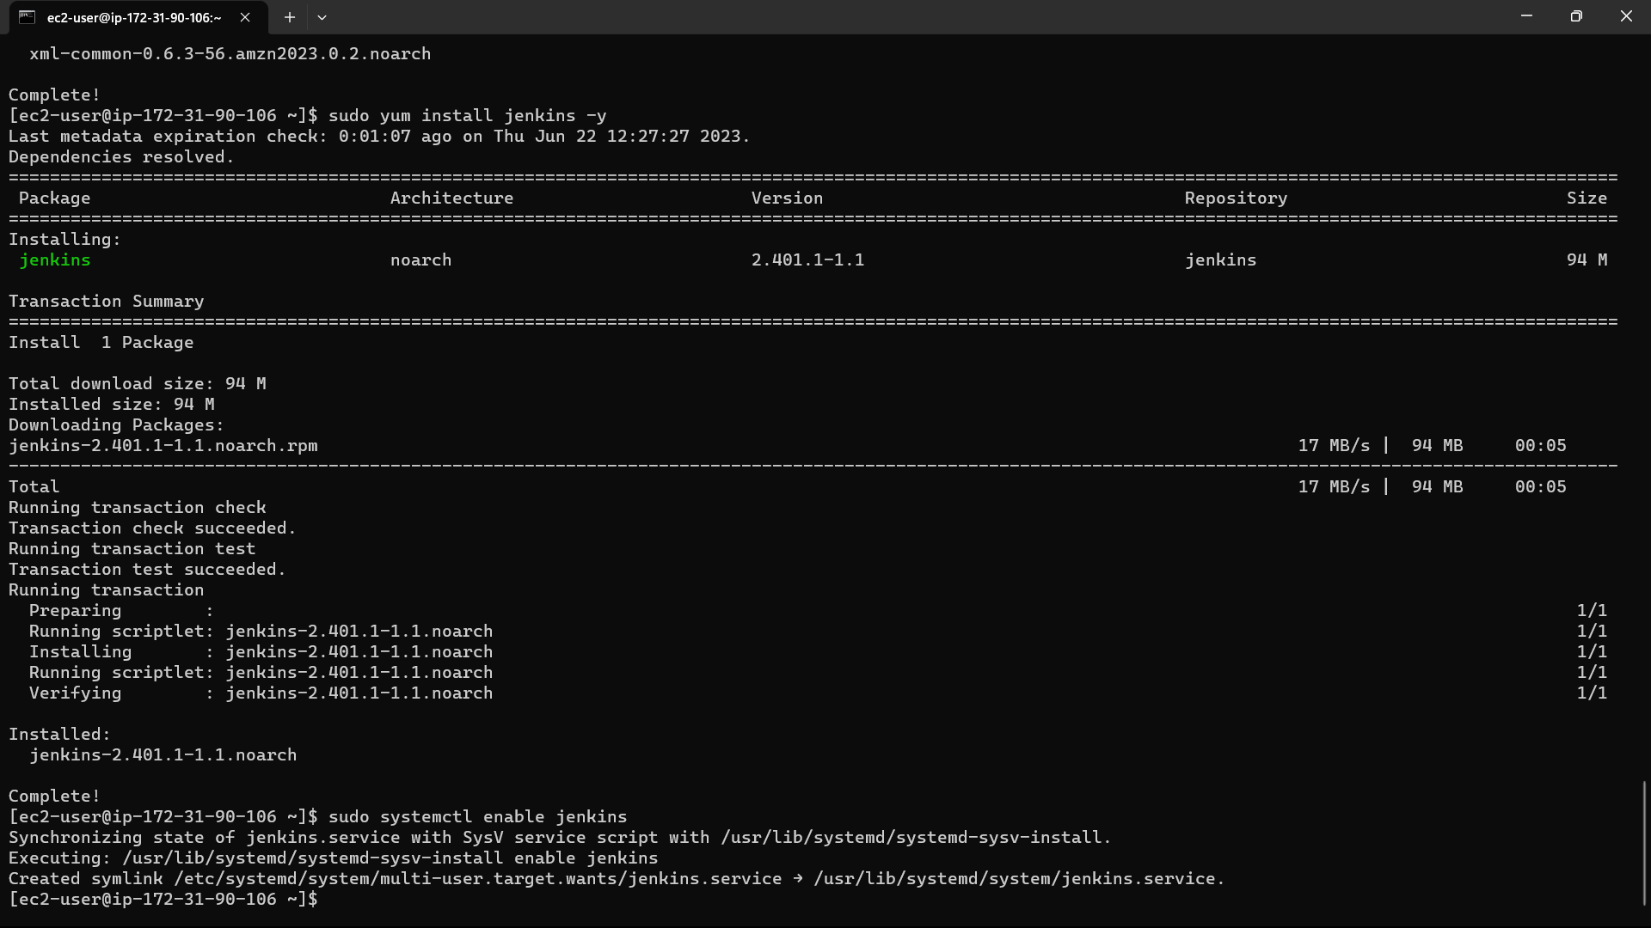

108)Now install git in the instance using the command “sudo yum install -y git”.

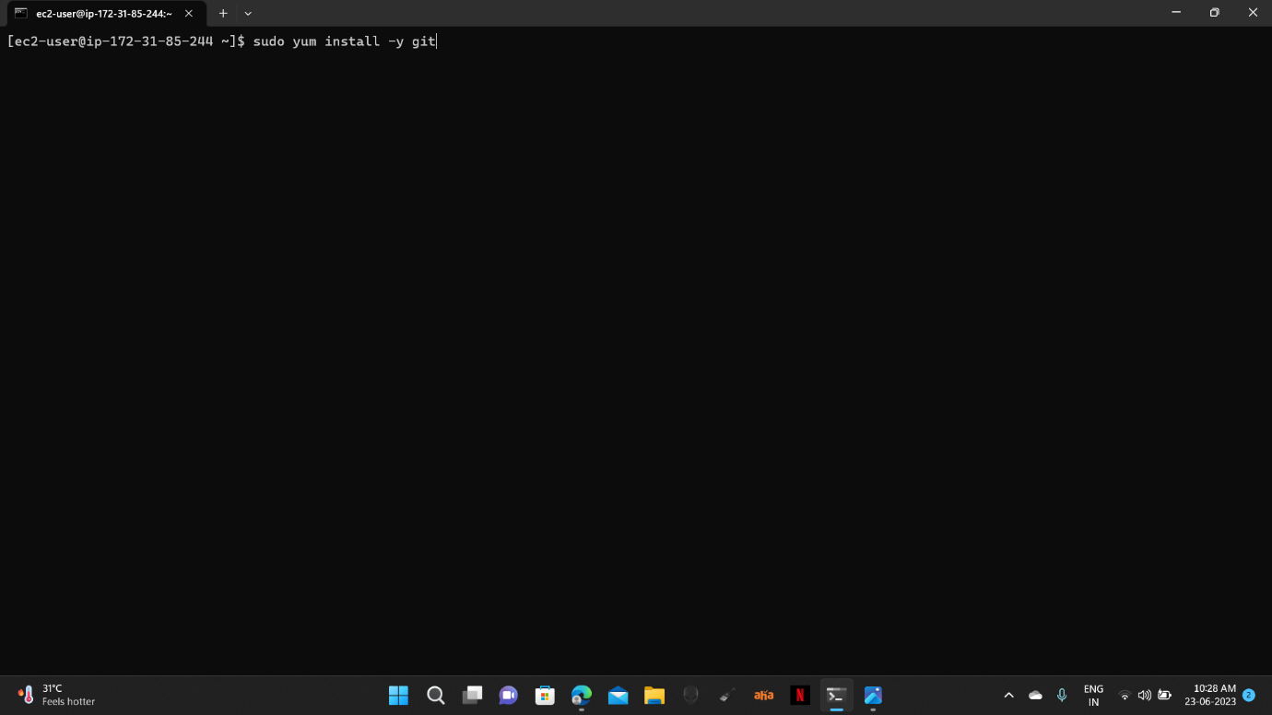

109)Now type the command “sudo visudo” for linux file.

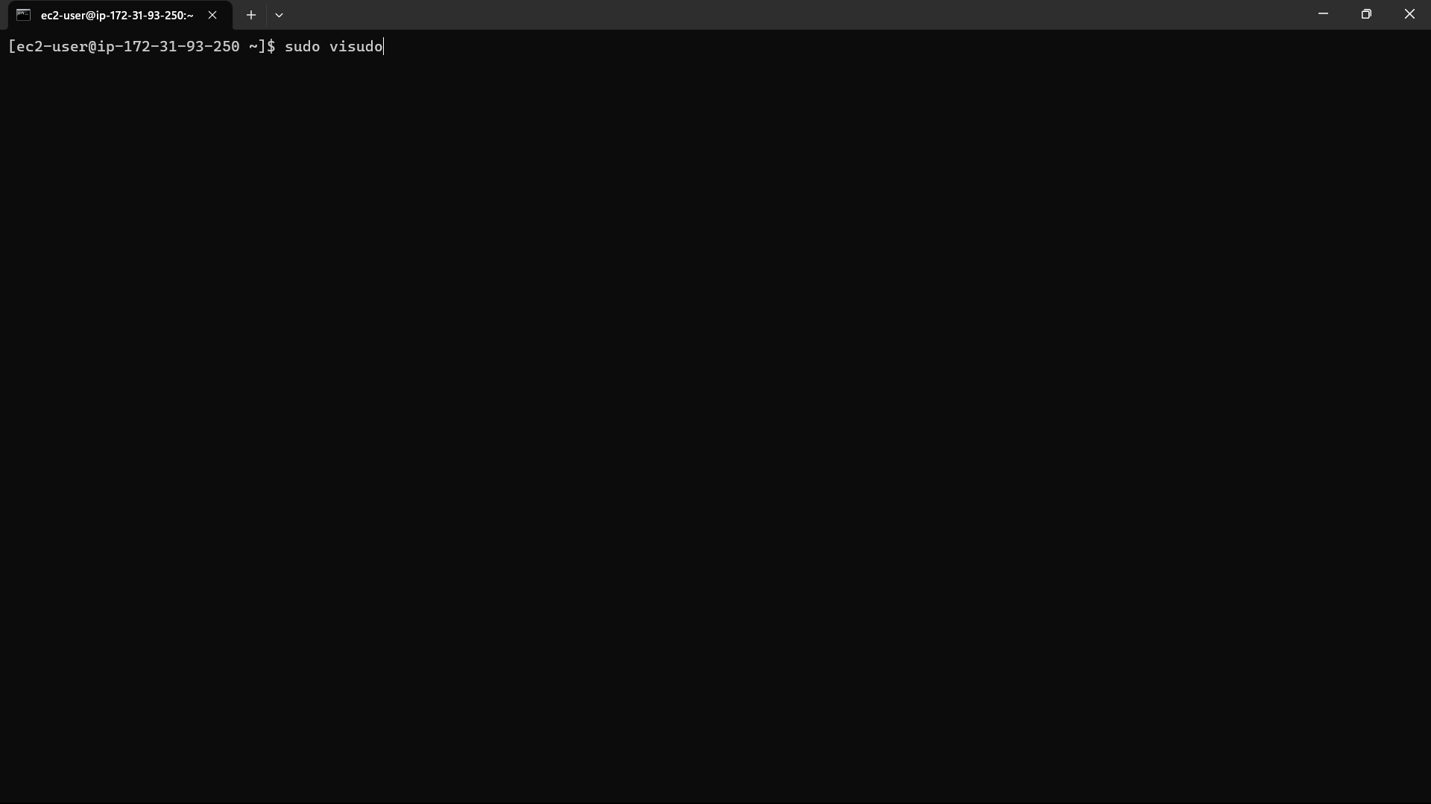

110)The file is opened. Go down and add an extra line below the root user i.e.,

“jenkins ALL=(ALL) NOPASSWD: ALL”. The ctrl+s, ctrl+x.

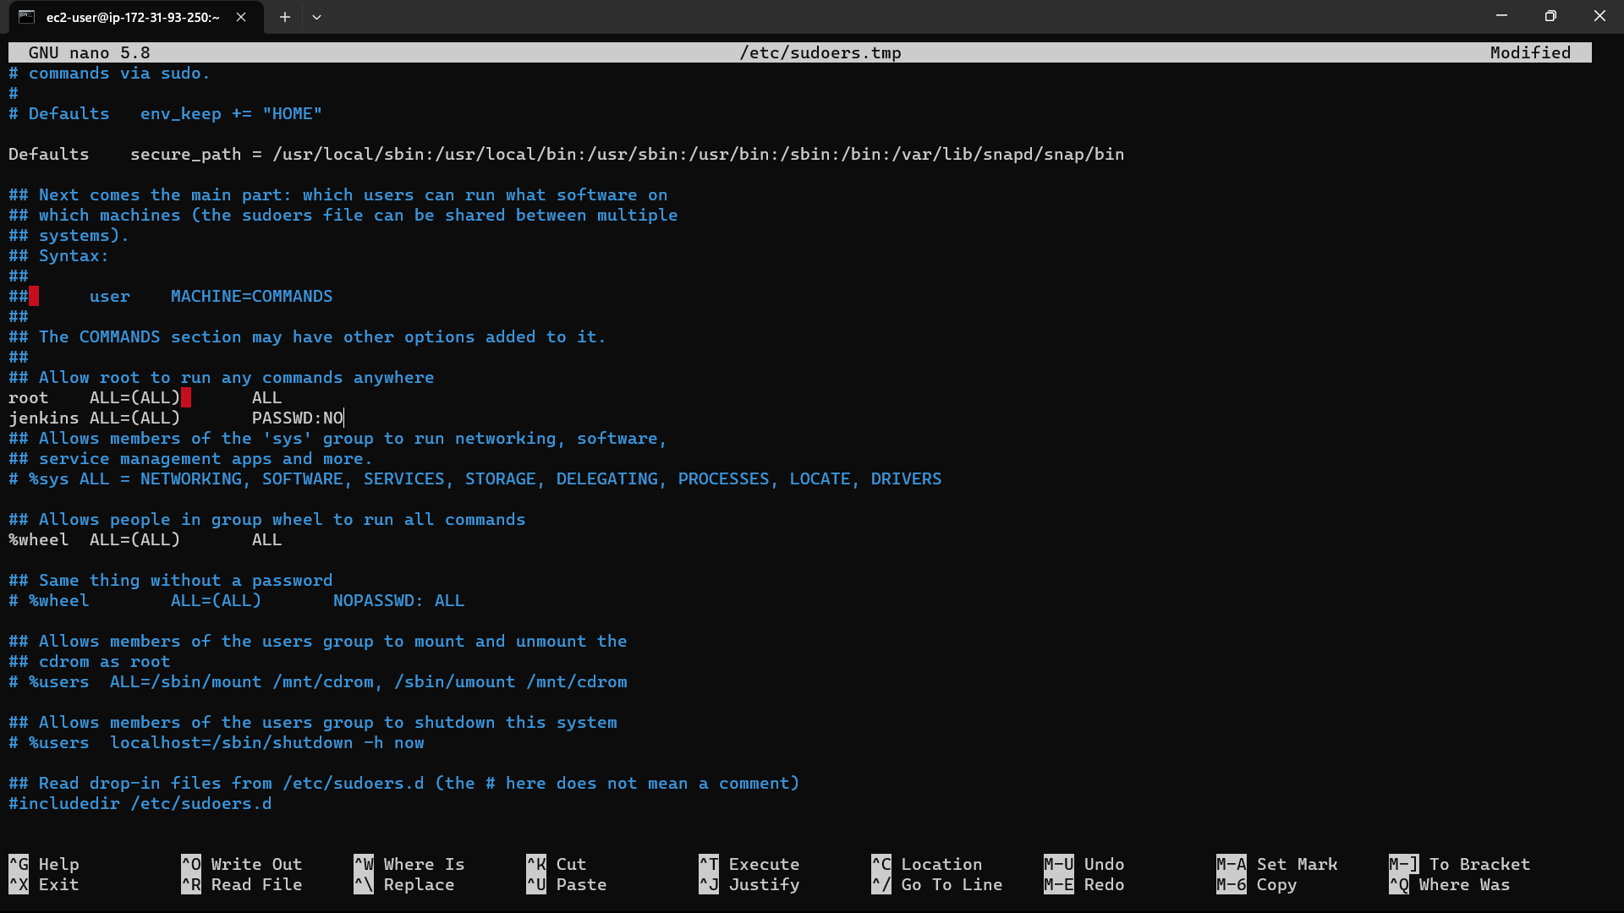

111)Go to the instances in console and select the instance you created.

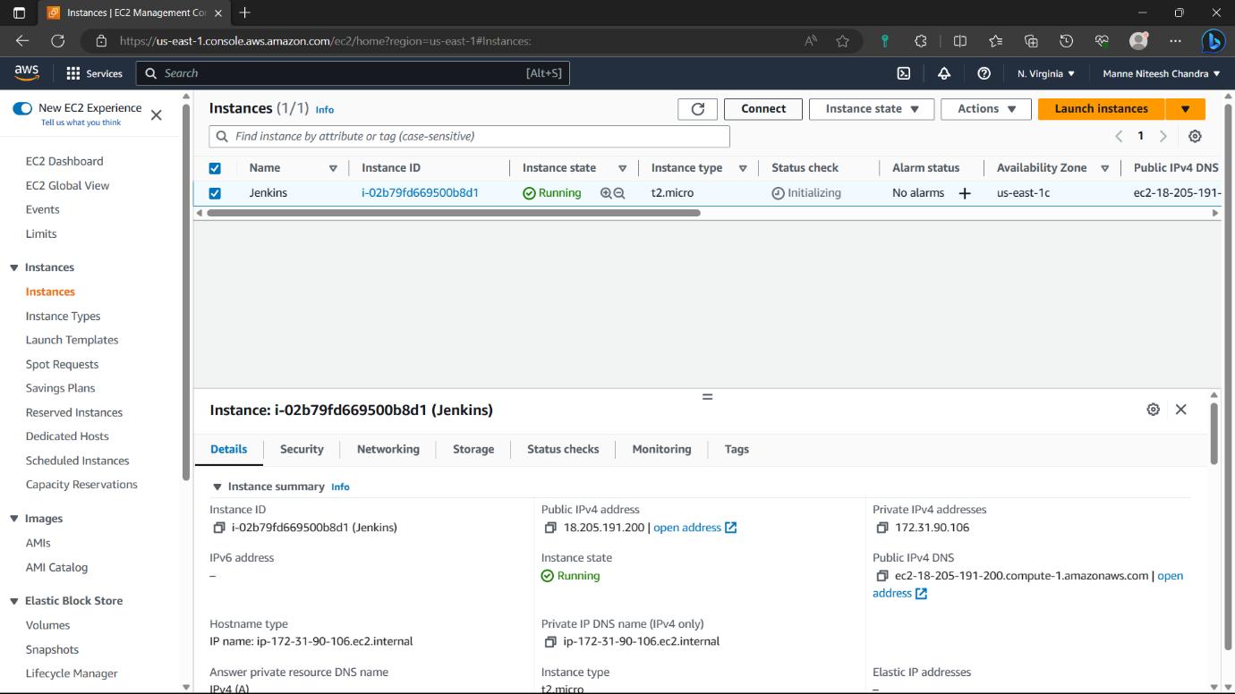

112)Navigate to security of the instance and click on the security group.



113)Click on “edit inbound rules” option.

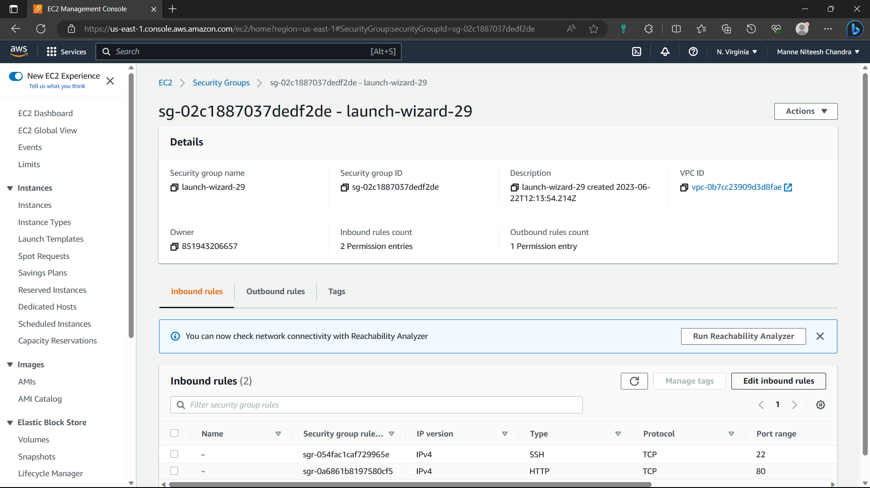

114)Click on “Add rule”.

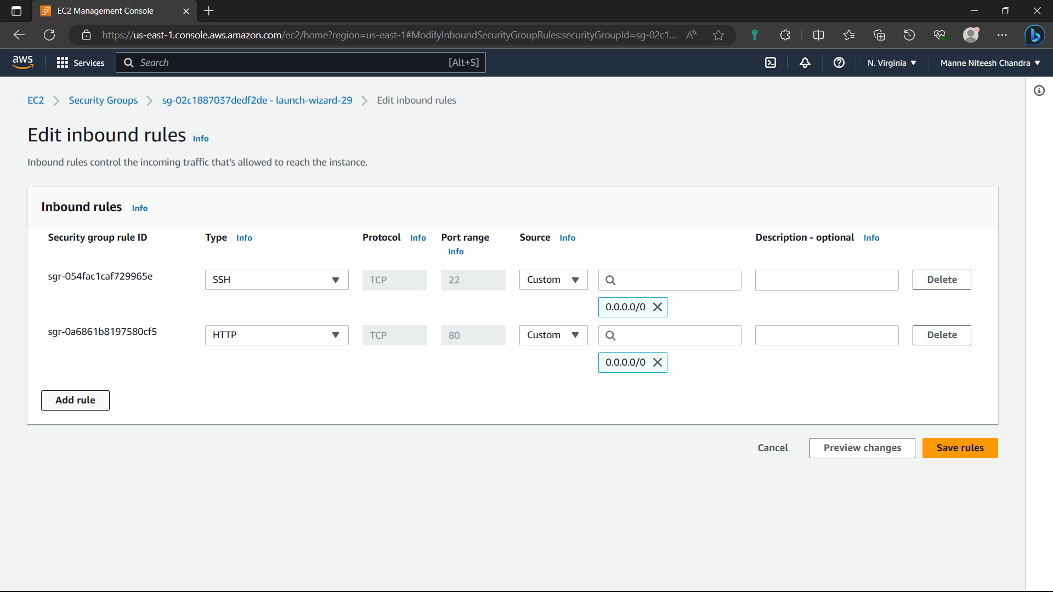

115)Type-Custom, port-8080, cidr-0.0.0.0/0 and click on “save rules” option.

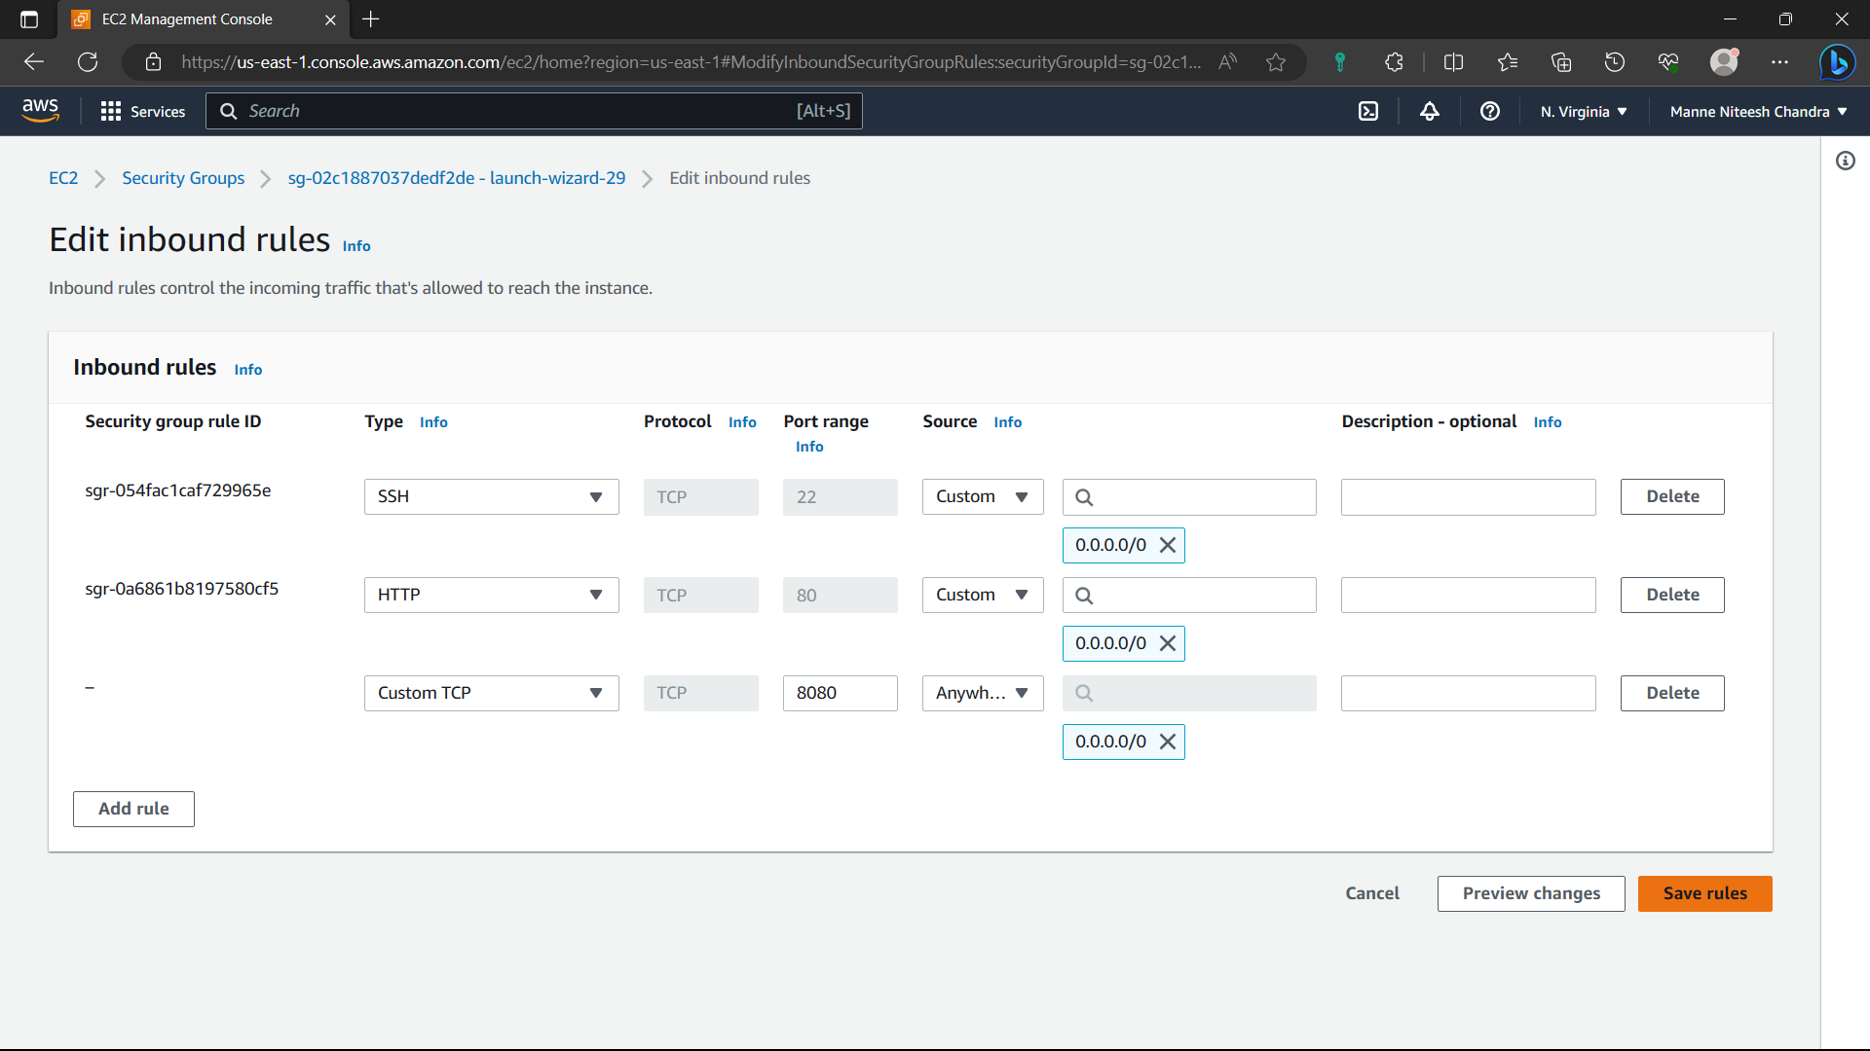

116)Now the rule is saved.

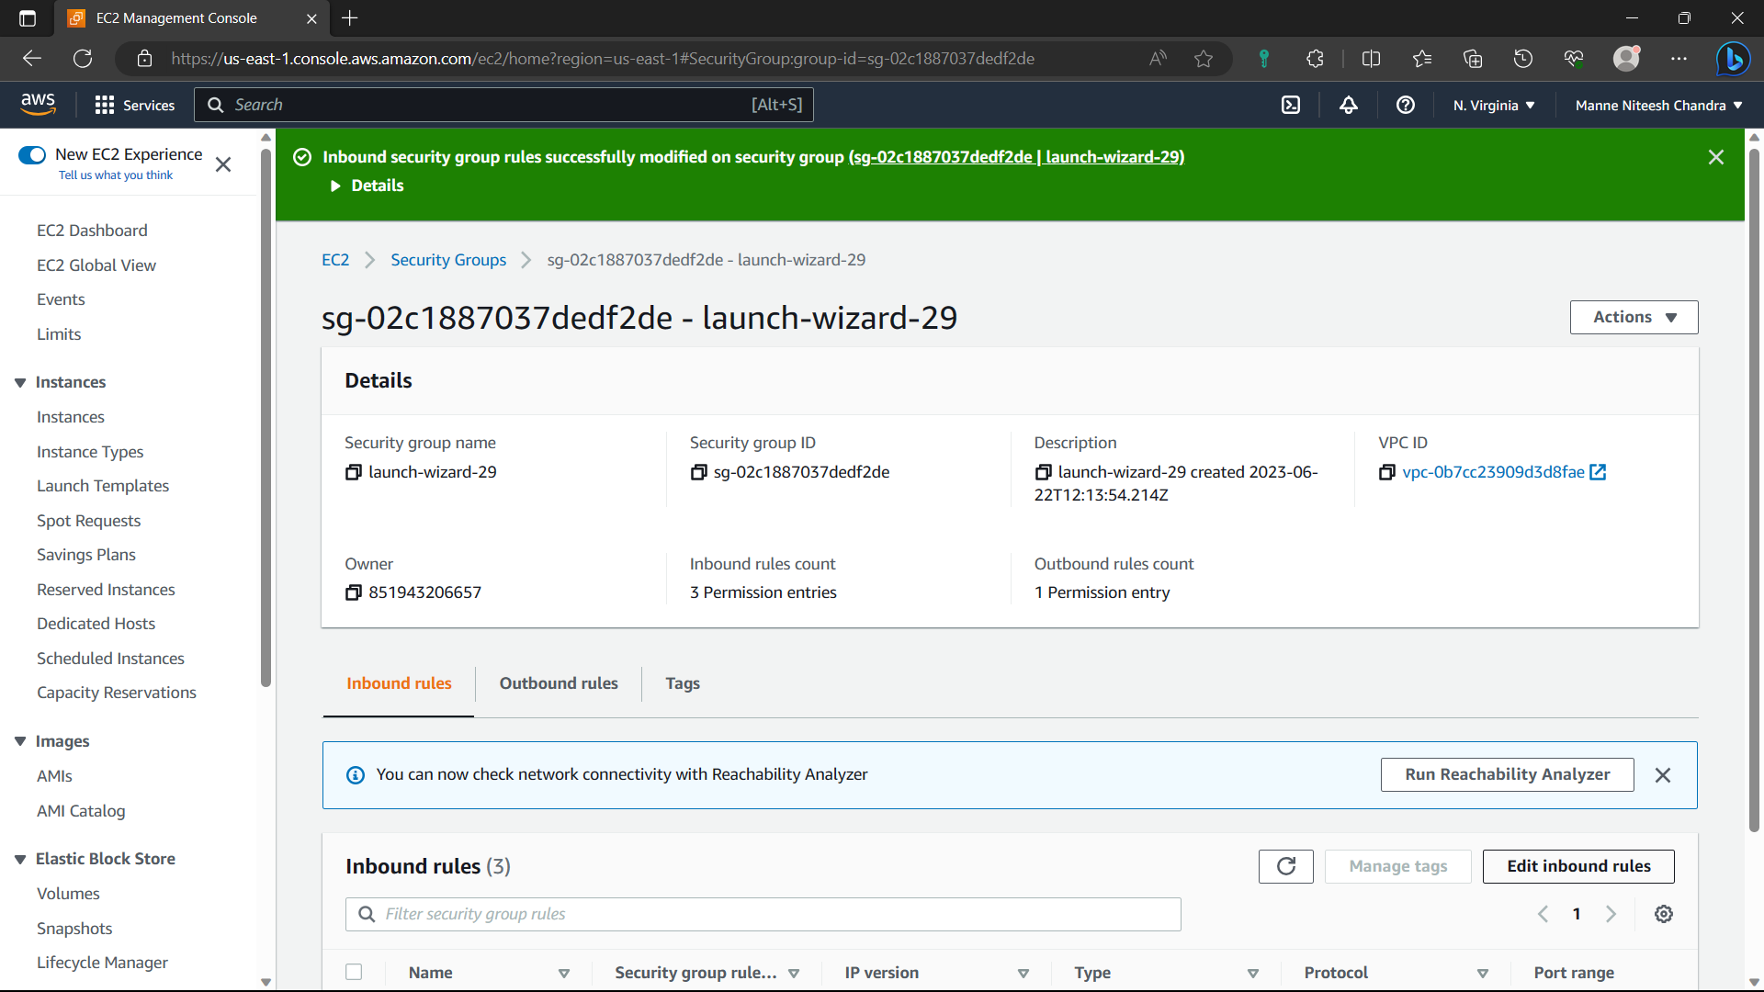

117)Go to “Instances” and select the instance you created and copy the ipv4address.

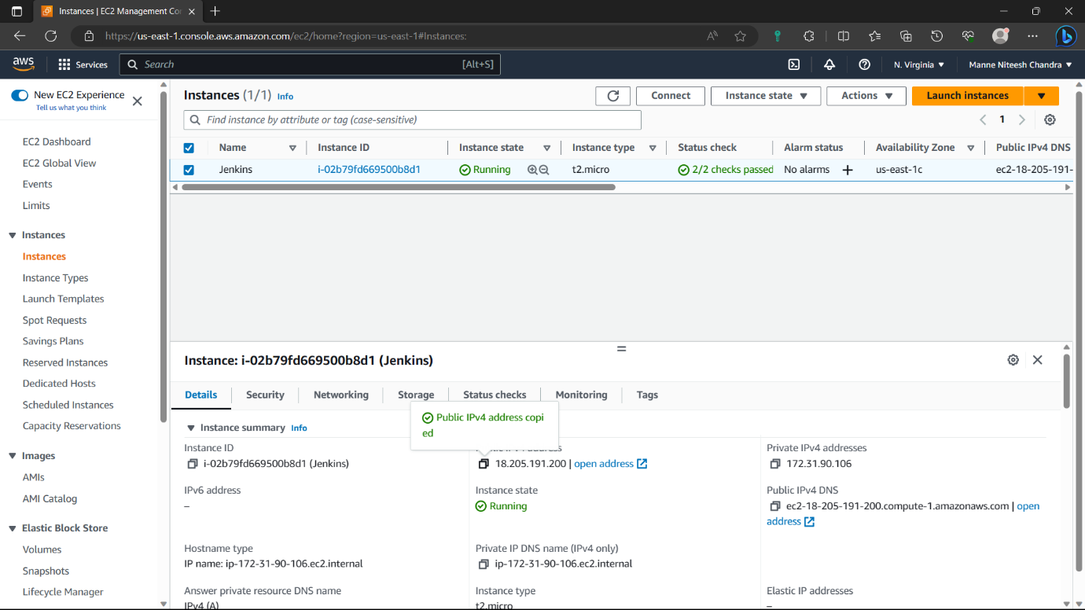

118)Before pasting it in browser add ”:8080” to the ipv4address to open Jenkins in the browser. Jenkins is opened in browser. Copy the pathi.e., in red colour.

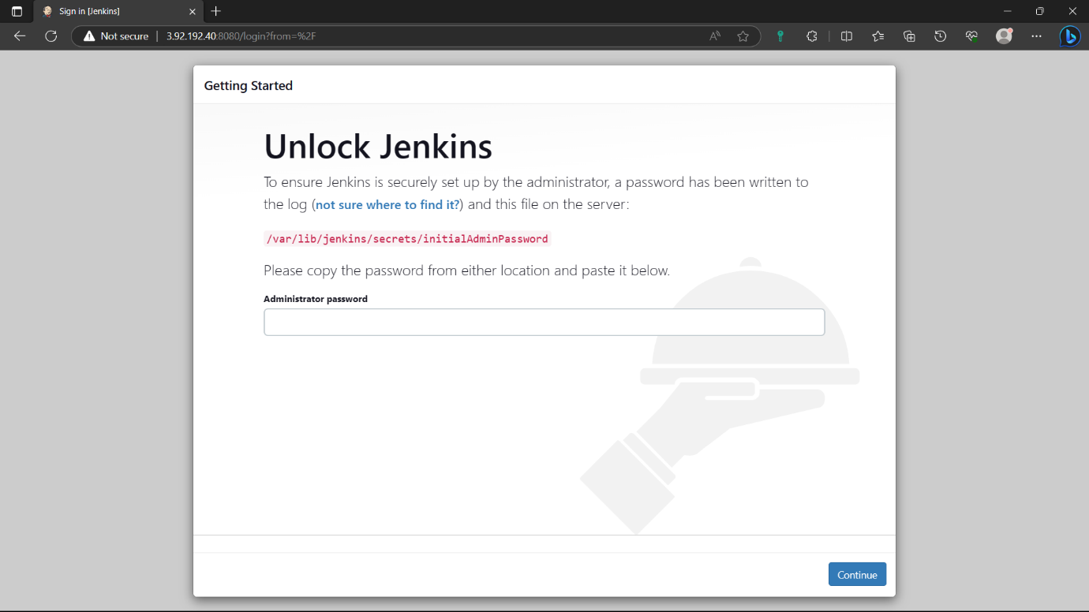

119)go to instance and type the command “sudo cat path”: for password to create Jenkins account.

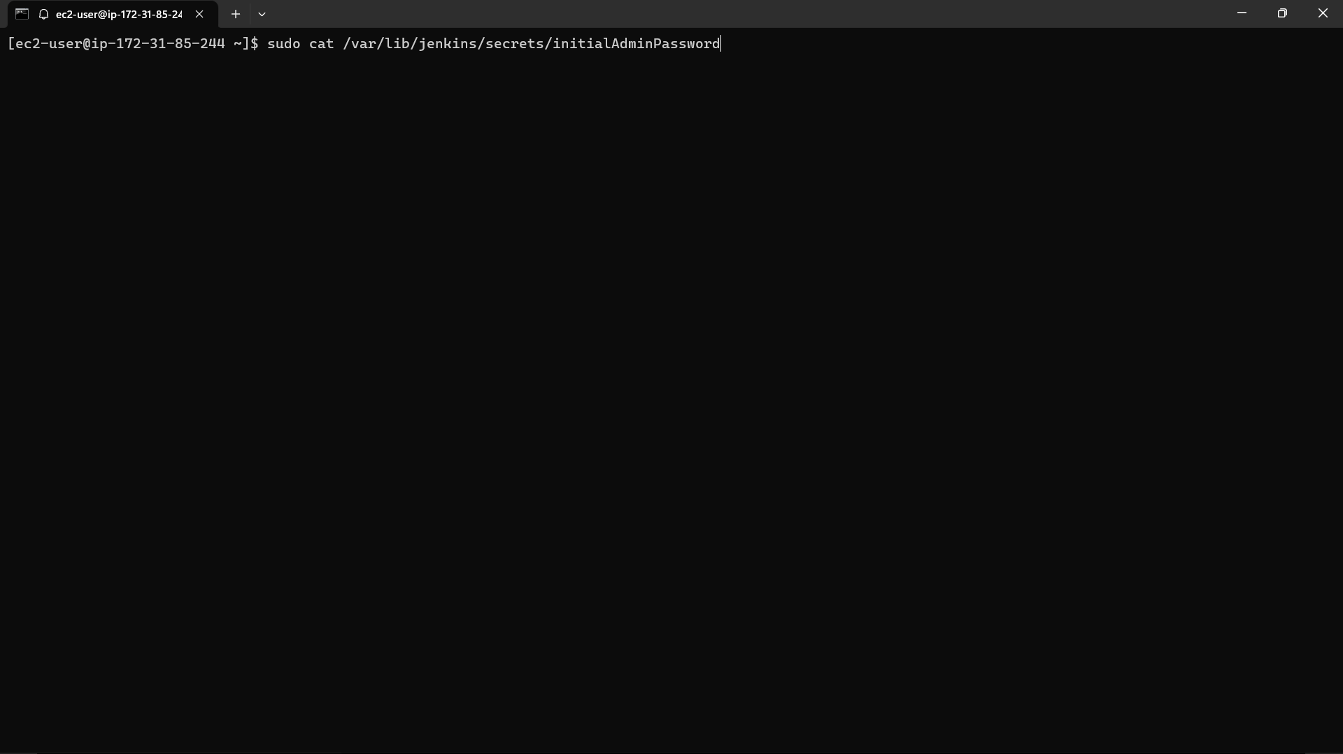

120)Copy the output and paste it in the Jenkins and click on continue.

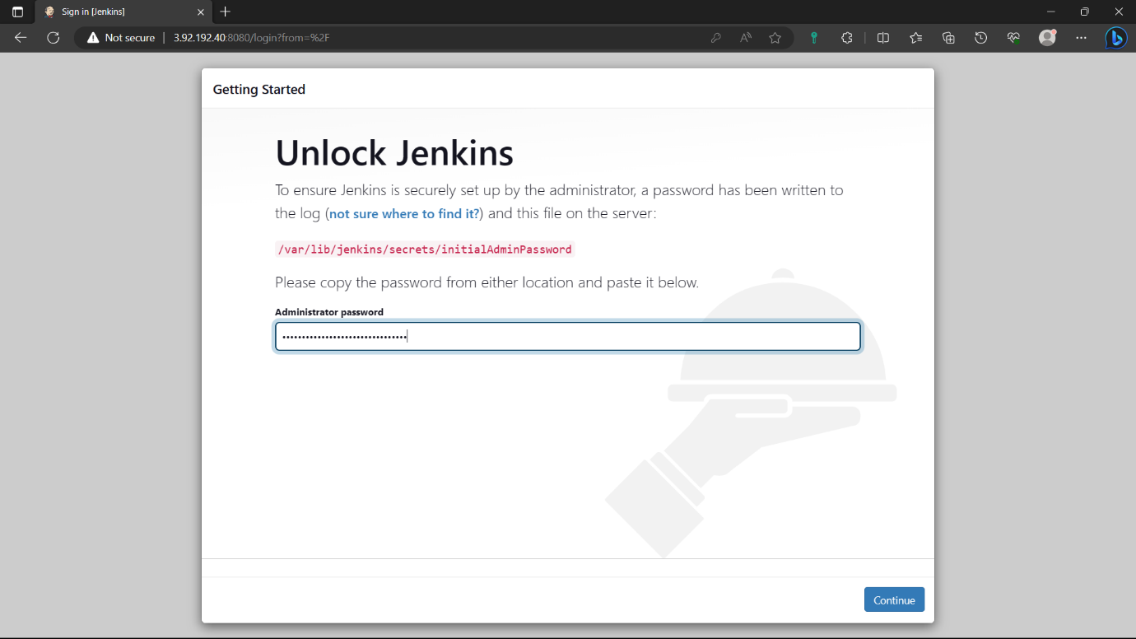

121)Select the “Install suggested plugins” option. And wait for some to install required plugins.

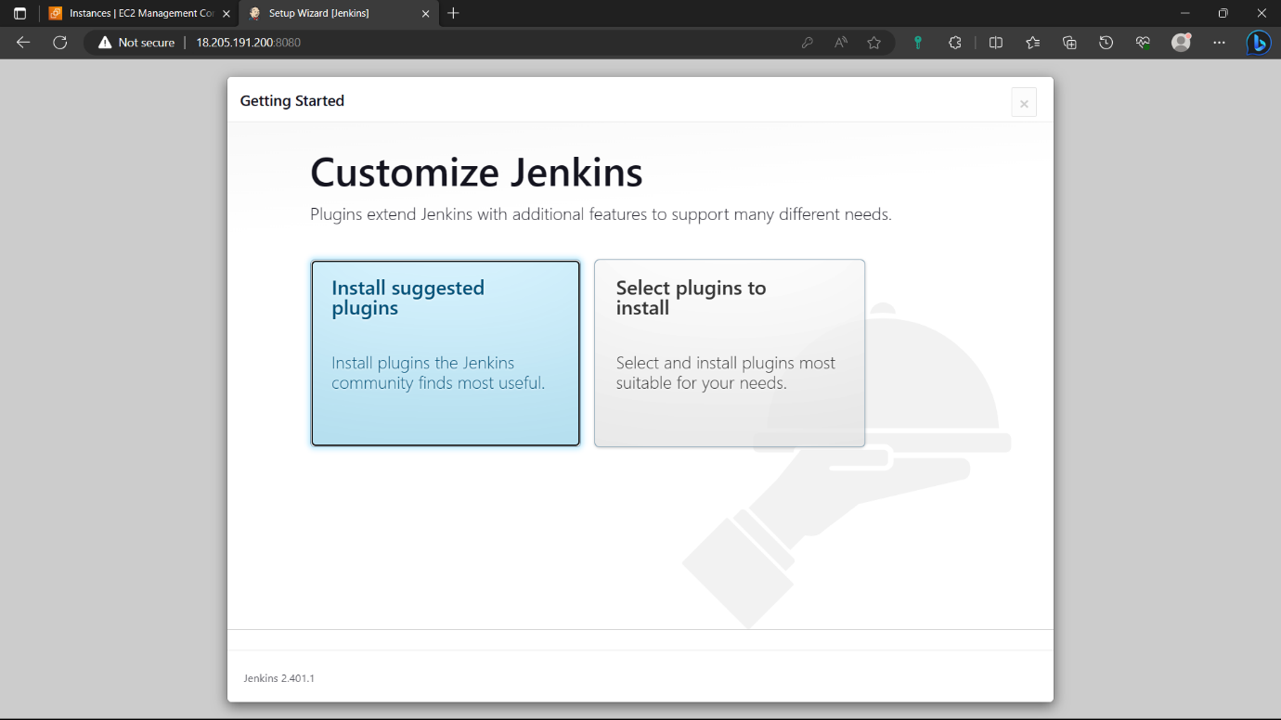

122)Give credentials to create an account click on “save and continue” and click on “continue” again.

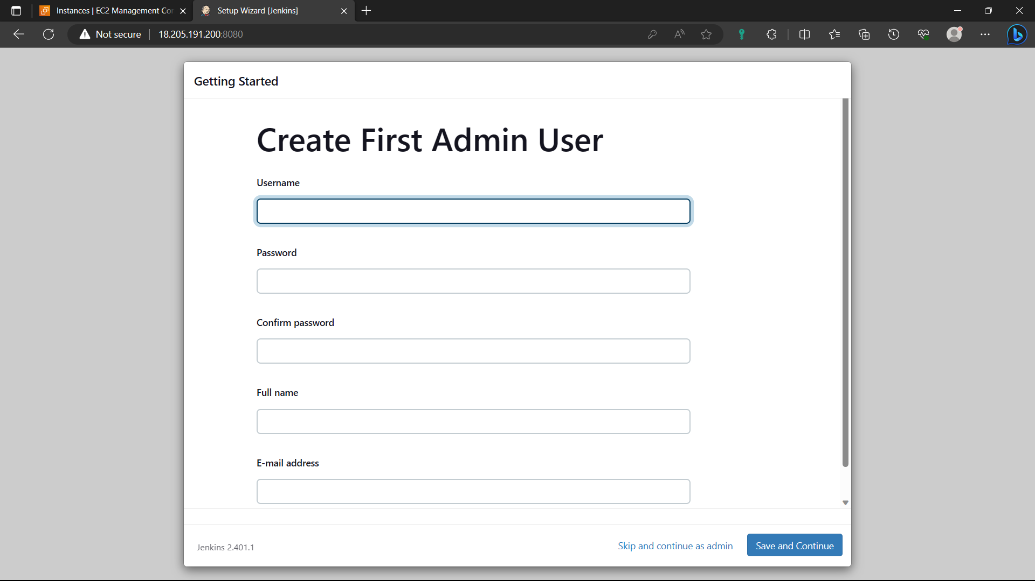

123)click on “start using Jenkins”.

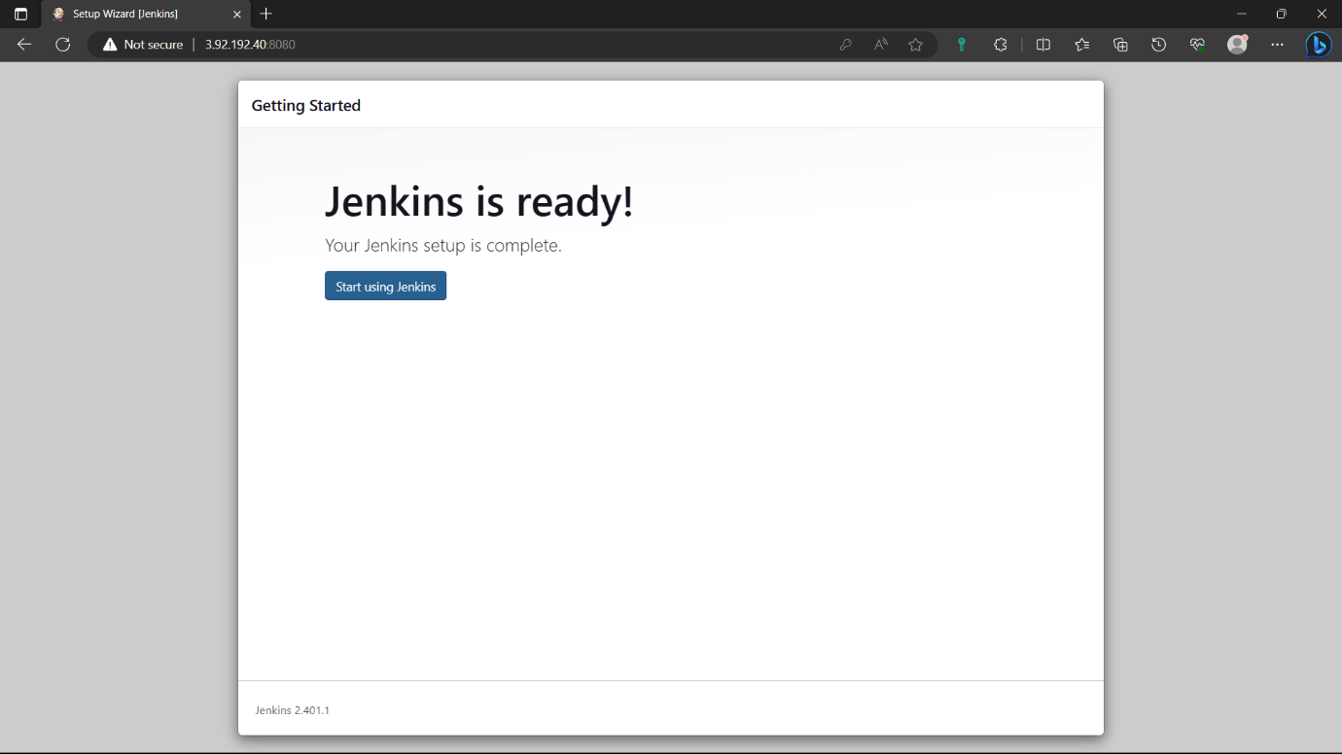

124)Jenkins is ready. Click on “create a job”.

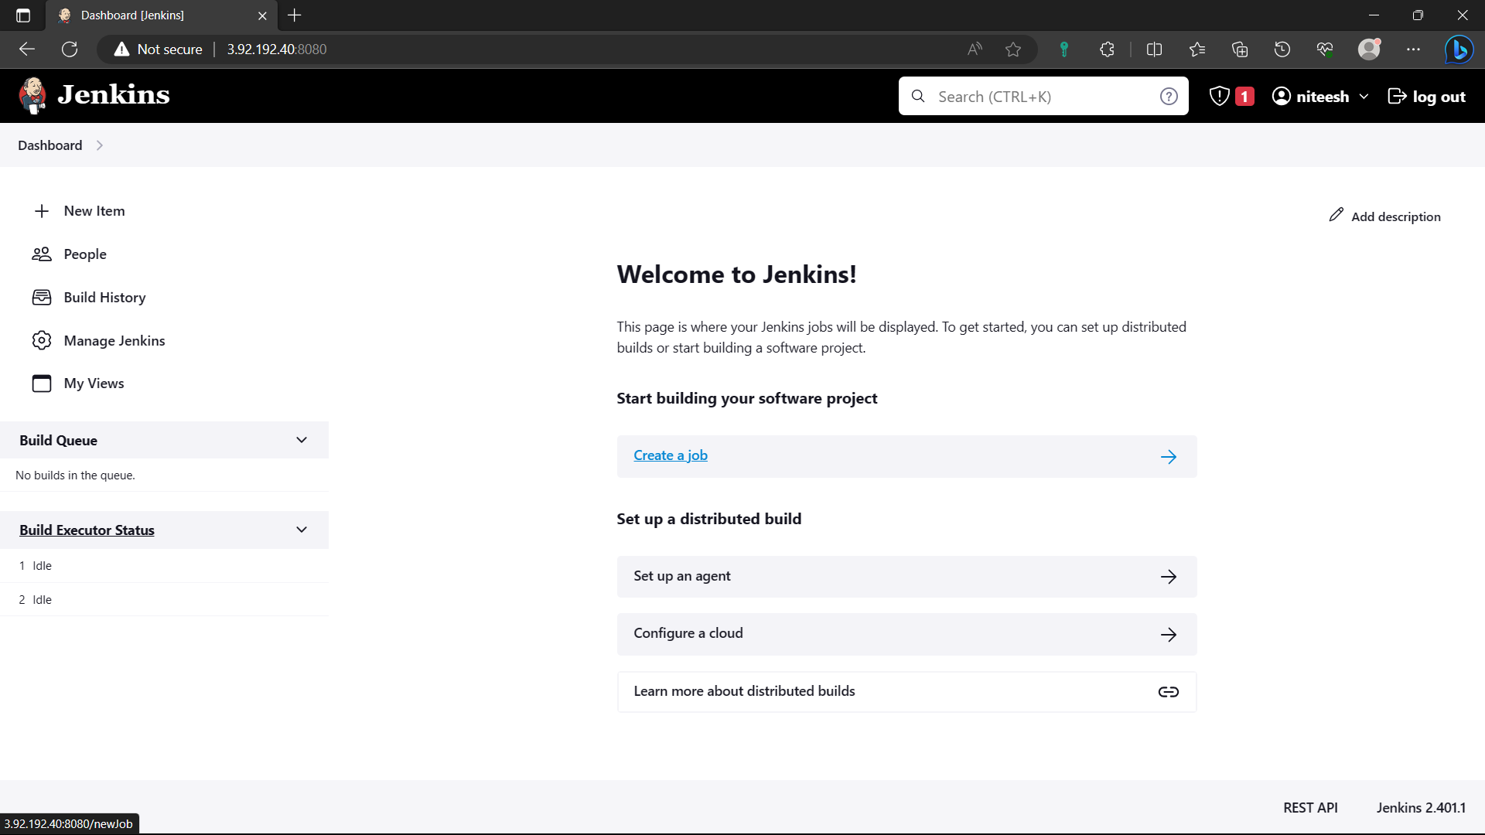

125)Give a name to the job, Select “Free style project”, click on “ok”.

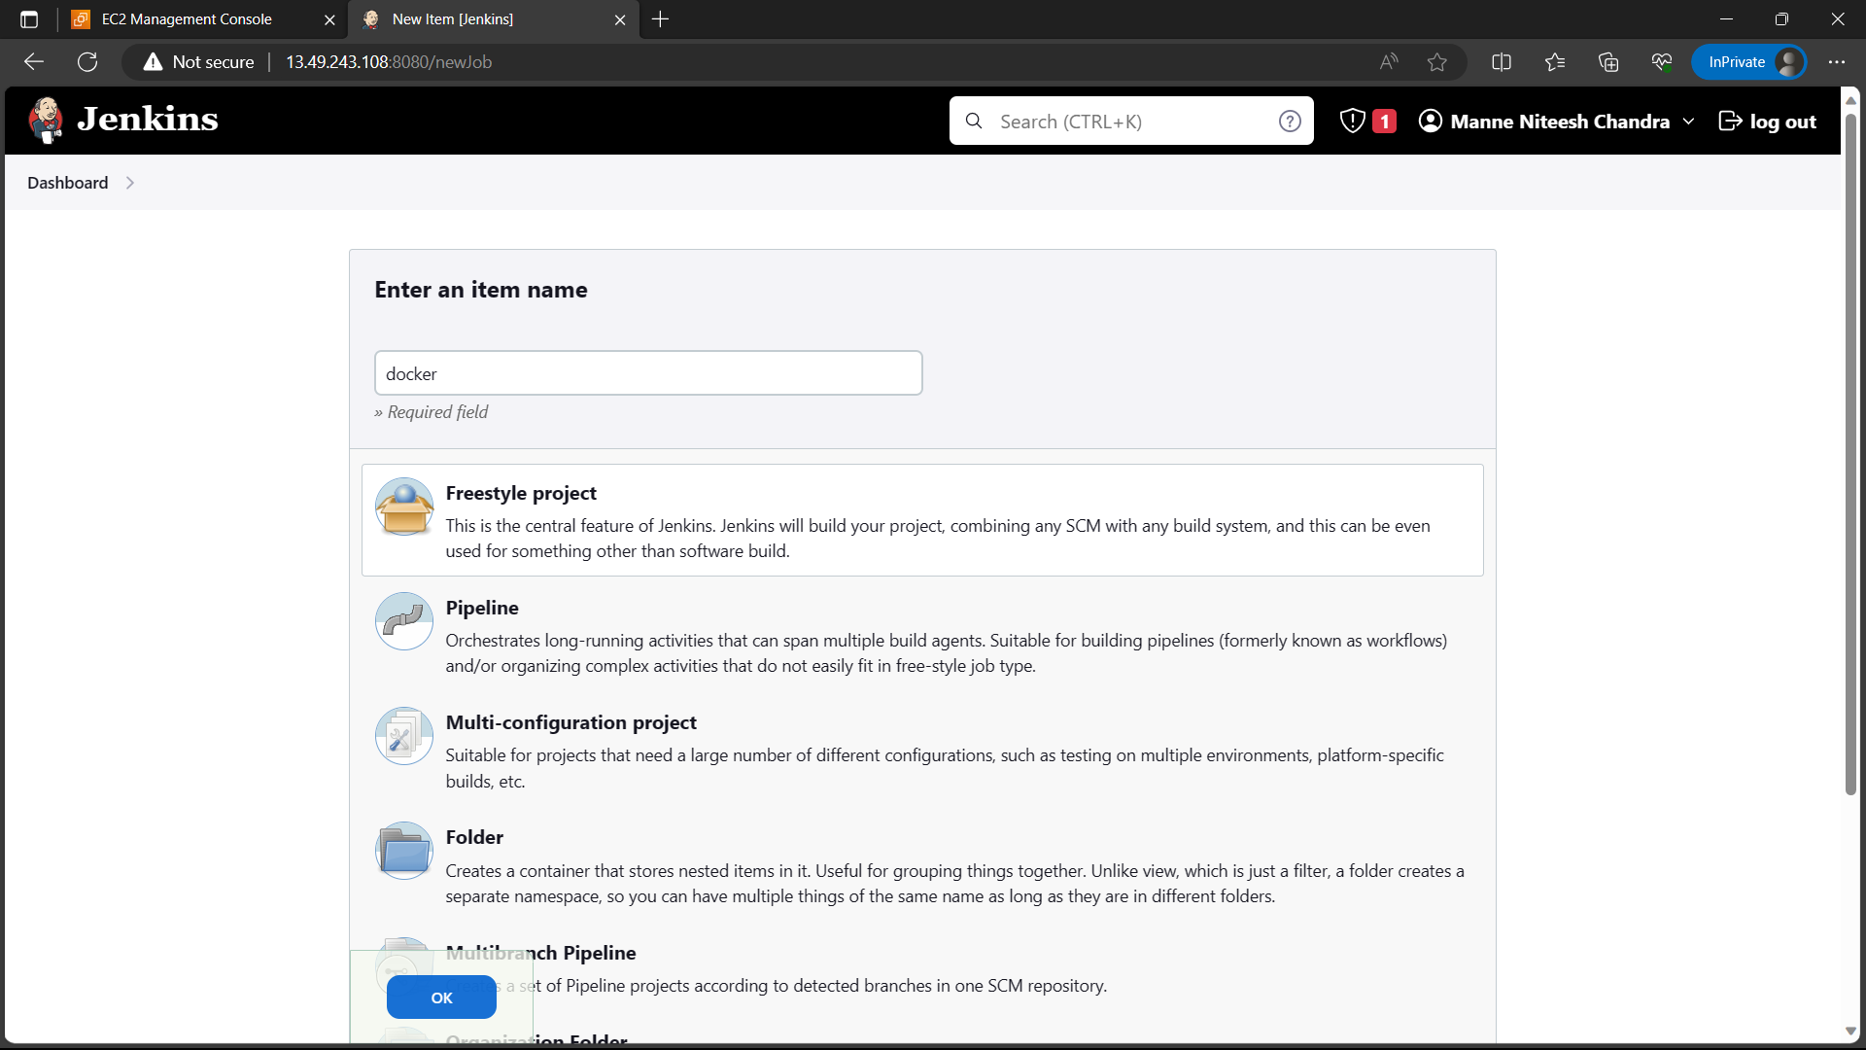

126)Go to github and copy the “HTTP” link from “code” of the repo where you pushed docker compose file.

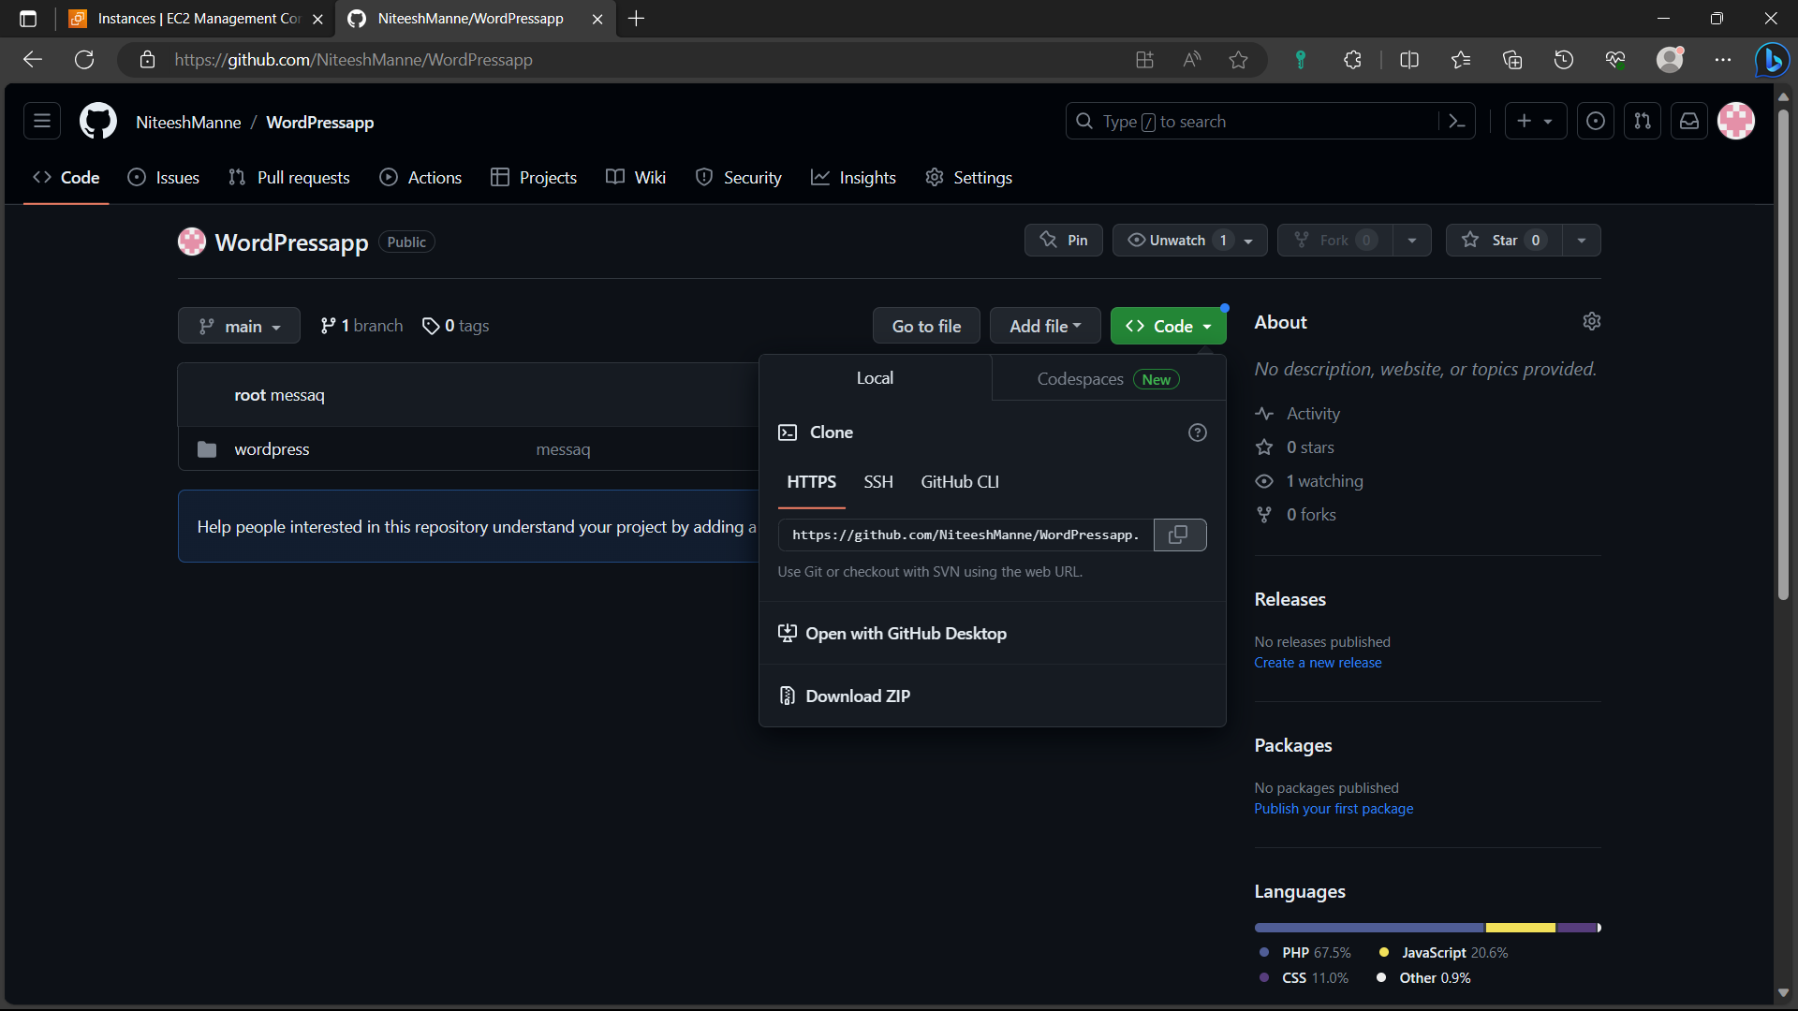

127)Paste it in the “Repository URL” and click on “Add”🡪”Jenkins”.

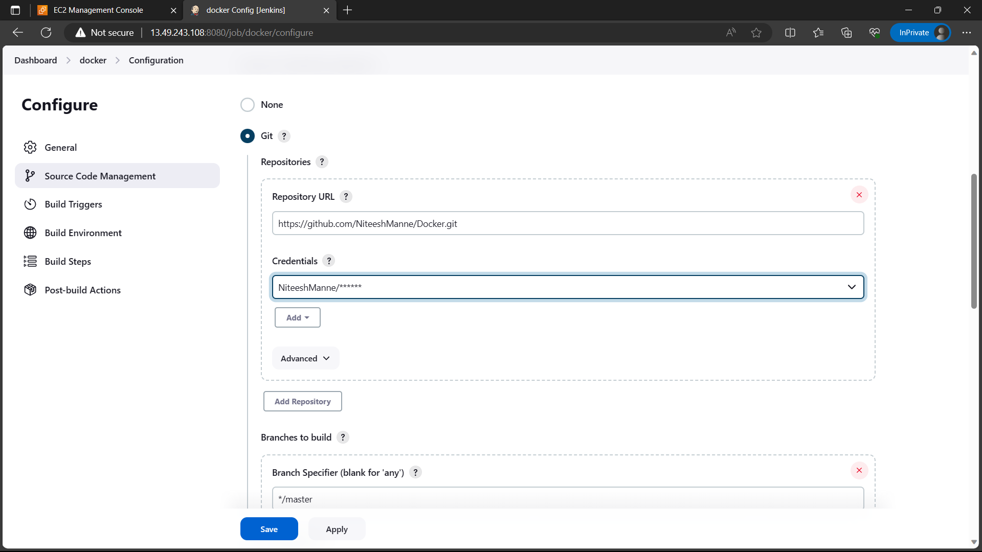

128)Give the github username and for password give personal token. And click on add. If you don’t have any follow the below step.

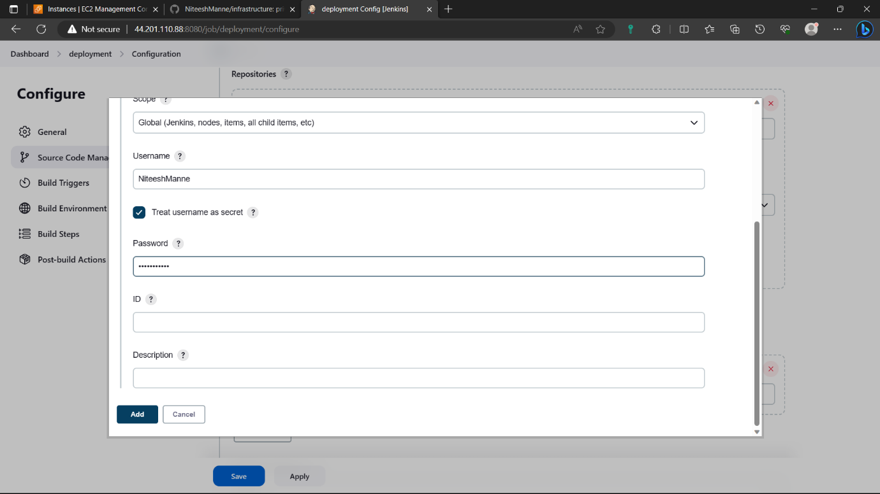

129)Click on profile🡪settings🡪developer settings🡪personal access token🡺create personal access token(classic)🡪give a name🡪enable repo🡪click on create🡪copy the token and paste it in secure file.

In credentials of Jenkins select your credentials.

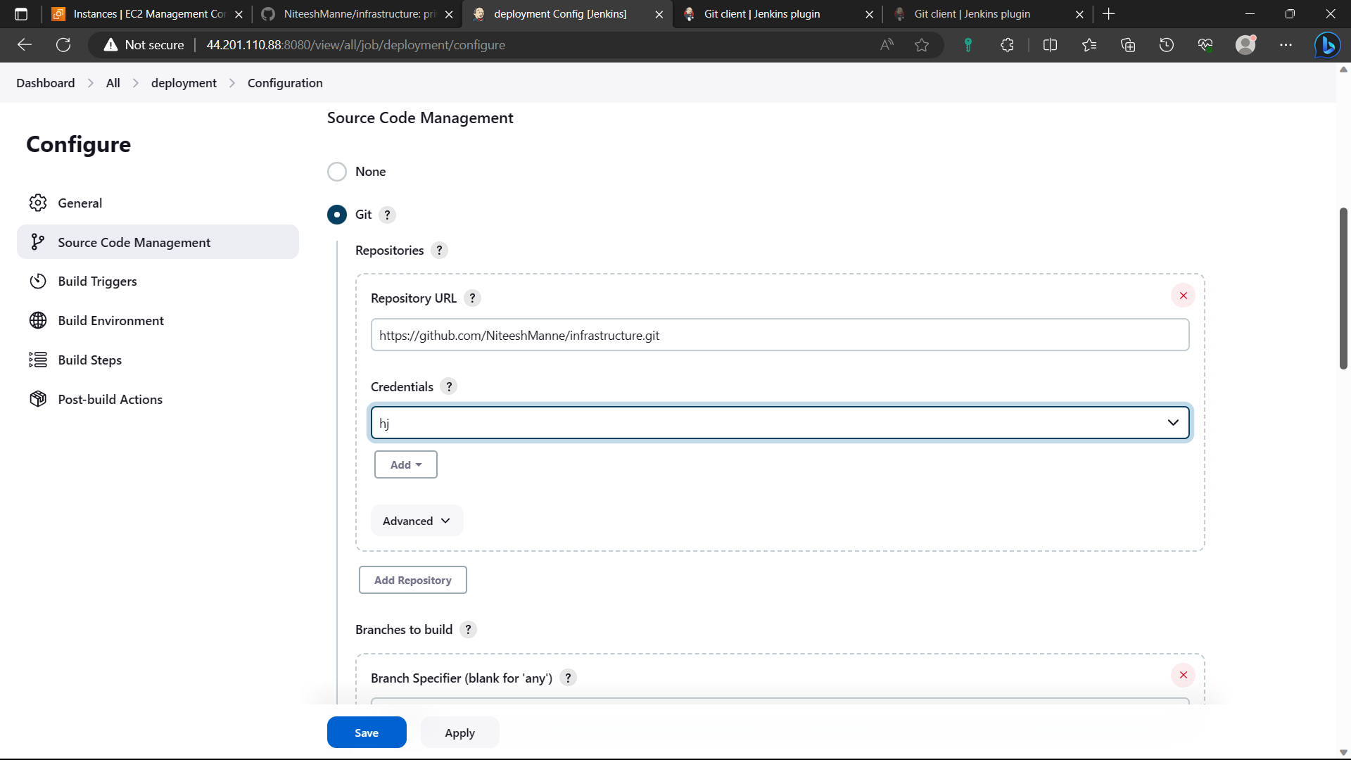

130)Change branch name to “main” if your branch name is “main”.

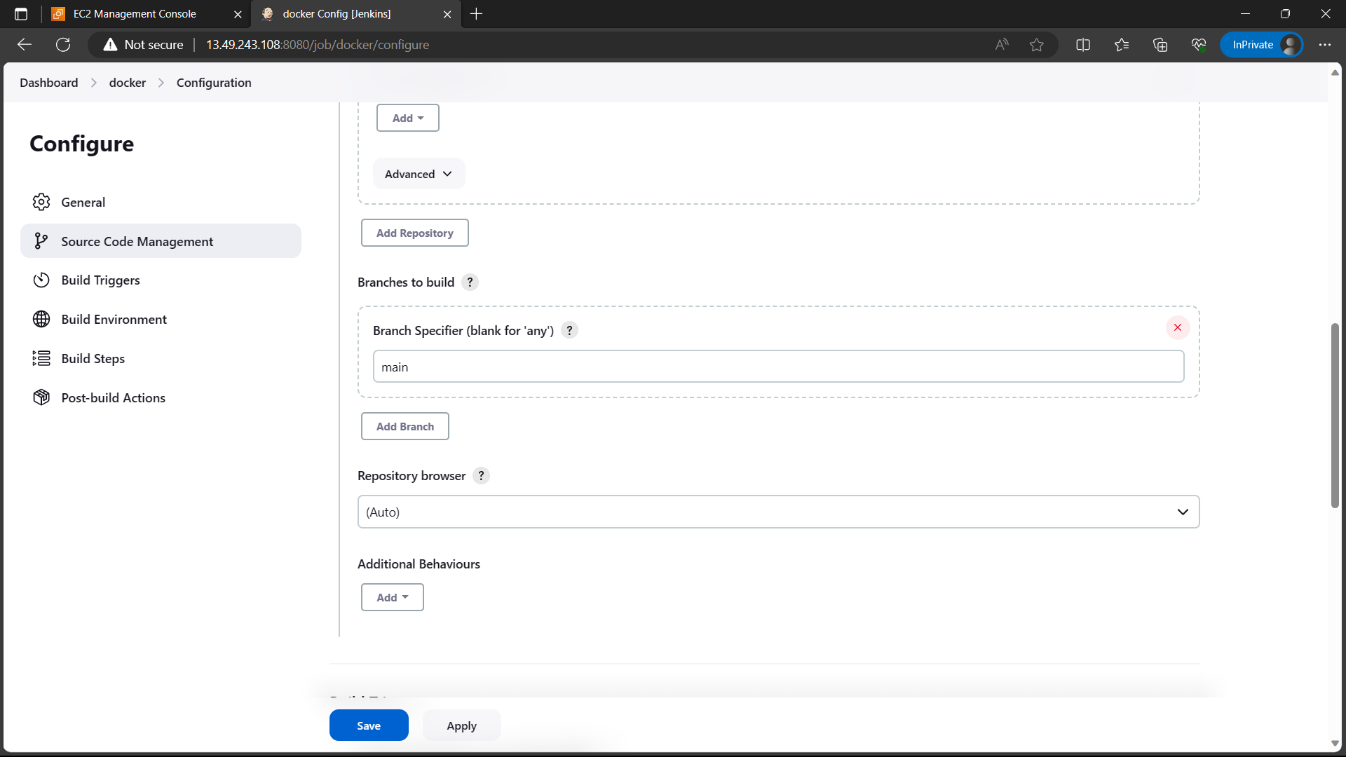

131)Now go to ”Build steps” select “execute shell” and type the commands below. Click on “save” option and come to dashboard, Click on “Build now” option now job is currently executing you can see it below search bar in navigation panel.

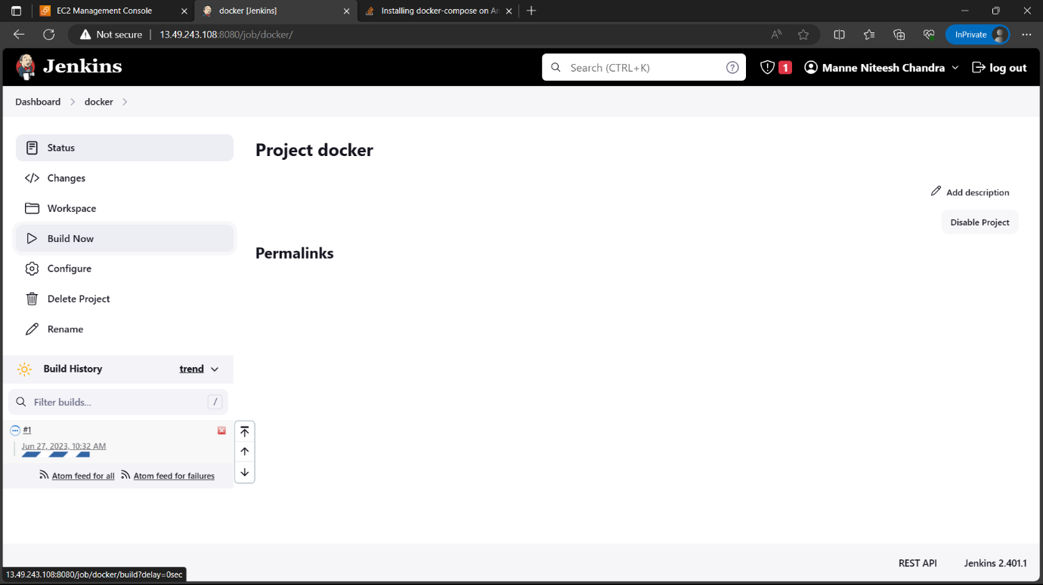

132)Select the “#1” and go to “console output”.

